Style Guidelines for Final Year Project ReportsLAWWISE
Final Year Project
Session 2022-2026
A 4th Year Student

A project submitted in partial fulfillment of the requirements for the Degree
of
BSc. (Hons.)BS in Computer Science



Department of Computer Science
COMSATS University Islamabad (CUI), Lahore Campus

Project Details
Project ID (for office use)
Type of project |  |  | [✔] Traditional [ ] Industrial [ ] Continuing
Nature of project |  |  | [✔] Development [ ] Research & Development
Sustainable Development Goals(SDGs) |  |  | [ ] Good Health and Well-Being [✔] Quality Education  [ ] Industry, Innovation, and Infrastructure [ ] Gender Equality  [✔] Decent Work and Economic Growth [ ] Climate Action
Area of specialization |  |  | [✔] Artificial Intelligence (AI) [ ] Blockchain [ ] Cybersecurity  [ ] Data Science and Analytics [ ] Game Development  [ ] Internet of Things (IoT) [ ] Natural Language Processing (NLP)  [✔] Mobile App Development [✔] Web Development
Project Group Members
Sr.# | Reg. # | Student Name |  | Email ID | Signature
(i) | FA22-BCS-021 | Mahnoor Tariq |  | Fa22-bcs-021@cuilahore.edu.pk
(ii) | FA22-BCS-037 | Minal Amjad |  | Fa22-bcs-037@cuilahore.edu.pk
(iii) | FA22-BCS-153 | Maryam Bakhtyar |  | Fa22-bcs-153@cuilahore.edu.pk
Declaration: The candidates confirm that the work submitted is their own and appropriate credit has been given where reference has been made to the work of others.
Plagiarism Free Certificate
This is to certify that, I am Mahnoor Tariq S/D/o Tariq Mahmood, group leader of FYP under registration no CUI /FA22-BCS-021/LHR at the Computer Science Department, COMSATS University Islamabad, Lahore Campus. I declare that my FYP proposal is checked by my supervisor and the similarity index is 14% that is less than 20%, an acceptable limit by HEC. The report is attached herewith as Appendix A.
Date:03-06-2026 Name of Group Leader: Mahnoor Tariq Signature: __________

Name of Supervisor: Dr. Jawad Shafi Co-Supervisor (if any):_________________
Designation: Assistant Professor Designation: _____________________
Signature: _____________________ Signature: _____________________

HoD: _____________________
Signature: _____________________
ABSTRACT
LawWise is a digital lawyer assistant that is an artificial intelligence-driven application that seeks to enhance efficiency of legal work between lawyers, clients and students. There are fragmented and inefficient elements of case management, document drafting, and educational support on the majority of existing systems. Using the AI-powered document drafting, holistic case management, student learning modules, and lawyer-client communication is put on the same platform by LawWise. This system will be supported with secure databases, web, and mobile interfaces, and smart algorithms, which will automate regular duties and will give decision-makers a tangible suggestion. The expected outcomes are: a decrease in the time of handling cases, faster document preparation, increased legal knowledge access, and learning processes among students will improve. This solution will promote efficiency, transparency and accessibility in legal services as well as improve education and professional collaboration.

Acknowledgement
We are thankful to our supervisor Sir Jawad Shafi because of their help and support in this project. We also enjoy the support of the our university resources, and a conducive environment, and our families and peers, who have been instrumental in supporting us.
Table of Contents
Chapter 1. Introduction 15
1.1 Introduction 15
1.2 Problem Statement 16
1.3 Proposed Solution 16
1.4 Main Objectives 16
1.5 Assumptions & Constraints 17
1.6 Project scope 17
1.7 Software Development Lifecycle Model 17
1.7.1 Requirement Analysis: 18
1.7.2 System Design: 18
1.7.3 Implementation: 18
1.7.4 Testing: 18
1.7.5 Deployment: 19
1.7.6 Maintenance and Updates: 19
Chapter 2. Requirement Analysis 19
2.1 Literature Review 19
2.2 Stakeholders List 20
2.3 Requirements Elicitation 20
2.3.1 Functional Requirements 20
2.3.2 Non-functional Requirements 26
2.3.3 Requirements Traceability Matrix 27
2.4 Use Case Description 29
Chapter 3. System Design 45
3.1 Use Case Design 45
3.1.1 Login and Signup 45
3.1.2 Case History and Tracking 46
3.1.3 Profile Management 47
3.1.4 AI-Based Drafting 48
3.1.5 Communication and Appointment 48
3.1.6 Briefcase 49
3.1.7 AI-Based ChatBot 50
3.1.8 Digital Guidance 50
3.1.9 Notification and Reminders 51
3.1.10 Professional Networking 52
3.1.11 Calender 53
3.1.12 Case Marketplace 53
3.1.13 My Clients 54
3.1.14 Schedule Appointment 54
3.1.15 Case E-Filing 55
3.1.16 Lawyer Filtering 56
3.1.17 Lawyer profile and Reviews 57
3.1.18 Filed Case Tracking 57
3.1.19 Communication and Notification 58
3.1.20 Student GPA Calculator 58
3.1.21 Study Planner 59
3.1.22 Notes Sharing and Upload 59
3.1.23 Past Papers 60
3.2 Activity Diagram 60
3.2.1 Login 60
3.2.2 Signup 61
3.2.3 Case History and Tracking 62
3.2.4 Profile management 63
3.2.5 AI-Based Drafting 64
3.2.6 Communication and Appointment 65
3.2.7 Briefcase 66
3.2.8 AI-Based ChatBot 67
3.2.9 Digital Guidance 68
3.2.10 Notifications and Deadlines 69
3.2.11 Professional Networking 70
3.2.12 Calender 71
3.2.13 Case Marketplace 72
3.2.14 My Clients 73
3.2.15 Schedule Appointment 74
3.2.16 Case E-filing 75
3.2.17 Lawyer Filtering 76
3.2.18 Lawyer profile and Reviews 77
3.2.19 Filed case Tracking 78
3.2.20 Communication and Notification 79
3.2.21 Student GPA Calculator 80
3.2.22 Study Planner 81
3.2.23 Notes Sharing 82
3.2.24 Past Papers 83
3.3 Sequence Diagram 84
3.3.1 Login and Authentication 84
3.3.2 Signup 85
3.3.3 Case History and Tracking 86
3.3.4 Lawyer Profile Management 87
3.3.5 AI-Based legal Drafting 88
3.3.6 Communication 89
3.3.7 Briefcase 90
3.3.8 AI-Based ChatBot 91
3.3.9 Digital Guidance 92
3.3.10 Notifications and Deadlines 93
3.3.11 Professional Networking 94
3.3.12 Calender 95
3.3.13 Case Marketplace 96
3.3.14 My Clients 97
3.3.15 Schedule Appointment 98
3.3.16 Client Registration and Profile 99
3.3.17 Filed Cases 100
3.3.18 Communication and Notification 101
3.3.19 E-Filing 102
3.3.20 Lawyer Filtering and Selection 103
3.3.21 View Lawyer Profile and Reviews 104
3.3.22 GPA Calculator 105
3.3.23 Study planer 106
3.3.24 Notes Sharing and Upload 107
3.3.25 Past Papers 108
3.4 Software Architecture Diagram 109
3.5 Class Diagram 109
3.6 Database Diagram 111
3.7 Collaboration Diagram 112
Chapter 4. System Testing 112
4.1 Test Cases Design 112
4.2 Unit / Integration / Acceptance Testing 137
4.2.1 Authentication Module 137
4.2.2 Dashboard Module 138
4.2.3 Lawyer Profile Management Module. 138
4.2.4 Case History/ Tracking Module. 139
4.2.5 AI-Based Drafting Module 139
4.2.6 AI Chatbot 140
4.2.7 Digital guidance Module 140
4.2.8 Briefcase Document Module 140
4.2.9 Professional Networking Module 141
4.2.10 Communication and Appointment Module. 141
4.2.11 Messages, Deadlines & Reminders Module. 142
4.2.12 Calendar Module 142
4.2.13 Case Marketplace Module 143
4.2.14 My Clients Module 143
4.2.15 Schedule Planner Module 143
4.2.16 Client Registration and Profile Module 144
4.2.17 E-Filing Module 144
4.2.18 Lawyer filtering 145
4.2.19 Lawyer reviews 145
4.2.20 Filed Cases Module 145
4.2.21 Client Messaging & Notification Module 146
4.2.22 GPA Calculator Module 146
4.2.23 Study Planner Module 147
4.2.24 Notes Sharing & Upload Module 147
4.2.25 Past paper 148
Chapter 5. Implementation 148
5.1 Work Breakdown Structure (WBS) 148
5.2 Team Roles and Responsibilities 149
5.3 Tools and Technologies 151
5.3.1 Frontend (User Interface) 151
5.3.2 Backend (Server & Logic) 151
5.3.3 AI & Machine Learning (The Intelligence) 151
5.3.4 Databases (Data Storage) 152
5.3.5 Specialized Tools & APIs 152
5.4 Implementation Details 152
5.4.1 Frontend 152
5.4.2 Backend 153
5.4.3 AI Technologies 154
5.4.4 Deployment 155
5.5 Screenshots of Prototype / System 155
5.5.1 Home page 155
5.5.2 Lawyer Login 156
5.5.3 Lawyer signup 156
5.5.4 Lawyer Dashboard 157
5.5.5 Case history and tracking 158
5.5.6 Profile management 158
5.5.7 Mini law library / Briefcase 159
5.5.8 AI Chatbot 159
5.5.9 Digital Guidance 160
5.5.10 Notifications and reminders 160
5.5.11 Professional networking 161
5.5.12 Communication 161
5.5.13 Analytics 162
5.5.14 My clients 162
5.5.15 AI Legal Drafting 163
5.5.16 Case Marketplace 163
5.5.17 Consultation Booking 163
5.5.18 Manage Schedule 164
5.5.19 Client Login 165
5.5.20 Client Sign Up 165
5.5.21 Client Dashboard 166
5.5.22 Client Notification and Reminders 166
5.5.23 Client Communication Screen 167
5.5.24 Filed Cases 167
5.5.25 E-Filing Cases 168
5.5.26 Lawyer Filtering 168
5.5.27 Lawyer Reviews 169
5.5.28 Student Login 169
5.5.29 Student Sign Up 169
5.5.30 Studend Dashboard 170
5.5.31 Personalized Learning 170
5.5.32 Past Papers 171
5.5.33 Mini Library 171
5.5.34 Notes Sharing 172
5.5.35 GPA Calculator 172
5.5.36 Insights and Guides 173
5.5.37 Study Planner 173
5.6 Challenges During Implementation 173
Chapter 6. Conclusions 174
6.1 Summary 174
6.2 Recommendations for Future Work 174
Chapter 7. References 175

List of Tables
Table 2.1. FR01-Lawyer Authentication and Profile Management 21
Table 2.2. FR02-Case Management 22
Table 2.3. FR03-AI-Based Legal Drafting 22
Table 2.4. FR04-Communication and Appointment 22
Table 2.5. FR05-Lawyer Networking 23
Table 2.6. FR06-Briefcase 23
Table 2.7. FR07-My Clients 23
Table 2.8. FR08-Digital Guidance 23
Table 2.9. FR09-Notifications and Reminders 24
Table 2.10. FR10-AI ChatBot 24
Table 2.11. FR11-Calender and Schedule Appointnment 24
Table 2.12. FR12-Case MarketPlace 25
Table 2.13. FR13-Client Registration and Profile 25
Table 2.14. FR14-Case Filing and Management 25
Table 2.15. FR15-Lawyer Filtering 25
Table 2.16. FR16-Communication and Notification 25
Table 2.17. FR17-Filed Cases 26
Table 2.18. FR18-Lawyer Reviews 26
Table 2.19. FR19-GPA Calculator 26
Table 2.20. FR20-Study Planner 26
Table 2.21. FR21-Notes Upload and Sharing 26
Table 2.22. FR22-Past Papers 27
Table 2.23. NFR01-Performance Requirements 27
Table 2.24. NFR02-Reliability and Availability 27
Table 2.25. NFR03-Usability Requirements 27
Table 2.26. NFR04-Compatibility Requirements 27
Table 2.27. Requirements traceability matrix (functional) 28
Table 2.28 Requirements traceability matrix (non-functional) 30
Table 2.29. Login and Auth Module 30
Table 2.30. Case History and Tracking 31
Table 2.31. Lawyer Profile Management 32
Table 2.32. AI-Based Drafting 32
Table 2.33. Communication 33
Table 2.34. Briefcase 33
Table 2.35. AI Chatbot 34
Table 2.36. My Clients 34
Table 2.37. Calendar and Schedule Appointments 35
Table 2.38. Case Market Place 36
Table 2.39. Digital Guidance 37
Table 2.40. Notification and Reminders 37
Table 2.41. Professional Networking 38
Table 2.42. E-Filing 39
Table 2.43. Lawyer Filtering 39
Table 2.44. Lawyer Profile and Review 40
Table 2.45. Communication 41
Table 2.46. Filed Cases 41
Table 2.47. Personalized Learning 42
Table 2.48. Past Papers 43
Table 2.49. Mini Library and Notes Sharing 43
Table 2.50. GPA Calculator 44
Table 2.51. Study Planner 45
Table 4.1. Login and Signup 113
Table 4.2. Case History and Tracking 114
Table 4.3. Lawyer Profile Managemnet 115
Table 4.4. Briefcase 116
Table 4.5. Digital Guidance 117
Table 4.6. My Clients 118
Table 4.7. Notifications and Reminders 119
Table 4.8. Professional Networking 119
Table 4.9. AI Assistance and Legal Drafting 120
Table 4.10. My Calendar and Appointments 121
Table 4.11. Communication 122
Table 4.12. CaseMarket Place 123
Table 4.13. E-Filing 123
Table 4.14. Filed Cases 125
Table 4.15. Lawyer Search and Filtering 126
Table 4.16. Lawyer Reviews and Ratings 127
Table 4.17. Client Communication 128
Table 4.18. Client Notification 130
Table 4.19. Personalized learning 131
Table 4.20. Past Papers 132
Table 4.21. Mini Library 133
Table 4.22. Notes Sharing 134
Table 4.23. GPA Calculator 135
Table 4.24. Insights and Guides 136
Table 4.25. Study Planner 137
Table 5.1. Individual Tasks 150

List of Figures
Figure 3.1: Login and Signup Diagram 47
Figure 3.2: Case History and Tracking Diagram 48
Figure 3.3: Profile Management Diagram 49
Figure 3.4: AI-Based Drafting Diagram 50
Figure 3.5: Communication and Appointment Diagram 50
Figure 3.6: Briefcase 51
Figure 3.7: AI-Based ChatBot Diagram 52
Figure 3.8: Digital Guidance Diagram 52
Figure 3.9: Notification and Deadlines Diagram 53
Figure 3.10: Professional Networking Diagram 54
Figure 3.11: Calender Diagram 55
Figure 3.12: Case Marketplace Diagram 55
Figure 3.13: My Clients Diagram 56
Figure 3.14: Schedule Appointment Diagram 56
Figure 3.15: Case E-Filing Diagram 57
Figure 3.16: Lawyer Filtering Diagram 58
Figure 3.17. Lawyer profile and Reviews Diagram 59
Figure 3.18. Filed Case Tracking Diagram 59
Figure 3.19. Communication and Notification Diagram 60
Figure 3.20. Student GPA Calculator Diagram 60
Figure 3.21. Study Planner Diagram 61
Figure 3.22. Notes Sharing and Upload Diagram 61
Figure 3.23. Past Papers Diagram 62
Figure 3.24: Login Activity Diagram 62
Figure 3.25: Signup Activity Diagram 63
Figure 3.26: Case History and Tracking 64
Figure 3.27: Profile Management Activity Diagram 65
Figure 3.28: AI-Based Drafting Activity Diagram 66
Figure 3.29: Communication and Appointment Activity Diagram 67
Figure 3.30: Briefcase Activity Diagram 68
Figure 3.31: AI-Based ChatBot Activity Diagram 69
Figure 3.32: Digital Guidance Activity Diagram 70
Figure 3.33: Notifications and Deadlines Activity Diagram 71
Figure 3.34: Professional Networking Activity Diagram 72
Figure 3.35: Calender Activity Diagram 73
Figure 3.36: Case Marketplace Activity Diagram 74
Figure 3.37: My Clients Activity Diagram 75
Figure 3.38: Schedule Appointment Activity Diagram 76
Figure 3.39: Case E-Filing Activity Diagram 77
Figure 3.40: Lawyer Filtering Activity Diagram 78
Figure 3.41: Lawyer Profile and Reviews Activity Diagram 79
Figure 3.42: Filed Case Tracking Activity Diagram 80
Figure 3.43: Communication and Notification Activity Diagram 81
Figure 3.44: GPA Calculator Activity Diagram 82
Figure 3.45: Study Planner Activity Diagram 83
Figure 3.46: Notes Sharing Activity Diagram 84
Figure 3.47: Past Papers Activity Diagram 85
Figure 3.48: Login and Authentication Sequence Diagram 86
Figure 3.49: Signup and Authentication Sequence Diagram 87
Figure 3.50: Case History and Tracking Sequence Diagram 88
Figure 3.51: Lawyer Profile Management Sequence Diagram 89
Figure 3.52: AI-Based Legal Drafting Sequence Diagram 90
Figure 3.53: Communication Sequence Diagram 91
Figure 3.54: Briefcase Sequence Diagram 92
Figure 3.55: AI-Based Chatbot Sequence Diagram 93
Figure 3.56: Digital Guidance Sequence Diagram 94
Figure 3.57: Notifications and Deadlines Sequence Diagram 95
Figure 3.58: Professional Networking Sequence Diagram 96
Figure 3.59. Calender Sequence Diagram 97
Figure 3.60. Case Marketplace Sequence Diagram 98
Figure 3.61. My Clients Sequence Diagram 99
Figure 3.62. Schedule Appointment Sequence Diagram 100
Figure 3.63. Client Registration and Profile Sequence Diagram 101
Figure 3.64. Filed Cases Sequence Diagram 102
Figure 3.65. Communication and Notification Sequence Diagram 103
Figure 3.66: E-Filing Sequence Diagram 104
Figure 3.67: Lawyer Filtering and Selection Sequence Diagram 105
Figure 3.68: View Lawyer Profile and Reviews Sequence Diagram 106
Figure 3.69: GPA Calculator Sequence Diagram 107
Figure 3.70: Study Planner Sequence Diagram 108
Figure 3.71: Notes Sharing and Upload Sequence Diagram 109
Figure 3.72. Past Papers Sequence Diagram 110
Figure 3.73. Software Architecture Diagram 111
Figure 3.74. Class Diagram 112
Figure 3.75. Database Diagram 113
Figure 3.76. Collaboration Diagram 114
Figure 5.1. Work breakdown structure 150
Figure 5.2. Gantt Chart 153
Figure 5.3. Home page 157
Figure 5.4. Home page 157
Figure 5.5. Home page 158
Figure 5.6. login page 158
Figure 5.7. dashboard 159
Figure 5.8. case history and tracking page 160
Figure 5.9. case history and tracking page 160
Figure 5.10. profile management page 161
Figure 5.11. mini law library / briefcase 161
Figure 5.12. AI Chatbot page 162
Figure 5.13. digital guidance page 162
Figure 5.14. Notifications and reminders page 163
Figure 5.15. Professional networking page 163
Figure 5.16. Communication 163
Figure 5.17 Analytics 164
Figure 5.18 My Clients 164
Figure 5.19 AI legal based drafting 165
Figure 5.20 Case MarketPlace 165
Figure 5.21 Consultation Booking 166
Figure 5.22 Manage Schedule 166
Figure 5.23 Client login 167
Figure 5.24 Client Sign Up 167
Figure 5.25 Client Dashboard 168
Figure 5.26 Client Notification and Reminders 168
Figure 5.27 Client Communication 169
Figure 5.28 Filed Cases 169
Figure 5.29 E-Filing Cases 170
Figure 5.30 Lawyer Filtering 170
Figure 5.31 Lawyer Reviews 171

Introduction

Introduction
The legal sphere is a complicated and highly regulated sphere which implies the diversity of activities: case management and legal research; contract and notices drafting, communication with the clients, and court documentation.Lawyers have traditionally relied on manual means or fragmented software solutions for tracking all these activities, which leads to inefficiencies, further errors, and delays. Clients also often experience great problems in searching for reliable legal consultations, finding an appropriate lawyer, and understanding the stage of their cases. Another issue at hand is that law students cannot find practical learning resources, structured case studies, and interactive study materials to help them gain practical insights and improve their understanding of legal concepts. Although some technological solutions exist, such as case management software or AI-powered legal assistants, they either cater exclusively to lawyers' workflows or focus on document drafting, leaving much to be desired in terms of integration, accessibility, and learning support for students. This indicates a need for an integrated, AI-powered platform that combines case management, document drafting, educational modules, and lawyer-client communication under one hood.
The reason for the formation of this project emanates from the dire need to modernize the services while improving access to legal education. In the digital present, industries like finance, health, and education have embraced technology in facilitating smoother processes and efficiency. The legal field, however, is relatively less digitized, particularly in areas with poor access to professional legal advice. As defined by Lau et al. (2021) and Hideyuki et al. (2020), the incorporation of artificial intelligence, secure data handling, and interactive learning tools into LawWise will be far in between helping resolve the inefficiencies by affording attorneys to the automated drafting of documents, customers with access to case tracking, and students with access to study resources. The significance of this project is that operational delays may decrease and human error may be minimized in case everything succeeds and thus closes the gap that exists between theory and practice in terms of learning among students and improving professional practice and education.
The primary goals of the LawWise platform are indeed multifaceted. The system is to develop an efficient case management system, automate document drafting using AI algorithms, provide learning modules with quizzes and study notes for students, and facilitate secure communication between lawyers and clients. The system is also web and mobile-friendly, enabling members to use it from any location.These are the features that are within the scope of this project: case management, AI document generation, student learning modules, notifications, and reminders, and document and case history storage. Those not within the scope of the work at this stage include offline support, full AI-based legal decisions, and interfacing with court systems, which may be developed in the future.
LawWise is a non-separable platform which provides several features. Lawyers will also enjoy case management system and document drafting to help them avoid repetitions of manual work and enhance more precision. The Web and mobile interfaces will provide the clients with an opportunity to see the status of the cases and communicate with lawyers and get real-time reminders about the necessity to meet deadlines or submit documents. In the case of students, it will make the learning environment have an organized exposure to study materials and examples of cases and the learning results will be reinforced through interactive quizzes.. The system will implement secure databases for storing sensitive information, user-friendly web and mobile interfaces for ease of use, and AI algorithms for automating document preparation and dispensing legal guidance.
Anticipated outcomes include heightened efficiency in handling legal cases, fewer errors in the preparation of documents, increased access to legal knowledge for students, and better communication among lawyers and clients.The platform is likely to result in the streamlining of legal services, contributes to the education outcomes, and allows collaboration of all stakeholders as a result of harmonization of workflows and AI integration.
- Main Contributions:
- A legal document drafting system 2 to be drafted with help of AI to cut down on manual work load and errors.
- Lawyers and client case management system.
- As well as student-focused learning modules, such as quizzes, notes, and case work.
- Storing and handling legal documents and histories of case in a secured storage.
Combined notifications, reminders, and communication systems to enhance workflow. Both web and mobile interfaces. Overall, LawWise is an answer to the gap in the legal practice and education that is critical in each case and addressed by a centralized, AI-oriented, user-friendly platform. It shows how with technological innovation a professional efficiency can be optimized, the client experience can be improved and a student learning outcome can be improved all involved in the modernizing and accessibility of legal services.

Problem Statement
The legal domain is plagued by fragmented workflows, manual documentation, and a general lack of reliable legal resources. Attorneys tend to be overwhelmed by the volume of cases to be handled, documents to be drafted with high precision and communicating with the clients effectively.
Clients have difficulties in tracking their cases and having timely legal consultations, while students need more interactive and easily accessible learning material to connect theory with practice. Current software solutions either cover case management or AI-based document drafting, but neither of them unifies the functionalities into one system. This results in delays, errors, and inaccessibility. The addressal of this issue is highly crucial for improving the efficiency of legal services, enhancing educational resources for students, and providing an integrated platform which will facilitate smooth case handling, automate documentation, and support all stakeholders effectively.

Proposed Solution
The proposed AI-based integrated platform introduced by LawWise tackles known issues in the case management of law, drafting of documents, and student learning. The system is a combination of web and mobile interface to ensure easy accessibility by lawyers, clients, and students. Such significant characteristics as AI-based drafting of legal documents, full management of cases, interactive modules with quizzes and notes that allow students to learn properly, as well as safe communication between lawyers and clients, will be included. The case files, documents, and user data will be placed in a safe database on the platform, and aggressive notifications and reminders will also be used to make the workflow more effective. The integration of AI algorithms decreases human effort, reduces errors, and speeds up document preparation. This is different from the existing approaches because a single environment will serve multiple stakeholders together, enhancing its usability, accessibility, and scalability. The expected outcomes are rapid case processing, accuracy in legal documents, enhanced access to learning resources for students, and effective communication between lawyers and their clients to ultimately enhance transparency and efficiency in legal services.

Main Objectives
- To develop a unified web and mobile platform for efficient legal case management.
- To deploy AI-based solutions to automated drafting of legal documents.
- To deliver interactive learning modules and quizzes and notes to the students.
- To optimize information exchange between lawyers and customers using secure messages.
- To provide a secure storage, data integrity and easy access of legal document

Assumptions & Constraints
Assumptions:
- The user can get good Internet services and devices, which can support the Internet services, both online and by the use of mobile devices..
- Each of the mentioned elements is available to support the case management and drafting of documents.
- Clients, students, and users-are willing to work with and accept the platform..
- Feedback on development by supervisors and stakeholders is given on time.
Constraints:
- Restricted project funds and infrastructure and software equipment.
- The establishment and implementation will be in accordance to the HEC and university laws
- Scalability can be constrained by the server performance, storage capacity.
- Phase development and testing and implementation time constraints.

Project scope
Included in project:
- Creation of web and mobile application among lawyers, clients and students.
- Intelligent attorney case management and legal drafting.
- Learning student modules: Quizzes, notes, and resources
- Safety of storage of case data, documents and user profile.
- Notifications, reminders and communication facilities that enhance efficiency in the workflow.

Excluded from the Project:
- Online support of the platform.
- Integration with official courts or databases of law.
- Artificial Intelligence-based legal advice or automated legal advice..
- Sophisticated analytics that are not simple reports and summaries.
- Target Users: Lawyers, clients and students of law.
This extent makes sure the project is narrowed down to the improvement of efficiency, accessibility, and learning, but the boundaries are quite well drawn to remain within the framework of feasibility and the set of objectives that are attainable.

Software Development Lifecycle Model
The development of the LawWise software involves use of the Agile Software Development Life Cycle (SDLC) model. The Agile approach is particularly suitable for the project because of its iterative approach, adaptability, and the importance of stakeholder involvement in the development process. Since the LawWise software targets different users such as law students, legal professionals, and clients, the functional requirements may change in relation to feedback from the users. The Agile approach enables the developer to incorporate these changes in the development process without compromising on quality.

In the case of the Agile SDLC approach, the development cycle is segmented into a number of smaller cycles known as sprints through use of modularity. In each sprint, there is design, development, and testing of incremental parts of the system. Such an approach eliminates integration risks, promotes early discovery of bugs, and improves system usability.

The following is a description of the stages of the Agile SDLC model for the LawWise project:

Requirement Analysis:
Requirement Analysis entails the continuous activity of collecting, organizing, and refining requirements based on feedback obtained from three key stakeholders: Law Students, Legal Practitioners (Lawyers), and Clients (General Users).
- Functional Requirements: Functional requirements are directly mapped to User Stories and segregated by portal-specific modules, including:
- Lawyer Portal: Case management, scheduling, and client approval for connectivity.
- Client Portal: Court petition filing, verification of advocates, and case management.
- Student Portal: Planner, peer study notes sharing, GPA calculator, and learning aids.
- AI Features: Query processing of legal chatbots and AI-based document preparation using templates.
- Non-Functional Requirements: Non-functional requirements are critical constraints that have been addressed from the onset, which include encryption of legal documents, performance efficiency (query indexing and ChromaDB vector search efficiency), API rate-limiting, and UI responsiveness.

System Design:
Design involves translating functional requirements to technical designs through a series of iterative activities.
- System Architecture: This system adopts a modern architecture that uses a combination of frontend technologies (Next.js App Router), backend (Node.js/Express) technologies, and MongoDB database for storing transactional/legal document data and Chroma Vector Database for AI-based chatbot operations.
- DB Modeling: MongoDB schemas (such as Case.js, Lawyer.js, SharedNote.js) undergo iterative normalization and indexing optimization for optimized query performance.
- Interface & Prototyping: Workflows are documented with the help of UML diagrams. User Interface feedback on prototypes is used to create premium aesthetically pleasing dashboard layouts.

Implementation:
The development of this project follows a progressive and agile path in which developers code, integrate, and optimize individual components of the application within two weeks sprints.
- Progressive Coding: Individual modules are developed based on priority of product backlogs. Important implementations include configurations of Express routers, methods in MongoDB controllers, and dynamic React/Next.js components.
- Fault Tolerance & Fallbacks: To ensure system reliability, deterministic logic layers are coded even when implementing advanced functionality. For instance, adding a regular expression based template generator to the legal draft module as a backup solution in case of Gemini limitations.
- Version Control & CI: Developers use Git to maintain version control. Code updates are made continuously to ensure a working build after the end of each sprint iteration.

Testing:
Testing is done in parallel with the implementation phase for continued quality assurance (QA). There are four layers within the validation strategy as outlined below:
- Unit Testing: Checking individual utilities, validation middleware, and controllers for databases (such as checking password hashing functions and domain helpers work as required).
- Integration Testing: Ensuring there is seamless interaction among different elements, including ensuring that the client case e-filing action writes entries in the MongoDB database, causes files to be saved on the disk, and sends out notification documents to the target lawyer.
- AI Output Validation: Doing rigorous testing on the LLM output to ensure that the RAG pipeline provides accurate citations of legal codes and constitutional sections from the PPC.
- User Acceptance Testing (UAT): Using early sprints on a group of law students and lawyers.

Deployment:
The modules that are successfully tested are gradually implemented on the web and mobile platform. This simulated implementation helps in the early use, getting of feedback and evaluation of performance under real world situation.

Maintenance and Updates:
After deployment, the app goes through a series of ongoing maintenance and evolution processes.
- Performance Optimization: Analysis of logs generated by the server to find any slow queries, setting up the API rate limit depending upon their scope such as having a higher poll frequency at endpoints that handle notifications and chat, and compressing assets.
- Bug Fixing: Fixes for any bugs found in production use such as bugs concerning missing download header and field value validations.

Requirement Analysis

Literature Review
The practice of digital legal services and intelligent legal assistance finds its foundations in the larger context of the development of legal informatics and AI applications in the legal profession. Early legal-tech applications primarily served the purpose of legal document digitization and basic web-based statute and case law retrieval. Surden et al. [1] point out that early rule-based expert systems encoded legal rules to be used for decision-making, yet those were lacking in flexibility and adaptive qualities to dynamically changing legal contexts. With the heightened Internet adoption at the beginning of the 2000s, online legal service platforms were developed, enabling users to create simple legal documents and obtain access to legal information remotely, creating building blocks for what are now called legal-tech ecosystems.
With the rise of machine learning, the emphasis shifted to data-driven methodologies for legal analytics. Ashley [2] points out that through AI-driven legal analytics, pattern recognition can take place in judicial opinions, thereby helping attorneys predict cases and build arguments. While these systems significantly enhanced the efficiency in performing legal research, most were restricted to professional usage and did not help improve accessibility for either clients or students. Internet sites like Rocket Lawyer [3] went a step further by engaging in the automated drafting of documents, review of contracts, and offering legal advice to the layperson, though they would be less personalized and with little jurisdiction-specific intelligence.
Some recent studies are related to the use of NLP in automated document creation and legal conversation assistants. The numerous papers in the conference proceedings of the Jurix Conference [4] show that the chatbots based on NLP can understand legal requests, generate structured documents, and help lawyers avoid repetition. Yet, many of the available chatbots provide generalized information about the law but do not have context sensitivity and the ability to consider regional legislation. One of the examples of such initiatives can be Pakistan Law Bot [5], which is created to localize the legal chatbots and provides an access to the Pakistani legal codes, but does not include case management and educational elements.
In addition, a lot of research was done concerning the role of case management systems for lawyers. The system Vizlegal [6] is created to facilitate the work of a lawyer by providing a platform where it is possible to access court documents and manage the progress of cases. A similar case management tool is Lexoo [7], which aims to improve transparency in legal consultations by connecting clients and lawyers. Yet, none of these systems combines intelligent automation, education, and communication in one platform..
Generally speaking, the literature available seems to suggest that there is an overall absence of a comprehensive system capable of meeting the requirements of clients, lawyers, and law students. Although considerable improvements have been witnessed in AI-powered legal drafting, chatbots, and case management systems, most of the solutions so far deal with each issue piecemeal. There is little research and implementation regarding an integrated digital ecosystem that incorporates AI-driven legal support, professional case management, security-related communication, and student-related educational tools all within a single platform. This deficiency, therefore, justifies the imperative need for the proposed system, LawWise, in enhancing the previous research while addressing their shortcomings through a unified, role-based, AI-enabled legal platform

Stakeholders List
- Clients:
The platform is utilized by them to file cases, document uploading, search and employment of lawyers, and chatting.
- Lawyers:
They handle cases, update their professional profile, can chat with clients, and the AI drafting tools, as well as the mini-law library.
- LawStudents:
They can study materials using the system, take quizzes, post notes, and receive explanations of laws, which are based on AI.
- Academic Advisors:
Manage the project and work well.
These people will develop the system and design the software and interface
- Project Development Team(Developers, Database Managers, UI/UX Designers):
Architected, developed, tested and deployed the entire platform, including front end, back end, database, user interface/ user experience and artificial intelligence modules.
- Courts & Judicial Bodies:
Their processes determine the way in which the filing of cases, their tracking and law steps are going to be arranged.
- AI & Cloud Service Providers:
Infrastructure and AI model of drafting, hosting and authentication
- Third-Party API Providers:
Allow Scheduling, Reminders, OTPs and Push Notifications.
- General Public:
Indirect Communities receiving better access to the law and awareness.
- COMSATS University Lahore:
Assists and examines the project academically.
- Universities / Law Institutes:
LawWise can be used by students as an academic resource and research.

Requirements Elicitation

Functional Requirements
Table 2.1. FR01-Lawyer Authentication and Profile Management
Requirement ID | Functional Requirement
FR01-01 | Attorneys may make an account using their name, email address, password, specialization, and Bar registration ID, and their email needs to be verified before activating the account.
FR01-02 | Attorneys can log into the site, and if they get their password wrong 5 times, then the account gets locked for 30 minutes.
FR01-03 | Attorneys can reset their password using the one-time password (OTP) that is sent to their email.
FR01-04 | Attorneys can update their bio/profile information, including credentials, experience, and charges, and can even upload profile images.

Table 2.2. FR02-Case Management
Requirement ID | Functional Requirement
FR02-01 | The lawyer should be able to see their current and finished cases, with a manual change of their status at completion.
FR02-02 | The lawyer should be able to monitor in real-time the progress stage, specific case milestones, hearing dates, and tasks deadline
FR02-03 | The lawyer will be able to upload and classify case-related documents with specific file association with a particular case milestone or deadline.
FR02-04 | Auto-notification about upcoming case hearings and task deadlines should be synced to the lawyer’s account

Table 2.3. FR03-AI-Based Legal Drafting
Requirement ID | Functional Requirement
FR03-01 | A lawyer may choose a certain template such as notices or agreements and input facts from their cases to produce a legal document using AI.
FR03-02 | A lawyer can make modifications to the draft, and the software will automatically maintain version history of those changes.
FR03-03 | A lawyer can conduct a review of the legal draft through AI for any mistakes or omissions in the draft.
FR03-04 | A lawyer can save their legal drafts as a professionally formatted Word document (.docx).

Table 2.4. FR04-Communication and Appointment
Requirement ID | Functional Requirement
FR04-01 | Lawyer is able to communicate securely with the clients.
FR04-02 | Attorney will be able to schedule and manage appointments. Attorney will be capable of making and handling appointments.
FR04-03 | The attorney must include the option of booking on a calendar basis.

Table 2.5. FR05-Lawyer Networking
Requirement ID | Functional Requirement
FR05-01 | Lawyers can perform searches on the profiles of other lawyers within the system, either by name, by city, or by specialty.
FR05-02 | Lawyers can make a connection request to other lawyers, where their complete profile will stay locked until the request is accepted.
FR05-03 | Lawyers can look at their list of accepted connections through My Network.
FR05-04 | Lawyers can start a private message conversation with any lawyer who they have connected with.

Table 2.6. FR06-Briefcase
Requirement ID | Functional Requirement
FR06-01 | The lawyer shall have the ability to make folders and upload, store, and arrange professional legal documents inside his or her digital briefcase
FR06-02 | The lawyer shall have the ability to pick and load the selected briefcase files into the active context for immediate analysis.
FR06-03 | The lawyer shall have the ability to download the uploaded documents, share on WhatsApp and delete them if needed.

Table 2.7. FR07-My Clients
Requirement ID | Functional Requirement
FR07-01 | The lawyer will be able to accept or reject pending clients connection requests to establish or decline professional associations.
FR07-02 | The lawyer will be able to view a consolidated list of all their currently connected clients.
FR07-03 | The lawyer will be able to initiate and exchange secure messages with connected clients directly from the portal..

Table 2.8. FR08-Digital Guidance
Requirement ID | Functional Requirement
FR08-01 | Lawyers have access to search, explore and view tutorials and other educational legal videos in the app itself.
FR08-02 | The system will log all viewing history and give lawyers the option of saving these tutorial videos for future reference purposes.
FR08-03 | Lawyers can write down personal notes as they watch a legal video tutorial on their screen.
FR08-04 | Lawyers have the facility of using an AI-powered button that generates a text-based summary of the video.

Table 2.9. FR09-Notifications and Reminders
Requirement ID | Functional Requirement
FR09-01 | The system will automatically create alerts for any upcoming case hearing and task due date.
FR09-02 | The system should permit both lawyers and their clients to make request connections and accept or reject them from their side.
FR09-03 | The system will provide the facility for viewing and searching notifications.

Table 2.10. FR10-AI ChatBot
Requirement ID | Functional Requirement
FR10-01 | Legal questions posed by users will be answered by the chatbot through statutory laws.
FR10-02 | The chatbot will provide judgments, statutory links related to the topic inquired about, and their chat history.

Table 2.11. FR11-Calender and Schedule Appointnment
Requirement ID | Functional Requirement
FR11-01 | Lawyers have the ability to set and revise their available time slots for consulting purposes.
FR11-02 | The clients can check the availability slots of the lawyer and book appointments for a particular day and time slot.
FR11-03 | The calendar appointments list feature shall be used to showcase the appointments with dates and times together with the clients' names, with statuses such as confirmed, pending, or cancelled.
FR11-04 | Lawyers and clients will have the option to send messages and start video consultations right from the appointments list page.

Table 2.12. FR12-Case MarketPlace
Requirement ID | Functional Requirement
FR12-01 | Lawyers can search, filter, and view open case requests in the marketplace that match their specialization.
FR12-02 | Lawyers can accept a case request, which automatically creates an active case file and opens a chat conversation with the client.

Table 2.13. FR13-Client Registration and Profile
Requirement ID | Functional Requirement
FR13-01 | The user will have the ability to create an account with security, validate their registration through email verification, and login securely.
FR13-02 | The client will be able to update their personal profile information, add a profile photo.

Table 2.14. FR14-Case Filing and Management
Requirement ID | Functional Requirement
FR14-01 | The client shall be able to make an online submission of a new case by providing information such as its title, case description, type, and budget.
FR14-02 | The client shall be able to attach the primary documents related to the case during the submission process of the new case request.
FR14-03 | Once submitted, the case status will be marked as "unassigned" but will be automatically published in the lawyer marketplace for selection.

Table 2.15. FR15-Lawyer Filtering
Requirement ID | Functional Requirement
FR15-01 | Client will screen lawyers according to specialty, location, experience, ratings.
FR15-02 | The client shall be provided with a list of Perfect Matches containing lawyers suitable for their respective cases.
FR15-03 | The client shall be able to see public profiles of selected lawyers, available timeslots, and shall also be able to make connection or booking requests.

Table 2.16. FR16-Communication and Notification
Requirement ID | Functional Requirement
FR16-01 | The client can secure their communication channel with their lawyer, who is connected to them through instant messaging with text.
FR16-02 | The client will receive system notifications whenever an incoming connection or message is received from their lawyer.

Table 2.17. FR17-Filed Cases
Requirement ID | Functional Requirement
FR17-01 | The user shall have access to their history of all cases filed by them based on the status of the cases (Pending, Active, Complete).
FR17-02 | The client will receive system notifications whenever an incoming connection or message is received from their lawyer.

Table 2.18. FR18-Lawyer Reviews
Requirement ID | Functional Requirement
FR18-01 | The user shall be allowed to provide a detailed review of the lawyer allocated to them on the basis of communication, expertise, professionalism, and value.
FR18-02 | The user may choose to post reviews anonymously without disclosing any identity.
FR18-03 | The user shall be able to view historical ratings provided by clients on lawyers' profile pages.

Table 2.19. FR19-GPA Calculator
Requirement ID | Functional Requirement
FR19-01 | The student will be able to enter the names of subjects, mark scores from 0 to 100, and credit hours to calculate the approximate GPA value.
FR19-02 | The student will be able to access his/her past semester grades history board and remove previous grades.

Table 2.20. FR20-Study Planner
Requirement ID | Functional Requirement
FR20-01 | The student can be enabled to save, plan, and track information about future quizzes, assignments, and tasks, acting as an electronic diary for these purposes.
FR20-02 | The student can be enabled to check off tasks and display the number of incomplete tasks in relation to completed tasks. They can also see the history of tasks.

Table 2.21. FR21-Notes Upload and Sharing
Requirement ID | Functional Requirement
FR21-01 | The student would be able to upload study notes, sort them out into personal folders, and download files if required.
FR21-02 | The student would be able to either maintain notes privately or make them accessible in the community folder where other registered users could access the notes.

Table 2.22. FR22-Past Papers
Requirement ID | Functional Requirement
FR22-01 | The user can upload his past papers from law subjects after tagging each paper by subject, academic year, and LLB year.
FR22-02 | The user can search for past papers from law subjects based on subject name, academic year, and LLB year.

Non-functional Requirements
Table 2.23. NFR01-Performance Requirements
Requirement ID | Functional Requirement
NFR01-01 | The System will be able to serve at least 500+ concurrency users at the same time without compromising the performance.
NFR01-02 | The system should take 2-3 seconds to respond to the actions of the user.
NFR01-03 | he generation of AI documents will take place in 3-4 minutes.

Table 2.24. NFR02-Reliability and Availability
Requirement ID | Functional Requirement
NFR02-01 | The system availability should be 99 percent.

Table 2.25. NFR03-Usability Requirements
Requirement ID | Functional Requirement
NFR03-01 | The interface must be user-friendly to the non-technical users.
NFR03-02 | The system needs to be responsive
NFR03-03 | The tutorials and help manuals will be made accessible to the users.

Table 2.26. NFR04-Compatibility Requirements
Requirement ID | Functional Requirement
NFR04-01 | The system will be capable of cross-platform applications, say, Windows, Android.
NFR04-02 | The browsers should include Chrome, Firefox, Edge, and Safari.

Requirements Traceability Matrix
Table 2.27. Requirements traceability matrix (functional)
Requirement ID | Requirement Description | Module | Stakeholders | Verified By
FR-01 | User Registration | Authentication | Clients, Lawyers, Students | Testing
FR-02 | Email Verification | Authentication | All Users | Testing
FR-03 | Secure Login Authentication | Authentication | All Users | Testing
FR-04 | Profile Setup (Bio, legal specializations, locations, fees) | User Profile | Lawyers | Testing
FR-05 | Profile Configuration (University details, enrollment, year of study) | User Profile | Students | Testing
FR-06 | Search Lawyers | User Profile | Clients | Testing
FR-07 | Profile Reviews | User Profile | Clients, Lawyers | Testing
FR-08 | Consultation | Lawyer Portal | Lawyers | Testing
FR-09 | Appointment Booking | Client Portal | Clients | Testing
FR-10 | Appointment Status Management | Lawyer Portal | Lawyers | Testing
FR-11 | Reviews & Feedback submission | Client Portal | Clients, Lawyers | Testing
FR-12 | Case E-Filing Form | Client Portal | Clients | Testing
FR-13 | Case File Upload | Client Portal | Clients | Testing
FR-14 | Lawyer Case Marketplace (Browsing cases) | Lawyer Portal | Lawyers | Testing
FR-15 | Case Marketplace Claim | Lawyer Portal | Lawyers | Testing
FR-16 | Tracking and Updating case stage history | Lawyer Portal | Lawyers, Clients | Testing
FR-17 | Hearing Tasks & Reminders | Lawyer Portal | Lawyers | Testing
FR-18 | Folder Explorer (Organize files in directory folders) | Common / Shared | Lawyers, Clients | Testing
FR-19 | AI Legal Chatbot Queries | AI Integration | All Users | Testing
FR-20 | Knowledge Base Ingestion | AI Integration | System / Admin | Testing
FR-21 | Chatbot Offline Fallback (Using local Ollama Gemma2 when APIs fail) | AI Integration | All Users | Testing
FR-22 | AI Document Drafting | AI Integration | Lawyers, Clients | Testing
FR-23 | Drafting Fallback Engine | AI Integration | Lawyers, Clients | Testing
FR-24 | Draft Versioning (Maintaining draft history stack) | AI Integration | Lawyers | Testing
FR-25 | Document Export | AI Integration | Lawyers, Clients | Testing
FR-26 | Lecture/Study Notes Library | Student Portal | Students | Testing
FR-27 | Notes Sharing | Student Portal | Students | Testing
FR-28 | Past Papers Repository | Student Portal | Students | Testing
FR-29 | Study Calendar Planner | Student Portal | Students | Testing
FR-30 | Streak Metric Tracker | Student Portal | Students | Testing
FR-31 | Academic GPA Calculator | Student Portal | Students | Testing
FR-32 | Connections (Send, receive, and accept connection requests) | Communication | Students, Lawyers | Testing
FR-33 | Virtual Video Consultation | Communication | Lawyers, Clients | Testing
FR-34 | Notification Center | Common / Shared | All Users | Testing
FR-35 | Performance Analytics | Common / Shared | All Users | Testing

Table 2.28 Requirements traceability matrix (non-functional)
Requirement ID | Requirement Description | Category | Module impacted | Verified By
NFR-01 | Handles multiple users concurrently | Performance and efficiency | All modules | Load testing
NFR-02 | Response time within 2-3 seconds | Performance and efficiency | All modules | Performance testing
NFR-03 | Password hashing | Security | Login and signup | Security test
NFR-04 | Role based access | Security | All interfaces | Testing
NFR-05 | Easy to use | Usability | All interfaces | UI/UX testing
NFR-06 | Mobile responsiveness | Usability | All UI | UI/UX testing
NFR-07 | System 99% uptime | Reliability | System | Monitoring
NFR-08 | Scalable database | Scalability | All modules | Database test

Use Case Description
Table 2.29. Login and Auth Module
UseCase ID | UC-01
Name | Lawyer Login & Signup
Actor(s) | Lawyer
Summary | Authenticates the lawyer to email/password log in or an Auth to log in to dashboard securely.
Preconditions | - Lawyer must be registered.  - System should be active.
Postconditions | - Success: Lawyer is validated and redirected to the dashboard.  - Failure: Access is not granted; an appropriate error message is displayed.
Normal Course Of Events | - The lawyer enters his/her email address and password on the login page.  - Credentials are verified and checked for verification of the email address.  - A secure login token is created by the system.  - The lawyer is taken to the dashboard.
Exceptions | - Incorrect info: “Invalid email or password” message appears.  - Unverified email: Access is denied, and the user is requested to verify their email address.

Table 2.30. Case History and Tracking
UseCase ID | UC-02
Name | Case History and Tracking
Actor(s) | Lawyer
Summary | This facilitates the attorney to view all the cases currently underway and the past cases, documents, notes and timelines.
Preconditions | - Lawyer must be logged in.  - Case records must exist.
Postconditions | - Success: The details of the case are provided.  - Failure: Records fail to load.
Normal Course Of Events | - Lawyer clicks on Case History and Tracking on dashboard.  - System shows list of cases that have been done and those that are still undergoing.  - Lawyer picks a particular case on the list. System retrieves case information on the database.  - System lists case summary, case timelines, case documents and notes.  - System records all the newly added details, and changes the case timeline.
Exceptions | - No cases identified: No cases available.  - Continue: Database issue- Error in loading database.  - File preview error- Error cannot preview the document.

Table 2.31. Lawyer Profile Management
UseCase ID | UC-03
Name | Lawyer Profile Management
Actor(s) | Lawyer
Summary | Provides the attorney with a chance to access and update professional information such as expertise, experience, and profile picture.
Preconditions | - Lawyer must be logged in.  - Profile data must exist.
Postconditions | - Success: Profile has been updated successfully.  - Failure: Changes in system cannot be saved.
Normal Course Of Events | - Lawyer clicks the module. System retrieves the existing profile information in the database.  - Lawyer makes changes on area of practice, availability, city, experience, fees, and qualifications. Lawyer changes profile picture, documents or certifications.  - Lawyer clicks “Save Changes.” System checks on input fields.  - System updates and add the new information in the DB.  - System also updates the search index, therefore enabling the clients to appear through filters to locate the lawyer.  - System presents the following confirmation message: Profile updated successfully.
Exceptions | - Fields, which are not there → Please fill all required fields.  - Bad file uploaded Bad file.  - Database failure, update to profile.

Table 2.32. AI-Based Drafting
UseCase ID | UC-04
Name | AI-Based Drafting
Actor(s) | Lawyer
Summary | Provides the lawyers with the power to draft legal documents (notices, contracts, petitions) through AI basing on the case information provided.
Preconditions | - Lawyer must be logged in.  - AI should be working and be available.
Postconditions | - Success: Draft has been developed and can be saved/downloaded.  - Failure: Generation of draft fails.
Normal Course Of Events | - Lawyer selects the nature of document and completes the same.  - The system transmits data to AI engine.  - AI-generated draft is shown.System stores the draft (optional) in user’s case records or history.
Exceptions | - Fields having no values selected in them, fill in prompts.  - AI failure: “Was unable to come up with a draft version.

Table 2.33. Communication
UseCase ID | UC-05
Name | Communication
Actor(s) | Lawyer, Clients
Summary | Allows users to send private messages, attach documents, monitor tick read status, and send emails.
Preconditions | - Both users must be logged in.  - The lawyer and the client must have a lawyer-client relationship
Postconditions | - Success: Messages are successfully sent, and status ticks are updated.  - Failure: Message delivery fails, and the user receives an error notification.
Normal Course Of Events | - User accesses the Communication page.  - Contacts appear on the page indicating the number of unread messages and the last message.  - User picks a contact to access the messaging window.  - User enters a text or attaches a file before clicking send.  - System sends the message, updates the tick status, and adds it to the chat log.
Exceptions | - Delivery Failure: Delivery will fail if the server is offline, and the user gets an error message.  - File Attachments: The delivery process is aborted if the attachment file surpasses the maximum allowable size of the platform.  - Official Emails: Delivery will fail if the email service is offline; thus, the user gets an error message.

Table 2.34. Briefcase
UseCase ID | UC-06
Name | Briefcase
Actor(s) | Lawyer
Summary | Helps the lawyer create folders for organizing case files, uploading/downloading documents, sending documents on WhatsApp, and receiving AI-based legal analysis.
Preconditions | - The lawyer should be logged in.  - Folder or document exists; otherwise, a file needs to be uploaded.
Postconditions | - Success: Folder creation occurs; documents are filed, or an analysis via AI is undertaken.  - Failure: The document cannot be uploaded; a database error arises, or there are issues with AI services.
Normal Course Of Events | - The Lawyer opens up the Briefcase feature from the sidebar. The system retrieves all the folders available.  - The Lawyer opens "Create Folder" writes down the folder title and creates the folder.  - The Lawyer selects a folder to retrieve the list of documents within.  - The Lawyer clicks on "Upload Document", writes the title of the document, chooses the file, and uploads the document into the folder.  - The Lawyer selects the documents and clicks on "AI Analysis".  - The system does an analysis of the documents and retrieves the legal summaries and risks under the AI Insights section.  - The Lawyer reviews the insights provided or the history of analysis.  - The Lawyer downloads the documents or shares download links via WhatsApp.
Exceptions | - Invalid file: The system displays "Please select a valid file to upload".  - Timeout: The system displays "AI Analysis failed. Please try again later".  - Database/Network problem: The system alerts the user that the files cannot be either uploaded or stored.

Table 2.35. AI Chatbot
UseCase ID | UC-07
Name | AI Chatbot
Actor(s) | Lawyer
Summary | The text of the law has been simplified by means of AI.
Preconditions | - User logged in.  - AI engine available.
Postconditions | - Success: Explanation shown.  - Failure: AI cannot process..
Normal Course Of Events | - User asks a legal question.  - System sends query to AI.  - AI explanation is displayed.
Exceptions | - AI down: No AI explanation.  - Roland error: Illegible question: System will user to explain.

Table 2.36. My Clients
UseCase ID | UC-08
Name | My Clients
Actor(s) | Lawyer
Summary | Enables the lawyer to control professional client connections, accept/reject new connection requests, filter active clients, and send direct chat messages or emails.
Preconditions | - Lawyer should have an active account.  - Active client connections or new connection requests are available.
Postconditions | - Success: The system will update connection status, filter the list of clients, or redirect the lawyer to the communication section.  - Failure: then database changes could not be saved, or request responses could not be made.
Normal Course Of Events | - The lawyer opens the "My Clients" module in the sidebar menu.  - The system fetches and shows active client connections and new connection requests.  - The lawyer examines the new client request and either accepts or rejects.  - The system saves the change in connection status and refreshes both lists.  - The lawyer writes down his/her search in the box to filter active clients names or emails.  - The lawyer sees client profiles, profile photos, and contact details.  - The lawyer clicks "Send Message" to open the secure message portal to that client.  - The lawyer clicks "Official Email" to begin professional email correspondence.
Exceptions | - Accepting/rejecting request: The system shows "Could not respond to request" dialog box.  - Problem loading client directory: System can not load the client directory or update status

Table 2.37. Calendar and Schedule Appointments
UseCase ID | UC-09
Name | Calendar and Schedule Appointments
Actor(s) | Lawyer
Summary | To enable the lawyer to see his interactive calendar for legal matters, see case hearings and filing deadlines, and create custom appointments or events.
Preconditions | - Lawyer should be logged in.  - Some court cases, deadlines, or scheduling information exists in the system.
Postconditions | - Success: Case deadlines and custom appointments are combined, marked on the grid, and custom events are stored.  - Failure: Changes to the schedule are not saved, or events related to case cannot be obtained.
Normal Course Of Events | - Lawyer uses the "My Calendar" module located at the sidebar of the dashboard.  - The system obtains court case dates (filing dates, deadlines), custom appointments from database storage.  - The system marks color-coded event markers in the monthly grid and arranges events in the Agenda sidebar.  - Lawyer switches months and years using the "previous"/"next" arrow icons.  - Lawyer selects any date by clicking the corresponding date cell to see its schedule of events.  - Lawyer clicks "Add Event" button, enters the date, title, type of event (Custom, Hearing, Reminder, Matter), and an optional note.  - Lawyer saves the event using the "Save Event" button.  - Lawyer reviews the information about events in the Agenda sidebar.
Exceptions | - Mandatory Fields Not Complete: User is unable to save form due to incomplete mandatory fields.  - DB/Storage Error: The system fails to retrieve deadlines for cases or the scheduling changes are not saved.

Table 2.38. Case Market Place
UseCase ID | UC-10
Name | Case Market Place
Actor(s) | Lawyer
Summary | It provides an opportunity to view all the legal requests filed by clients in the marketplace, sort cases based on AI-based categorization and urgency level, view client evidence, and accept/reject requests with personal notes.
Preconditions | - Lawyer must be logged into the system.  - The client requests have been published in the marketplace.
Postconditions | - Success: The request status will be changed accordingly, the response notes will be saved in the system, and the queue will be refreshed.  - Failure: The database changes failed or the response cannot be processed by the back-end.
Normal Course Of Events | - Lawyer opens the “Case Marketplace” from the side panel.  - System presents a list of case requests available along with the details like Case ID, client name, AI classification of the case, and level of urgency.  - Lawyer applies filters based on category/urgency and even finds cases through search using Case ID/title.  - Lawyer clicks on the selected case request to view its details.  - System presents details about the client, budget, AI analysis of the case, and original description.  - Lawyer views the evidence documents filed by the client through attachments.  - Lawyer clicks on “Accept” or “Reject.”
Exceptions | - Response error: Displays the message “An error occurred while responding to the request.”  - Network/database error: System does not load the marketplace queue and/or respond.

Table 2.39. Digital Guidance
UseCase ID | UC-11
Name | Digital Guidance
Actor(s) | Lawyer
Summary | Facilitates browsing of legal videos based on topics, tutorial viewing through an embedded video player, creation of video summaries using AI-generated video summaries of the legal concepts, notetaking and saving of notes, and retrieval of the lawyer's video history.
Preconditions | - Lawyer is logged in.  - YouTube API and AI summarization services are active.
Postconditions | - Success: Videos are played, AI-based summaries are generated, and notations are recorded in the watch history database.  - Failure: The query returns nothing, the AI summarization times out, or notations cannot be saved.
Normal Course Of Events | - Lawyer accesses "Digital Guidance" module in the sidebar.  - System displays search suggestions and filters search results by categories or a search query input.  - Lawyer searches with a query to obtain instructional videos pertaining to that topic.  - Lawyer accesses "Watch Now" link on a selected video for viewing and adding it to watch history.  - Lawyer clicks "AI Summary" option during watching to have a structured summary of the video prepared.  - Lawyer takes notes in the "Take Notes" window.  - Lawyer saves his or her notations in the database by clicking "Save Progress".  - Lawyer goes to the "Watch History" page to access watched videos.
Exceptions | - Failure to generate AI summary: Displays "Failed to generate AI summary. Please try again."  - Saving notes failure: Displays "Failed to save notes."  - Timeout while searching: Displays "No videos found" or network connection error.

Table 2.40. Notification and Reminders
UseCase ID | UC-12
Name | Notification and Reminders
Actor(s) | Lawyers, Clients
Summary | Sends hearing, deadline and appointment reminders and notices.
Preconditions | - Events must exist in system.  - Notifications service- turned on.
Postconditions | - Success: Notifications are synced, flagged as read, and quick actions are successfully performed by the attorney.  - Failure: Notification synchronization failure or read flagging failure.
Normal Course Of Events | - Checks the notifications regularly.  - It detects events that are approaching soon.  - System prepares the notification details.  - Notification is sent via email, SMS, push, or in-app alert.  - Alert appears on the user’s device/dashboard.  - User opens the alert to view more details.
Exceptions | - Notification action submission failure: Attorneys fail to record accepted/declined actions within the system.  - Synchronization with database failure: Task completion and notification removal does not occur.

Table 2.41. Professional Networking
UseCase ID | UC-13
Name | Professional Networking
Actor(s) | Lawyers
Summary | Facilitates lawyers in finding and contacting other lawyers, showing their public profile, sending them an invitation for connection through message requests, and initiating a peer-to-peer chat.
Preconditions | - The attorney is logged in.  - Other legal professionals’ profiles have been created in the system’s database.
Postconditions | - Success: Filters are done, invites are sent, profiles are visible, and P2P communication begins.  - Failure: Message can't be sent, or request to connect failed.
Normal Course Of Events | - Attorney navigates to the "Professional Networking" module from the side bar.  - System retrieves all registered attorneys' profiles and attorney's connection list.  - Attorney switches between "Discover" (peers in general) and "My Network" (connections).  - Attorney searches other peers using name, specialty, or location.  - Attorney clicks "Connect" on the unconnected attorney's card to send the request.  - Attorney clicks either "Message" or "View Profile" on the connected attorney’s card to chat or open their public profile.  - Attorney uses the permanent Messaging Drawer at the bottom of the screen to message connected peers quickly.  - System sends messages in real-time and keeps peer-to-peer connection status up to date.
Exceptions | - Request submission error: System shows "Connection Request failed" alert.  - Directory load error: System cannot retrieve lawyer's directory due to database error.

Table 2.42. E-Filing
UseCase ID | UC-14
Name | E-Filing
Actor(s) | Clients, Lawyers
Summary | Enables clients to submit cases online by providing details and documents of cases
Preconditions | - Client should be logged into the client portal.  - All relevant case files and information should be ready.
Postconditions | - Success: Details entered, evidence documents uploaded in the database, AI intake summary, creation of a case ID, and listing of specialists for the case.  - Failure: Failure of case submission.
Normal Course Of Events | - Client launches the E-Filing wizard.  - Client inputs Case Title, Issue Description, Category, Urgency, Opponent, Location, and Budget.  - Client uploads files as evidence and may input time for preliminary consultation.  - Client views all details entered as part of the case summary.  - Client submits case.  - AI Analysis (Predicted Category, Priority Level, Legal Summary, Keywords) takes place.  - System lists specialists and creates connections to client.  - Client sends connection request to specialist listed.
Exceptions | - Case submission missing form fields.  - No upload of evidence documents (at least one document needed).  - File exceeds 10MB limit.  - Invalid file type.

Table 2.43. Lawyer Filtering
UseCase ID | UC-15
Name | Lawyer Filtering
Actor(s) | Clients
Summary | Allows clients to search and filter among the network of lawyers that are registered and verified using specific filters.
Preconditions | - User must be logged into the user portal.
Postconditions | - Success: Matching lawyers are displayed with their profiles, reviews, and rate information.  - Failure: Search does not return any matches.
Normal Course Of Events | - User logs in and navigates to search lawyers page.  - User types search query or select one of the filters (Practice Area, City, Experience, Maximum Rate, Availability).  - User clicks on search button.  - The system will make a database query and find out the matching lawyers.  - User selects lawyer details and either views their complete profile or contacts them.
Exceptions | - None matched selected criteria.  - Database/network error.

Table 2.44. Lawyer Profile and Review
UseCase ID | UC-16
Name | Lawyer Profile and Review
Actor(s) | Clients
Summary | Allows clients to submit multidimensional feedback and rating (Overall, Communication, Expertise, Professionalism, Value) on lawyers they have worked with, optionally posted anonymously.
Preconditions | - Client logged into their account via the client portal.  - Client has worked with or consulted the lawyer being reviewed.
Postconditions | - Success: The review is submitted, the lawyer's average rating is updated, and the review is published on the lawyer's public profile page.  - Failure: The submission does not succeed.
Normal Course Of Events | - Client clicks Lawyer Reviews tab.  - Client selects lawyer from the dropdown list.  - Client rates overall, communication, expertise, professionalism, and value aspects 1 to 5.  - Client selects one or more Case Outcomes tags (i.e., Case Won, Legal Drafting).  - Client writes detailed feedback.  - Client submits the review.
Exceptions | - Lawyer not selected from the dropdown list.  - At least one category not rated by client.  - Feedback text is empty.

Table 2.45. Communication
UseCase ID | UC-17
Name | Communication
Actor(s) | Clients
Summary | Allows users to send messages and files in real time to their lawyers.
Preconditions | - The user is logged into the client's portal.  - Active lawyer-client connection exists.
Postconditions | - Success: Message or attachment delivered and saved in the database.  - Failure: Message not delivered.
Normal Course Of Events | - User navigates to the Communications tab.  - Selects their lawyer from the list of active connections.  - Reads previous messages and determines active lawyer.  - Enters text in the message field.  - Attaches a file.  - Clicks Send button.  - The message pops up on lawyer’s screen instantaneously using sockets.
Exceptions | - The user gets disconnected from Internet access.  - Attachment is too big.

Table 2.46. Filed Cases
UseCase ID | UC-18
Name | Filed Cases
Actor(s) | Clients
Summary | Provides clients the ability to monitor the live status of their cases that they have filed, view timelines for the 9 stages of the process, and get access to the case documents.
Preconditions | - Login credentials entered in client portal by client.  - Previous submission of case filing by the client.
Postconditions | - Success: The system fetches case statistics, filter results, case cards, milestones, and download links for documents.  - Failure: Failed to load case or unable to connect to database.
Normal Course Of Events | - Client clicks on "Filed Cases" from the menu bar.  - System shows the total, active, pending, and completed case summary cards.  - Client selects "Status" or "Type" filter for selecting cases from the drop-down.  - System lists relevant cases along with their ID, court, jurisdiction, filing date, and progress bar indicating how many milestones have been reached out of 9.  - Client clicks on the "View Details" button within the case card.  - System shows a popup window including Case Overview (case details, opposing party, court, and judge information), judicial milestones timeline for 9 steps, and Case Documents section.  - Client can download required files or click on "Print Summary".
Exceptions | - Empty search result (case not found).  - Links broken during downloading of case documents.  - Timeout on database connection attempt.

Table 2.47. Personalized Learning
UseCase ID | UC-19
Name | Personalized Learning
Actor(s) | Students
Summary | The student’s performance and study activity is analysed to present AI-curated study recommendations, strengths, weak areas, and an on-the-fly intensity of studying graph.
Preconditions | - The student is logged in the Student Portal.  - The student has at least uploaded some notes.
Postconditions | - Success: Personalized study plan is presented, including AI banner, readiness score, what should be improved, strengths and materials recommendations.  - Failure: No analytics are available; fallback recommendations are provided.
Normal Course Of Events | - The student accesses “Personalized Learning” tab.  - The system retrieves analytics (notes number, papers number etc).  - The system presents an Overall Readiness progress bar for the student.  - The student sees AI banner and the personal studying plan.  - The system presents "Areas to Improve" badges ("Needs Focus") and "Your Strengths" badges ("Mastered").  - The system shows "What to Study Next" grid with matched study materials (type, subject and match percent).  - The student clicks the recommendation and gets redirected to the Mini Library page.
Exceptions | - Unable to use API: resorts to using hard-coded demo

Table 2.48. Past Papers
UseCase ID | UC-19
Name | Past Papers
Actor(s) | Students
Summary | Enables the users to view/download/upload past papers and model answers arranged by LLB Year (Year 1 – 5).
Preconditions | - The user is authenticated in the Student Portal.
Postconditions | - Success: Past papers and model answers are shown based on year, the user either downloads the paper or model answer, or contributes to upload past papers.  - Failure: The uploaded file could not be accessed.
Normal Course Of Events | - User navigates to the “Past Papers” module.  - The system presents the list of all the past papers grouped based on their LLB Year (1-5).  - User selects a year from the sidebar menu to navigate straight to the page with respective papers.  - Each past paper has the following information: Subject, Year, Title, Description, Uploader name, Downloads count.  - User clicks the "Paper" button to download the examination paper.  - User clicks the "Share" button to share the paper’s link via the share button using the system's built-in native sharing feature.  - User clicks "+ Contribute Paper" to start uploading the document using a modal form with fields such as Exam Title, Subject, Year, LLB Year Level (1-5), Description, Paper file attachment, and Model Answer file attachment.
Exceptions | - There are no papers available: the system encourages the student to be the first one to upload.  - The paper attachment is missing from the upload: system will prevent the upload.

Table 2.49. Mini Library and Notes Sharing
UseCase ID | UC-20
Name | Mini Library and Notes Sharing
Actor(s) | Students
Summary | Student can upload, categorize and share their notes
Preconditions | - The user is authenticated in the Student Portal.
Postconditions | - Success: Notes Uploaded, shared or Downloaded successfully.  - Failures: Upload Fail
Normal Course Of Events | - Student launches the “Notes Sharing” module.  - Two tabs displayed "My Library" (private notes) and "Public Discussions"  - Student creates a new folder such as "1st Semester" using the “New Folder” icon.  - Student clicks “Upload Notes”, enters the Title, Selects the Subject, chooses Folder, provides Description, uploads the document and may check “Share to Community Hub” option.  - The note gets saved and appears in the grid.  - Student downloads note from the note card by clicking “Download” option.  - Student uses "Share " to share via WhatsApp/Email or toggle Public/ Private visibility of notes.
Exceptions | - No file selected to upload: System gives error message and file is not uploaded.

Table 2.50. GPA Calculator
UseCase ID | UC-21
Name | GPA Calculator
Actor(s) | Students
Summary | Enables students to compute their semester GPA immediately by entering subject names, marks, and credit hours before storing the data into the history log.
Preconditions | - The user is authenticated in the Student Portal.
Postconditions | - Success: GPA calculation completed and grade badge displayed. GPA can optionally be saved to history.  - Failure: Incorrect data entry leads to erroneous GPA computation.
Normal Course Of Events | - The user launches the "GPA Calculator" module.  - The system will show a GPA calculator form where fields such as Subject Name, Marks (0 - 100), and Credit Hours must be filled up per row.  - User adds more subjects through "+ Add Another Subject".  - System computes GPA instantly using the grading scheme ≥85=4.0, ≥70=3.0, ≥60=2.0, ≥50=1.0, else = 0.0.  - The GPA estimation value will be shown with Grade Badge that reads Excellent, Very Good, Good, Pass, Needs Improvement.  - User types in the semester name (like "Semester 1 Final") and clicks on Save to History.  - Result is stored into the browser local storage for display in the Grade History tab.  - User views the grade history tab where past semesters GPAs are listed with strip colors.
Exceptions | - History saved without specifying semester name – system asks user to type a name first.  - No marks have been entered or invalid marks are found – GPA will be computed to 0.0.

Table 2.51. Study Planner
UseCase ID | UC-22
Name | Study Planner
Actor(s) | Students
Summary | Allows users to add, schedule and manage their daily learning activities based on subjects through today view filters, week filters, tomorrow reminder, streak counter, and history of completed plans.
Preconditions | - The user is authenticated in the Student Portal.
Postconditions | - Success: Plan created, status marked as done, and streak counter updated.  - Failure: Required information is missing, blocking task creation.
Normal Course Of Events | - Student opens the Study Planner module.  - System displays three summary counters: Active Plans, Completed Tasks, and Today's Tasks.  - Student fills in the Create New Plan form by entering the Subject, Task name, Date, and Duration.  - Student clicks Save and the task is stored in the system.  - System displays all tasks as a list, where each task is color coded by subject and shows the scheduled date and duration.  - Student uses the side menu to filter tasks by: Active Plans, Today's Tasks, This Week, or Task History.  - Any task scheduled for the next day is marked with a due tomorrow warning label.  - Student clicks the Mark as Done button on a task to change its status to completed.  - Student clicks the delete button on a task to permanently remove it from the list.  - System automatically updates the student's study streak based on how many tasks are completed each day.
Exceptions | - Missing information in the Subject, Task, or Date field: system prompts user about that.  - There are no plans for the specified filter criteria: empty state message is shown.

System Design

Use Case Design

Login and Signup
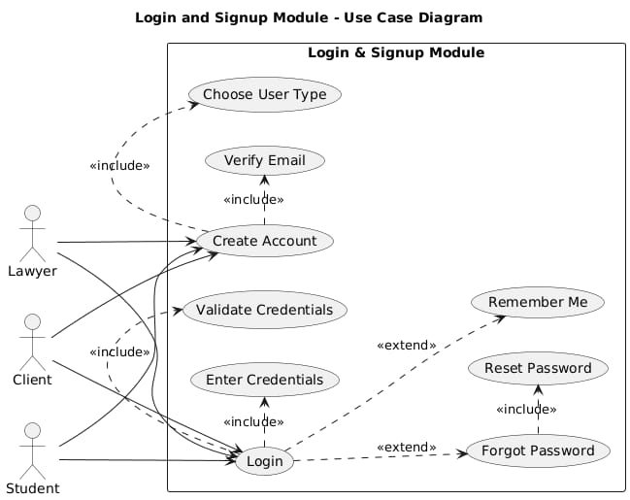
Figure 3.1: Login and Signup Diagram

Case History and Tracking
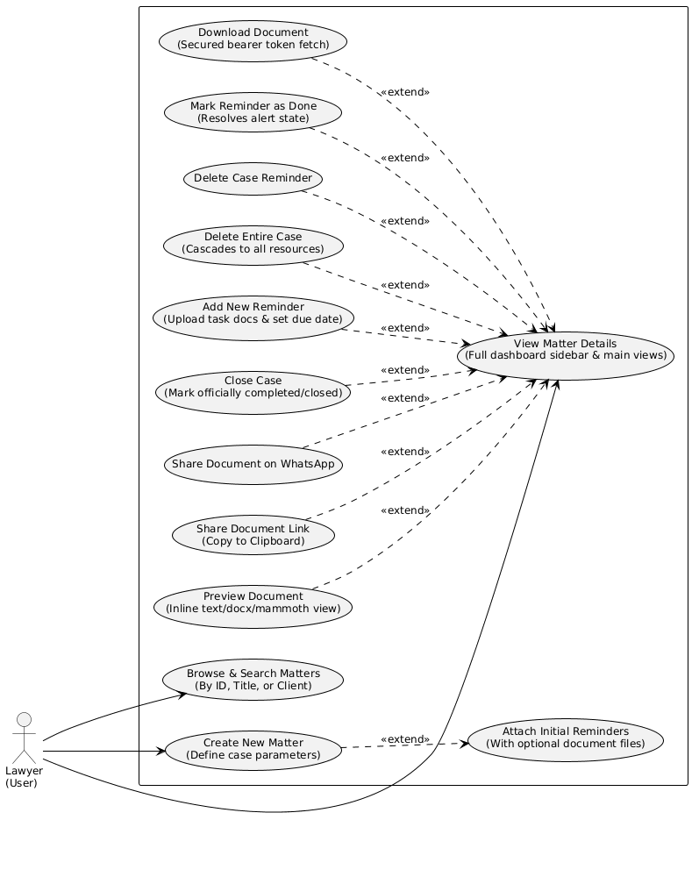
Figure 3.2: Case History and Tracking Diagram

Profile Management
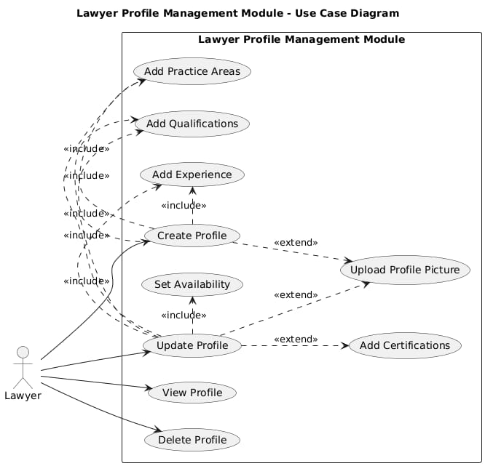
Figure 3.3: Profile Management Diagram

AI-Based Drafting
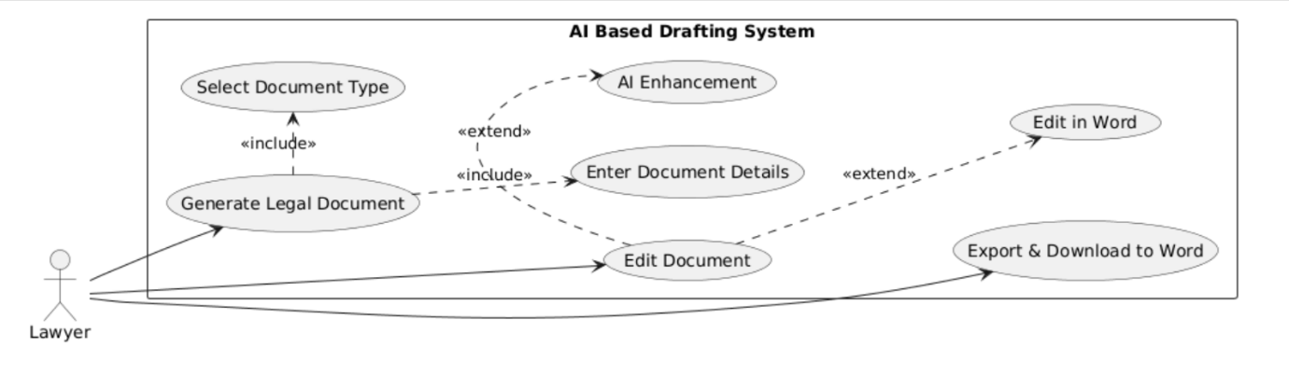

Figure 3.4: AI-Based Drafting Diagram

Communication and Appointment
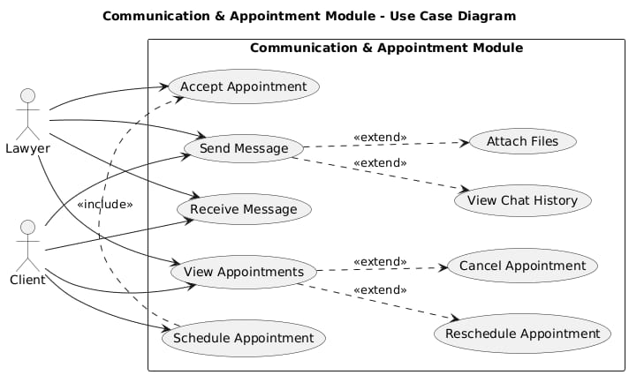
Figure 3.5: Communication and Appointment Diagram

Briefcase
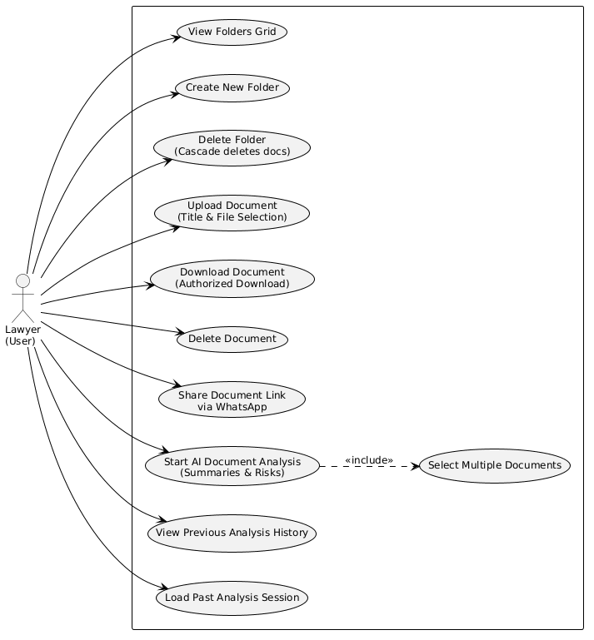
Figure 3.6: Briefcase

AI-Based ChatBot
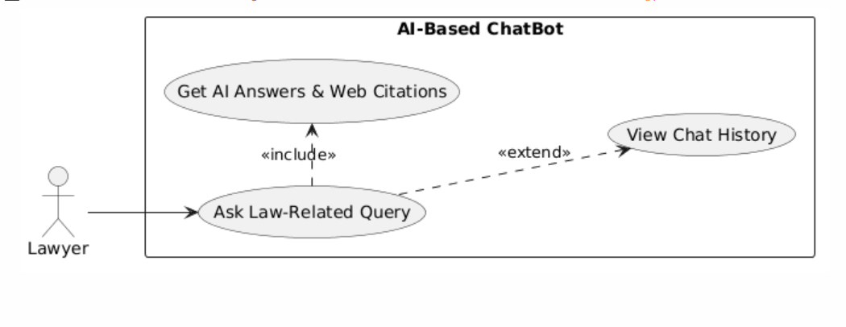
Figure 3.7: AI-Based ChatBot Diagram

Digital Guidance
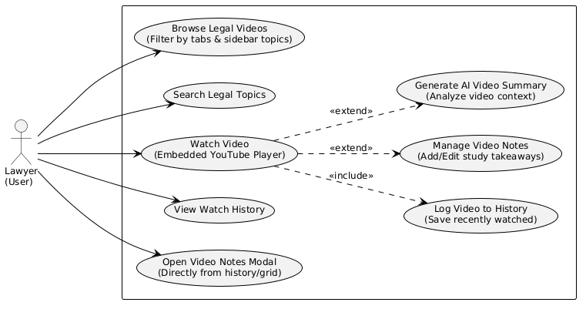
Figure 3.8: Digital Guidance Diagram

Notification and Reminders
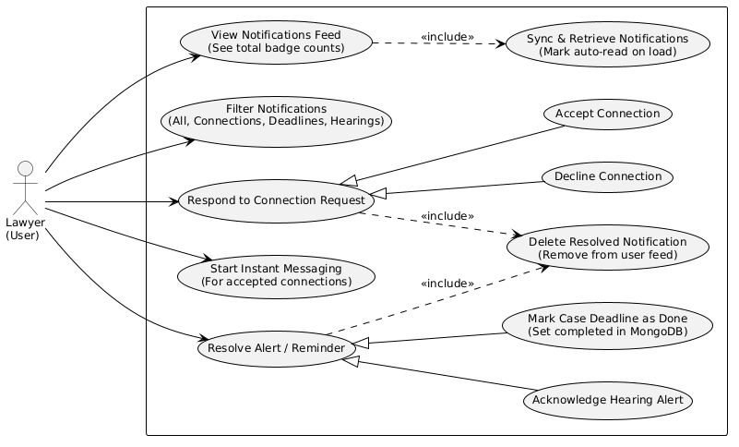
Figure 3.9: Notification and Deadlines Diagram

Professional Networking
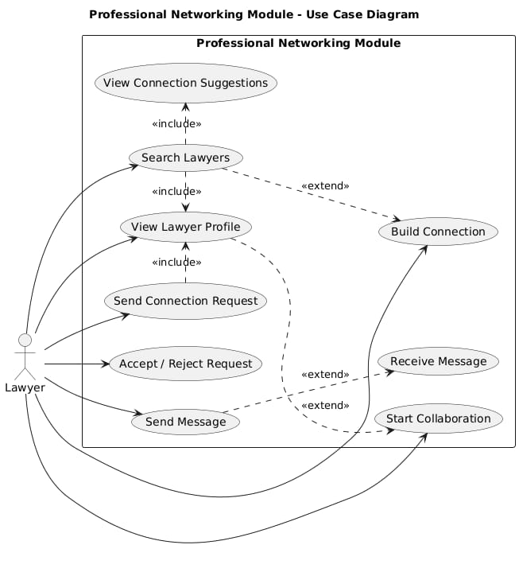
Figure 3.10: Professional Networking Diagram

Calender
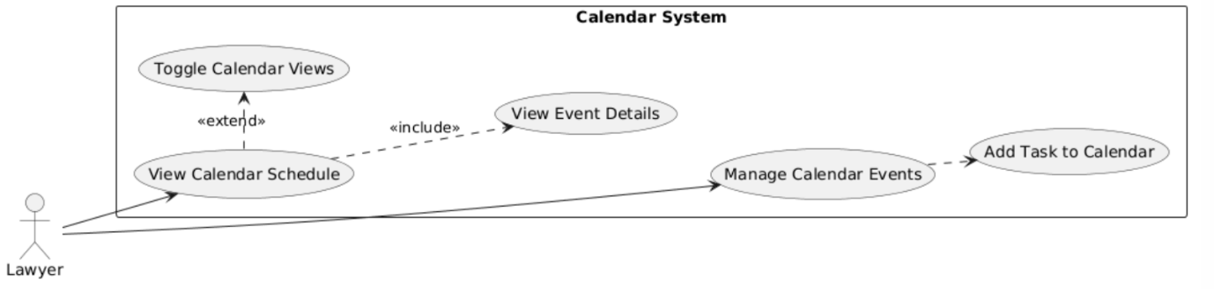
Figure 3.11: Calender Diagram

Case Marketplace
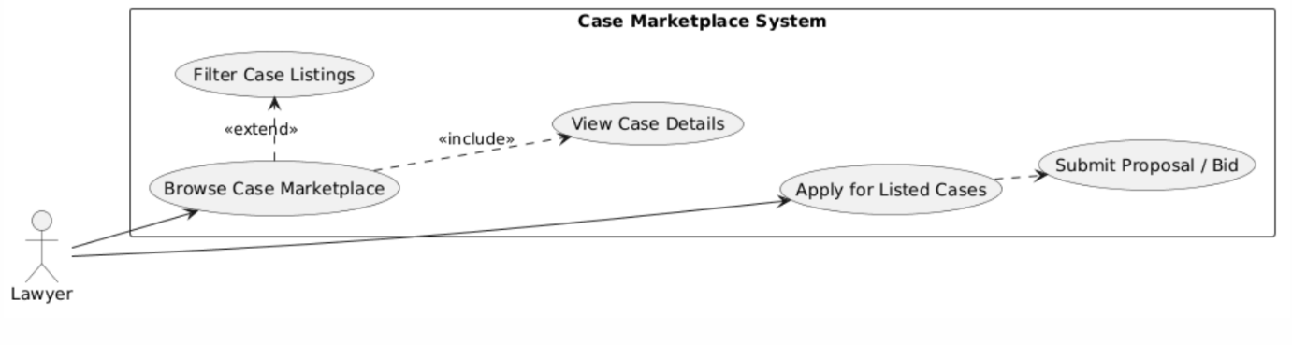
Figure 3.12: Case Marketplace Diagram

My Clients
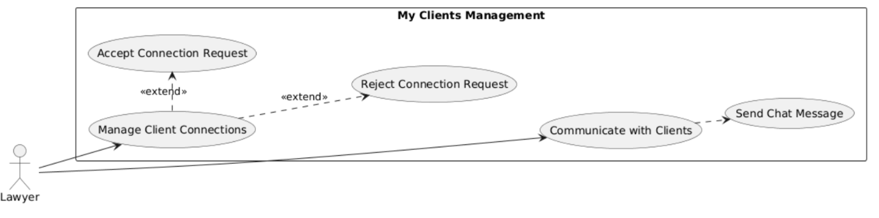
Figure 3.13: My Clients Diagram

Schedule Appointment
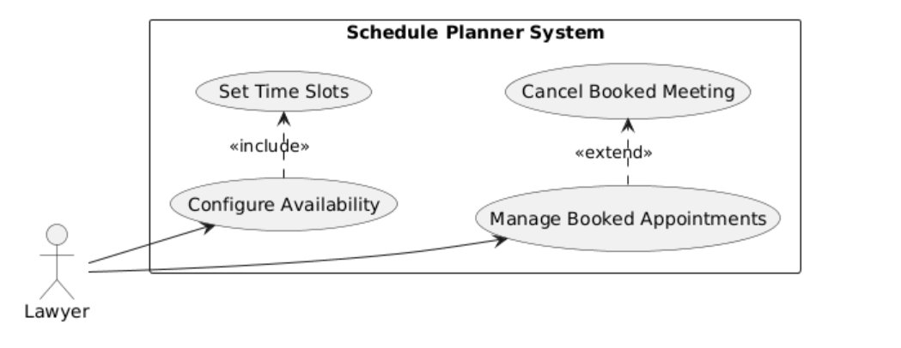
Figure 3.14: Schedule Appointment Diagram

Case E-Filing
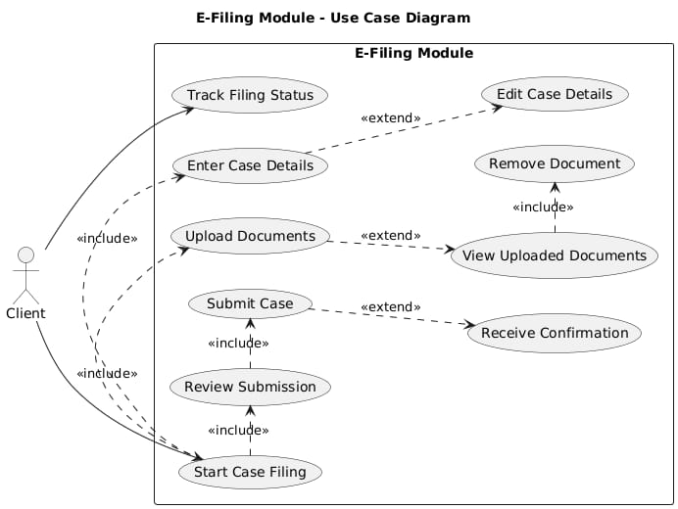
Figure 3.15: Case E-Filing Diagram

Lawyer Filtering
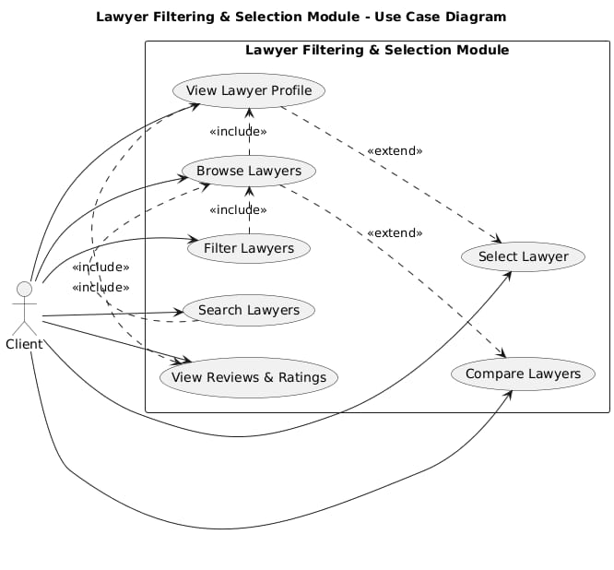
Figure 3.16: Lawyer Filtering Diagram

Lawyer profile and Reviews
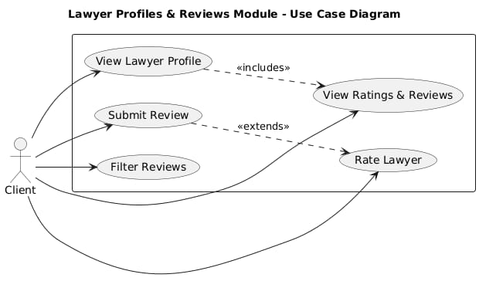
Figure 3.17. Lawyer profile and Reviews Diagram

Filed Case Tracking
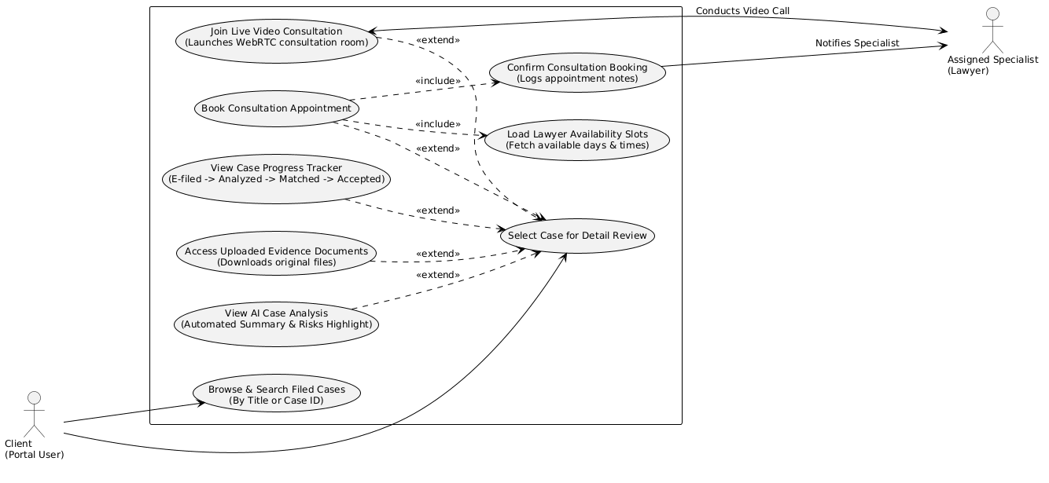
Figure 3.18. Filed Case Tracking Diagram

Communication and Notification
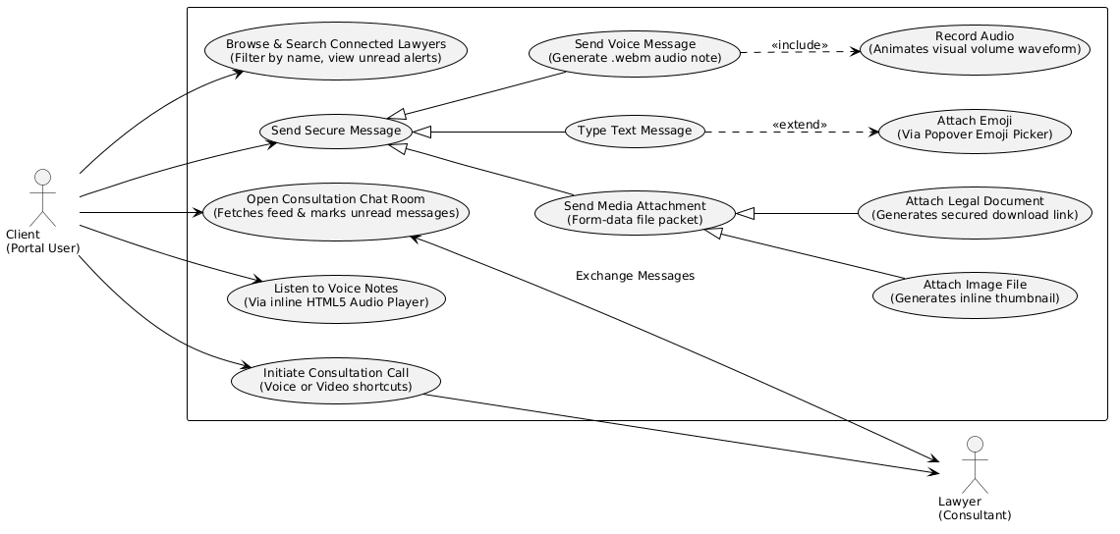
Figure 3.19. Communication and Notification Diagram

Student GPA Calculator
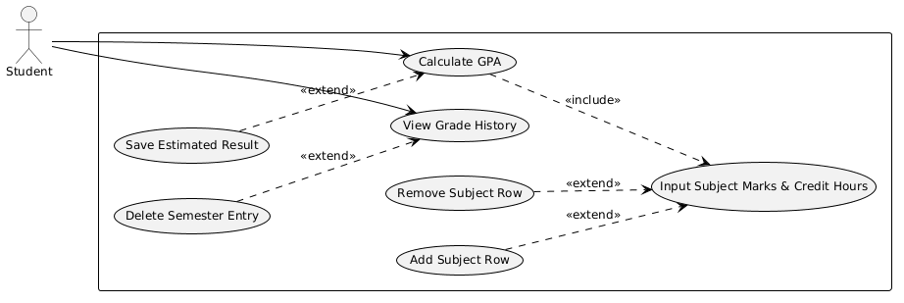
Figure 3.20. Student GPA Calculator Diagram

Study Planner
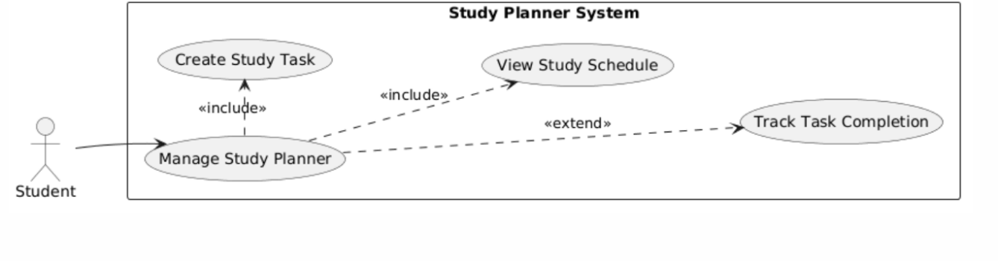
Figure 3.21. Study Planner Diagram

Notes Sharing and Upload
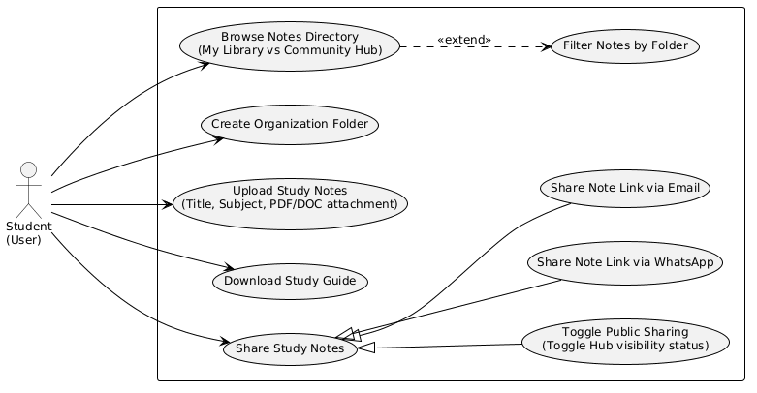
Figure 3.22. Notes Sharing and Upload Diagram

Past Papers
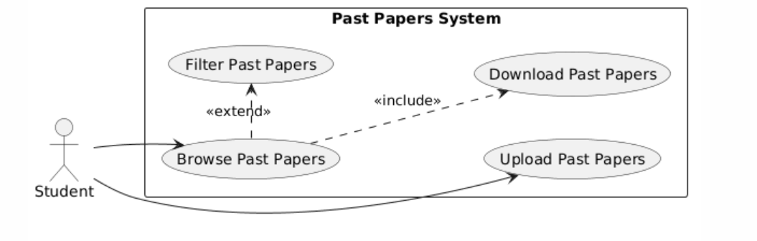
Figure 3.23. Past Papers Diagram

Activity Diagram

Login
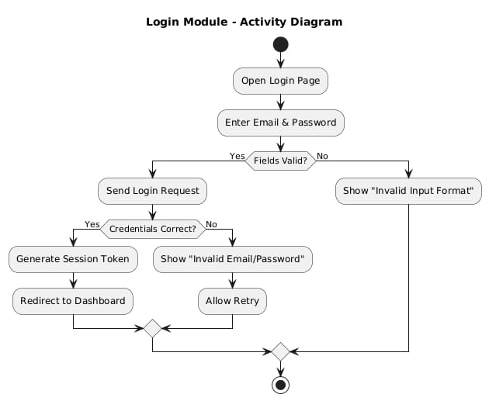
Figure 3.24: Login Activity Diagram

Signup
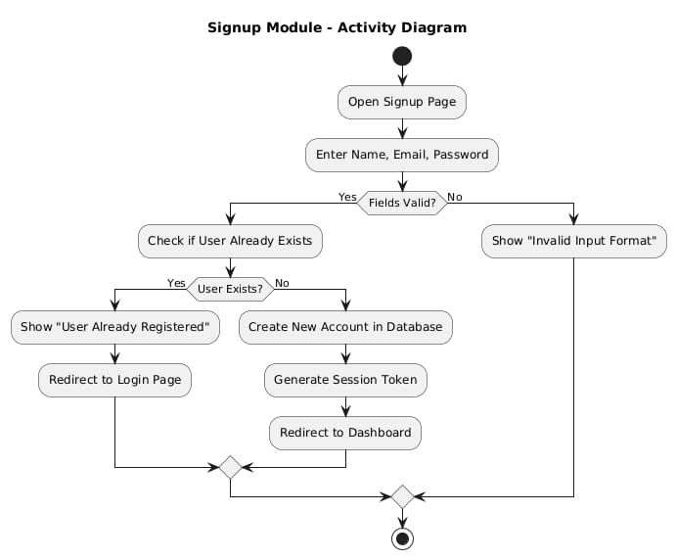

Figure 3.25: Signup Activity Diagram

Case History and Tracking
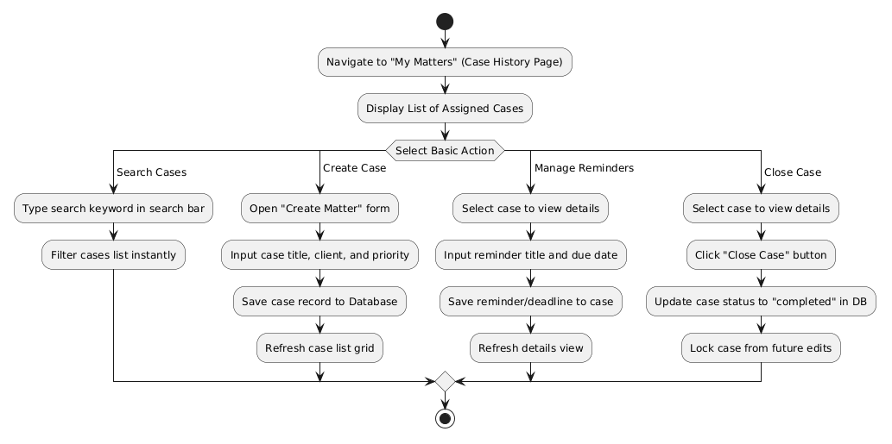
Figure 3.26: Case History and Tracking

Profile management
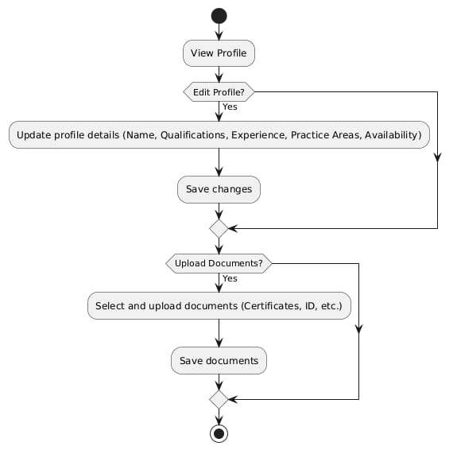
Figure 3.27: Profile Management Activity Diagram

AI-Based Drafting
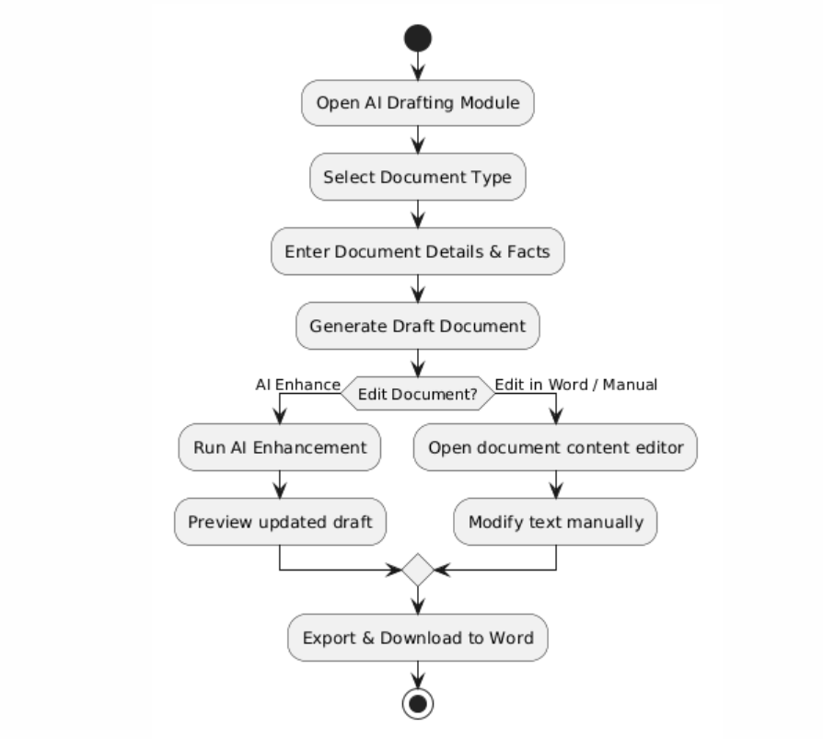
Figure 3.28: AI-Based Drafting Activity Diagram

Communication and Appointment
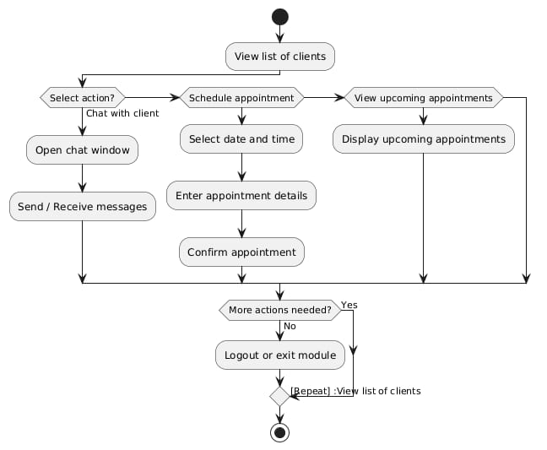
Figure 3.29: Communication and Appointment Activity Diagram

Briefcase
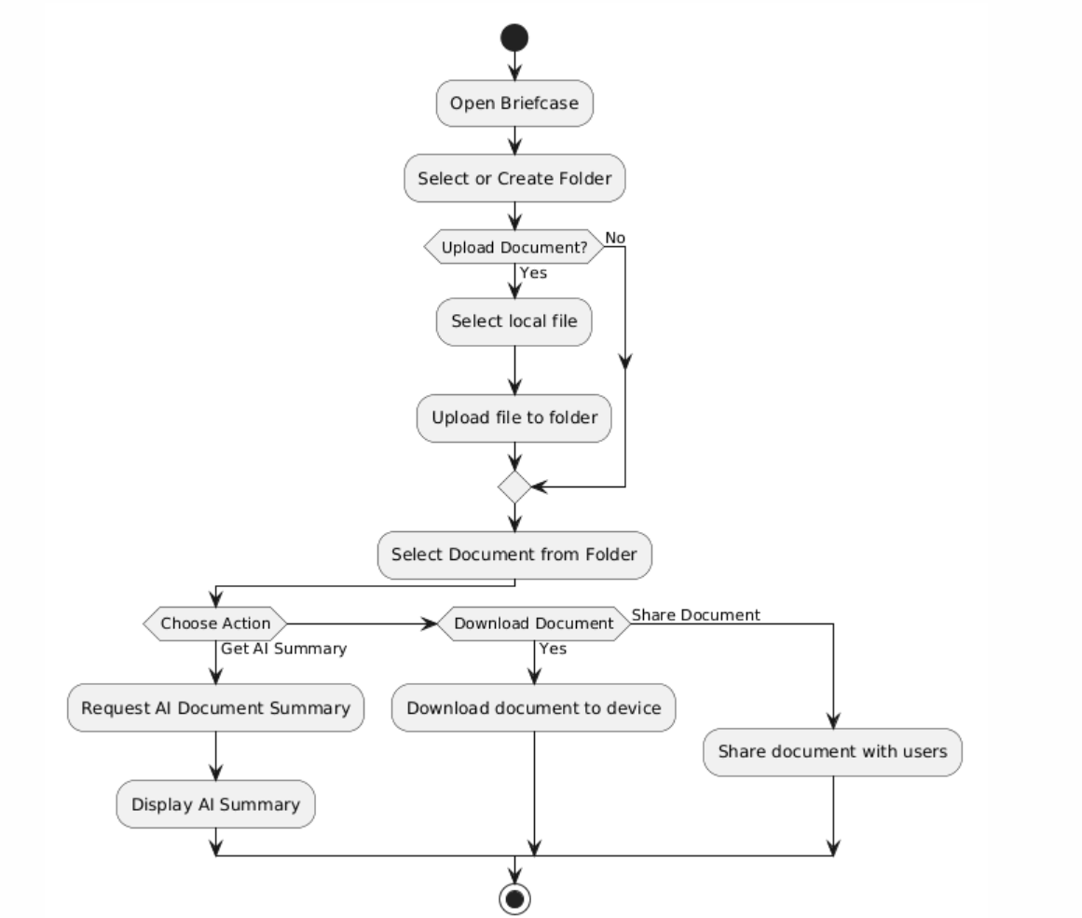
Figure 3.30: Briefcase Activity Diagram

AI-Based ChatBot
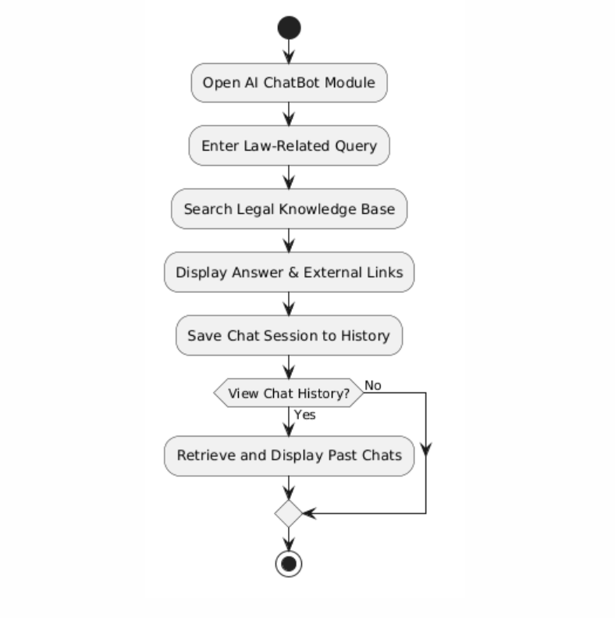
Figure 3.31: AI-Based ChatBot Activity Diagram

Digital Guidance
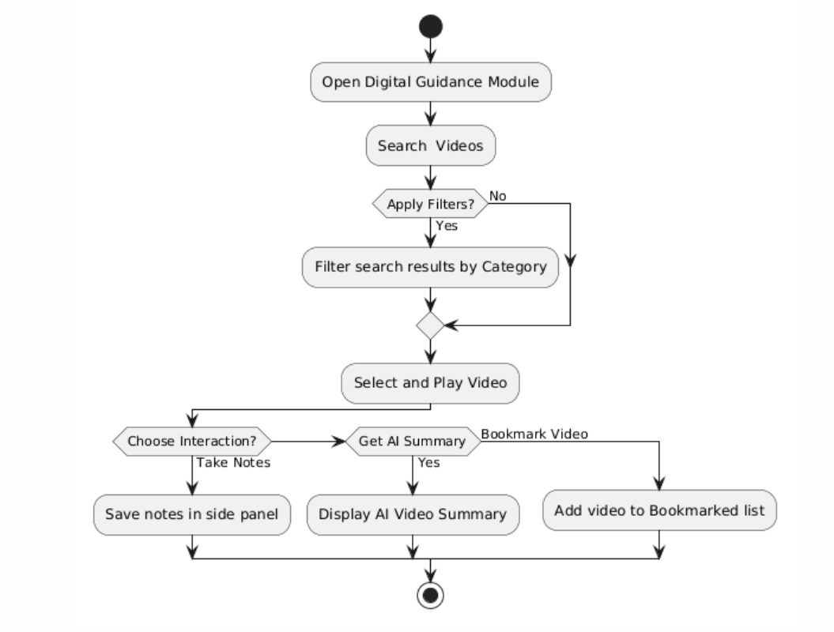
Figure 3.32: Digital Guidance Activity Diagram

Notifications and Deadlines
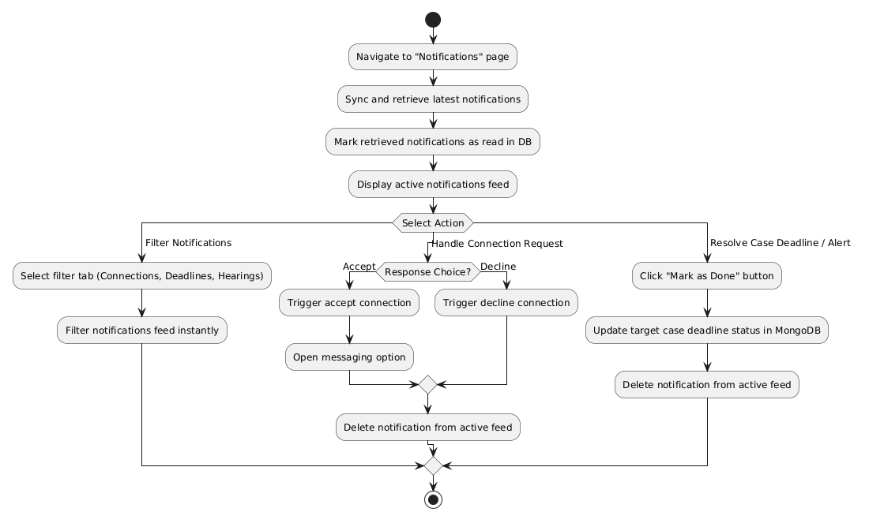
Figure 3.33: Notifications and Deadlines Activity Diagram

Professional Networking
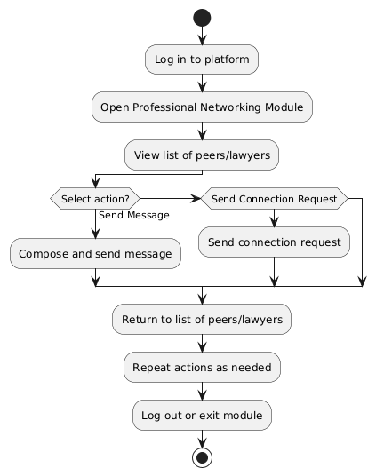
Figure 3.34: Professional Networking Activity Diagram

Calender
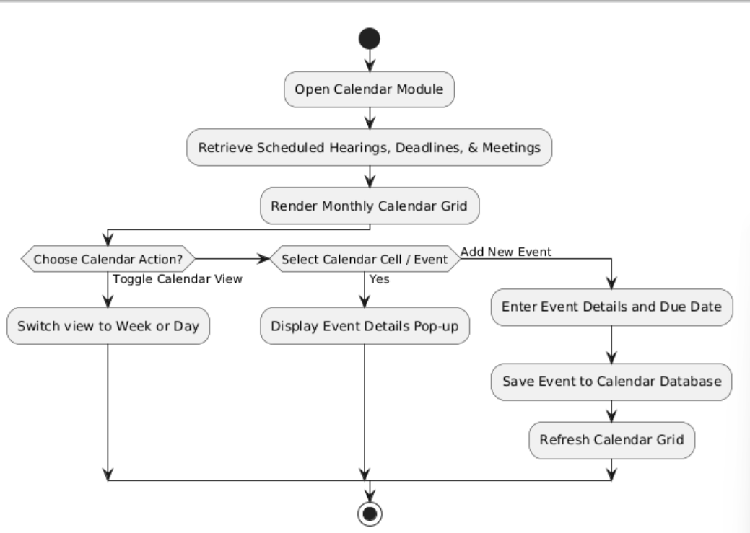
Figure 3.35: Calender Activity Diagram

Case Marketplace
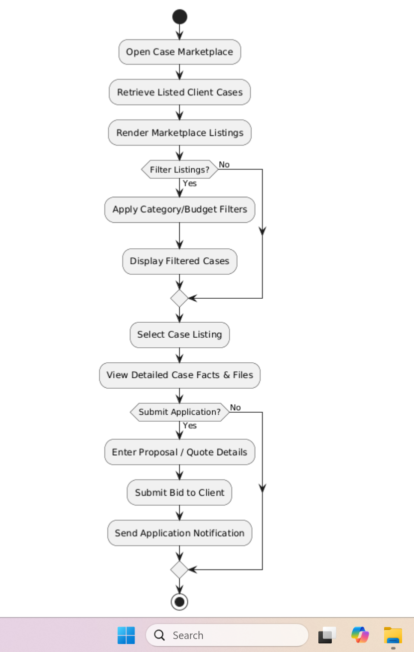
Figure 3.36: Case Marketplace Activity Diagram

My Clients
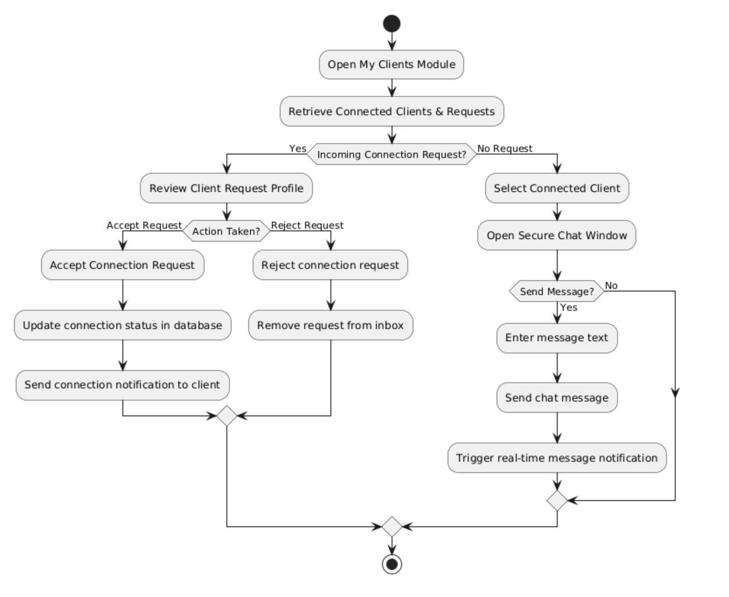
Figure 3.37: My Clients Activity Diagram

Schedule Appointment
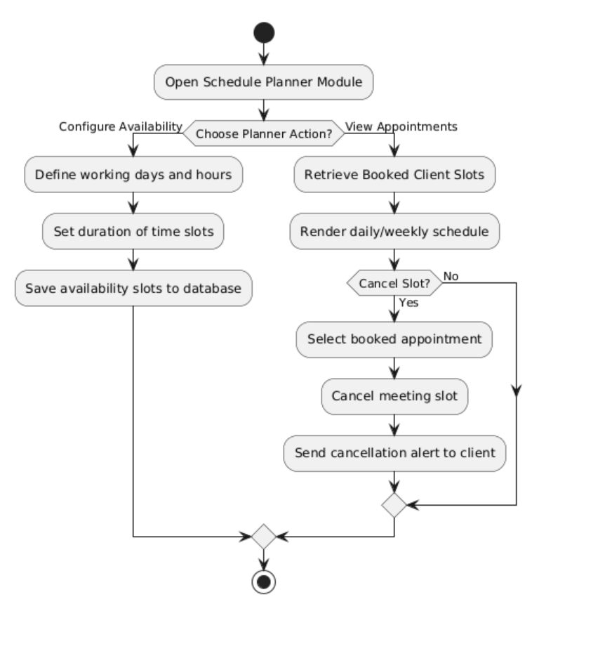
Figure 3.38: Schedule Appointment Activity Diagram

Case E-filing
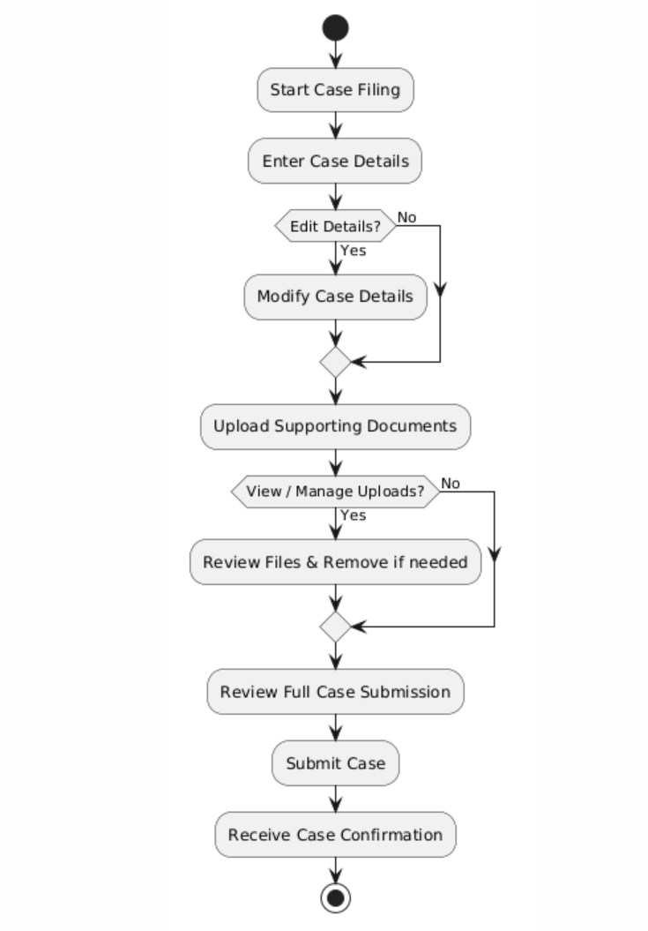
Figure 3.39: Case E-Filing Activity Diagram

Lawyer Filtering
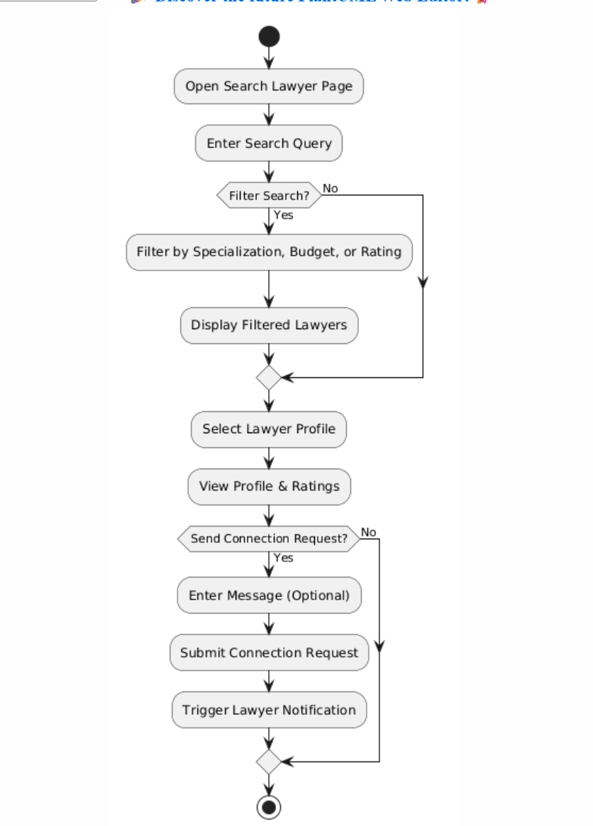
Figure 3.40: Lawyer Filtering Activity Diagram

Lawyer profile and Reviews
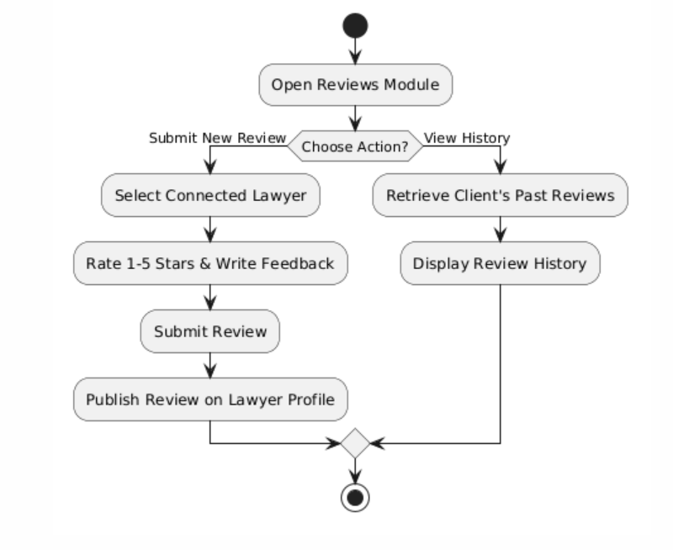
Figure 3.41: Lawyer Profile and Reviews Activity Diagram

Filed case Tracking
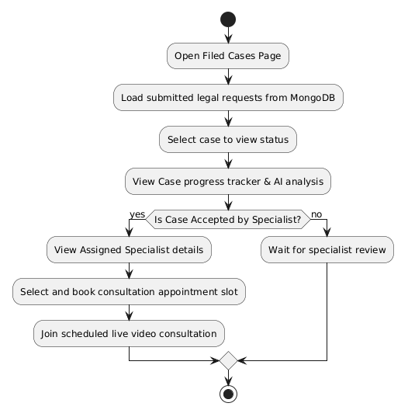
Figure 3.42: Filed Case Tracking Activity Diagram

Communication and Notification
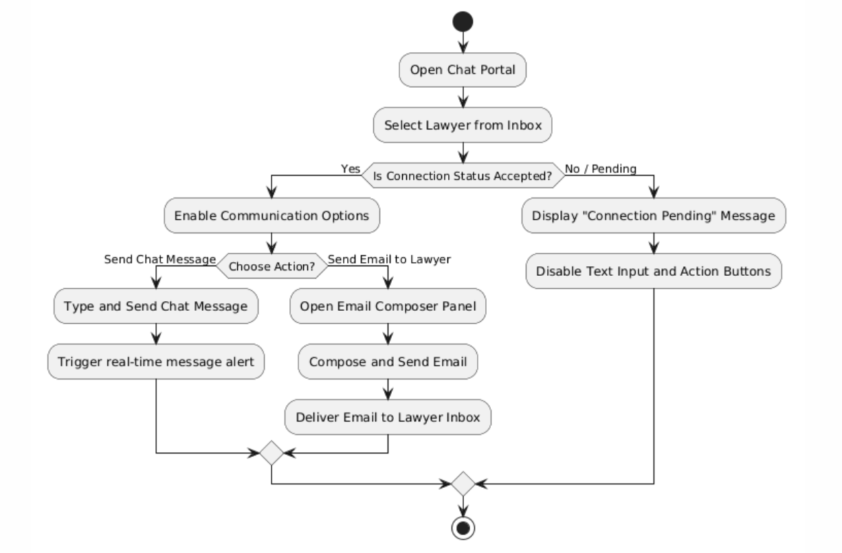
Figure 3.43: Communication and Notification Activity Diagram

Student GPA Calculator
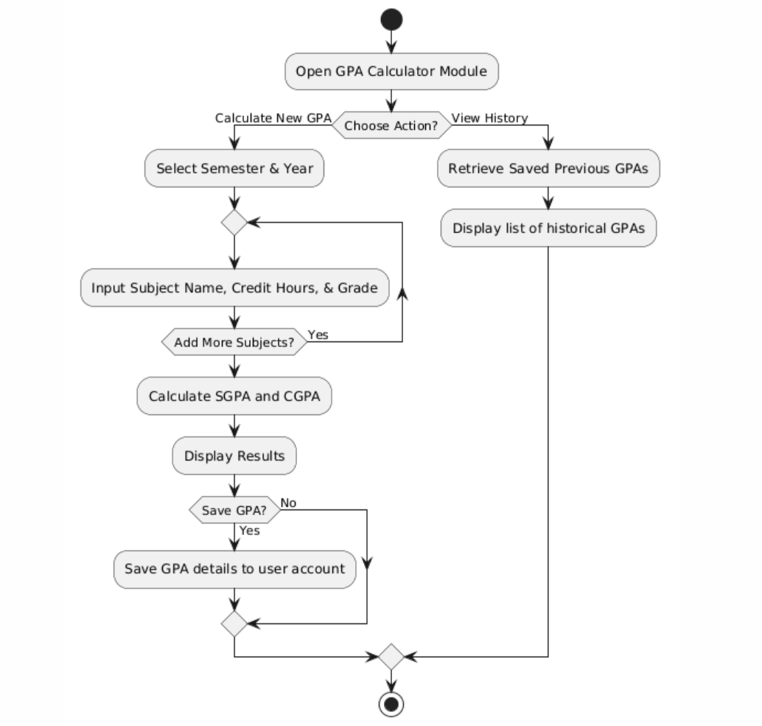
Figure 3.44: GPA Calculator Activity Diagram

Study Planner
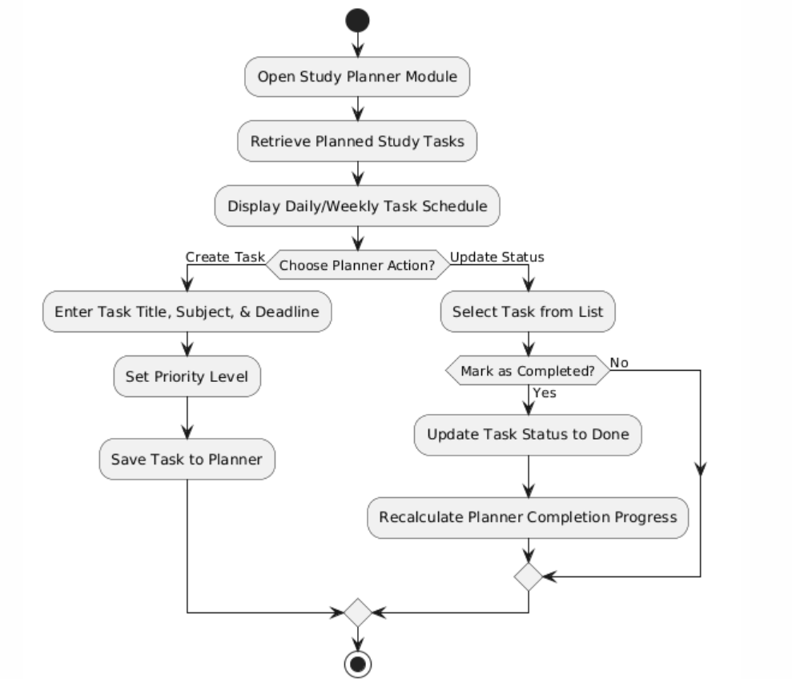
Figure 3.45: Study Planner Activity Diagram

Notes Sharing
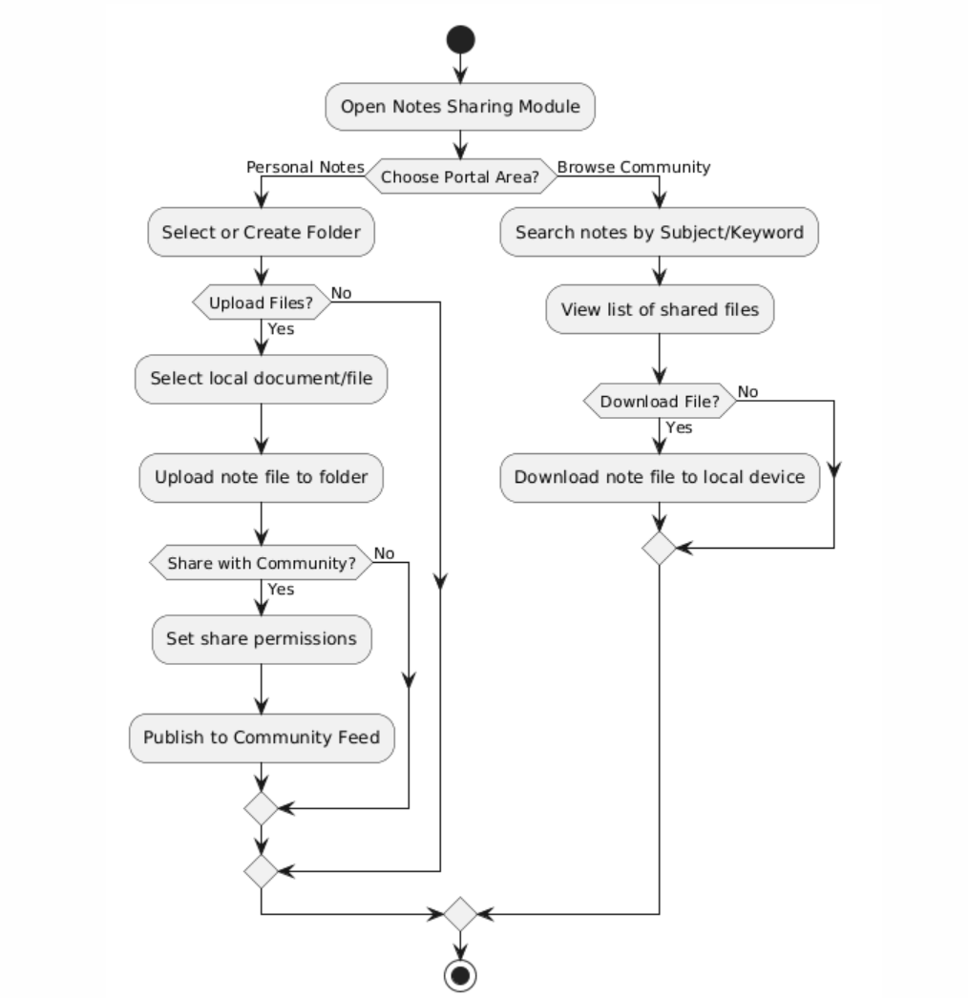
Figure 3.46: Notes Sharing Activity Diagram

Past Papers
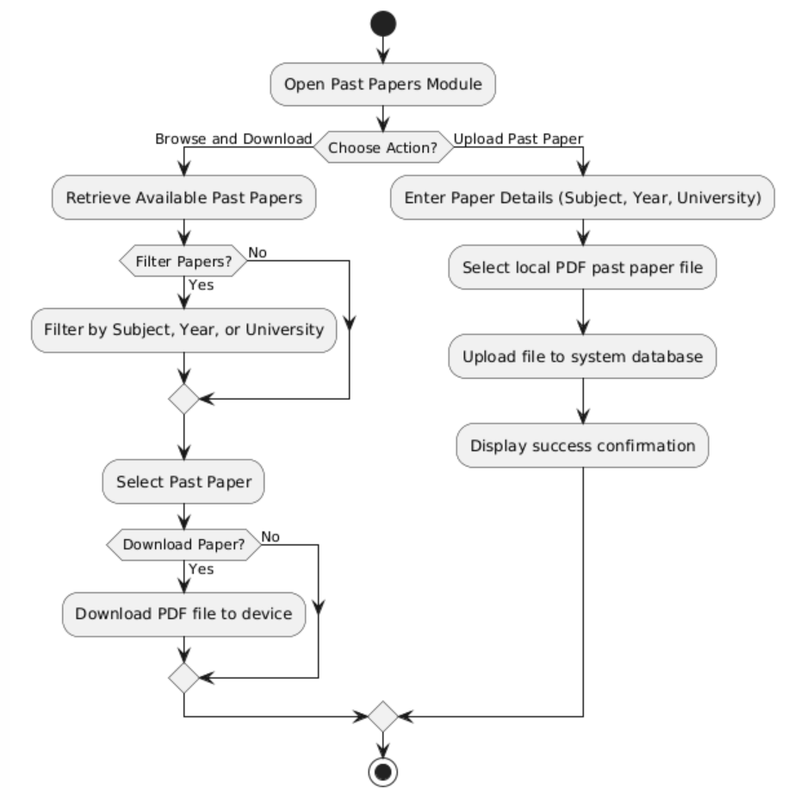
Figure 3.47: Past Papers Activity Diagram

Sequence Diagram

Login and Authentication
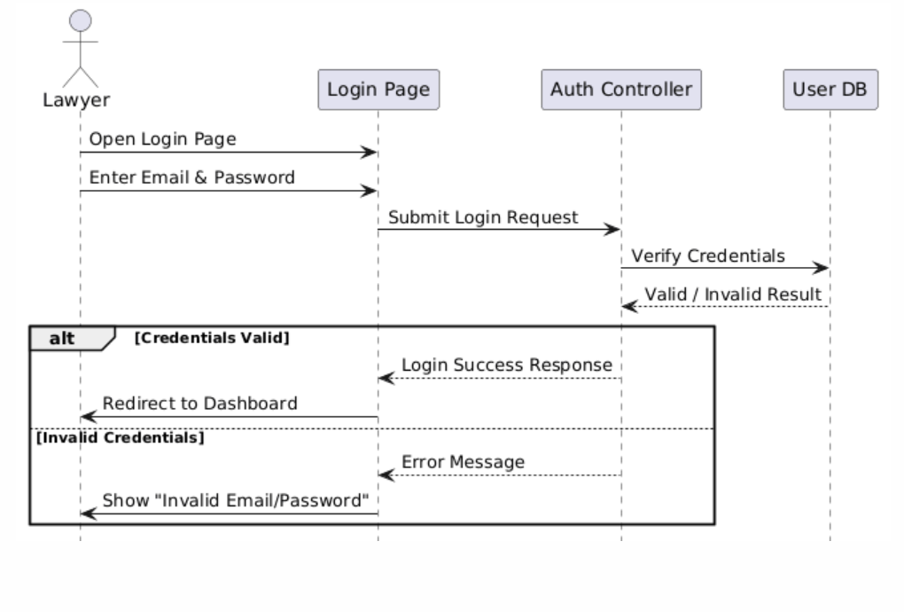
Figure 3.48: Login and Authentication Sequence Diagram

Signup
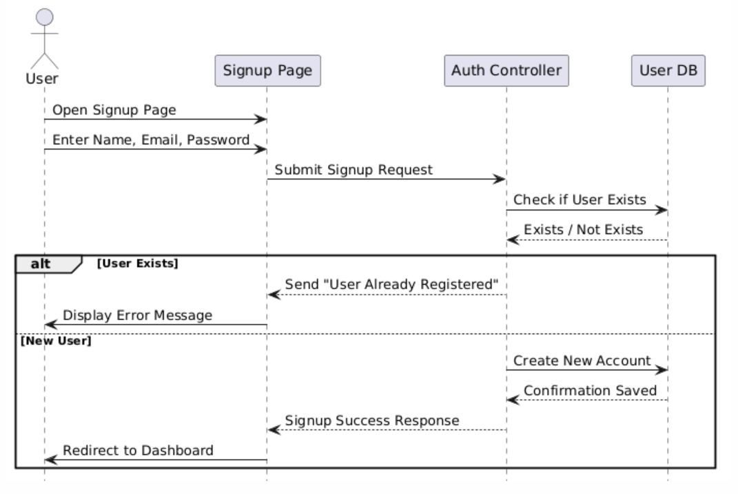
Figure 3.49: Signup and Authentication Sequence Diagram

Case History and Tracking
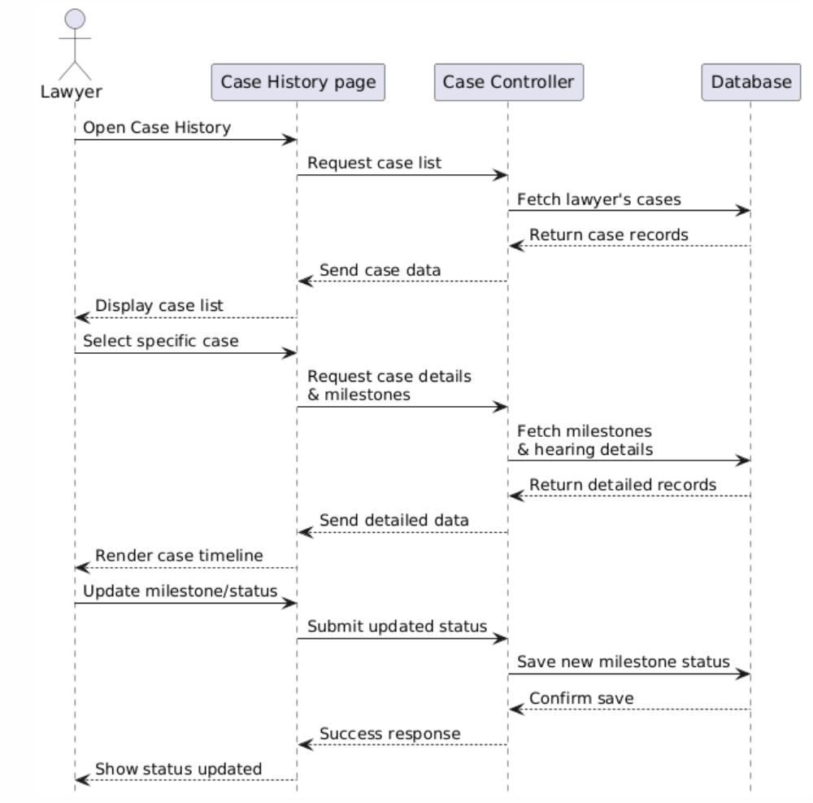
Figure 3.50: Case History and Tracking Sequence Diagram

Lawyer Profile Management
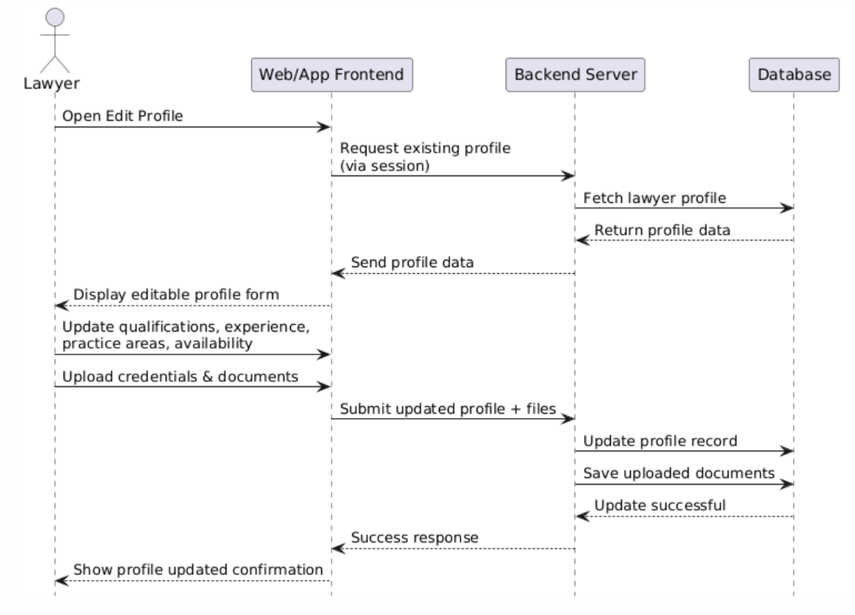
Figure 3.51: Lawyer Profile Management Sequence Diagram

AI-Based legal Drafting
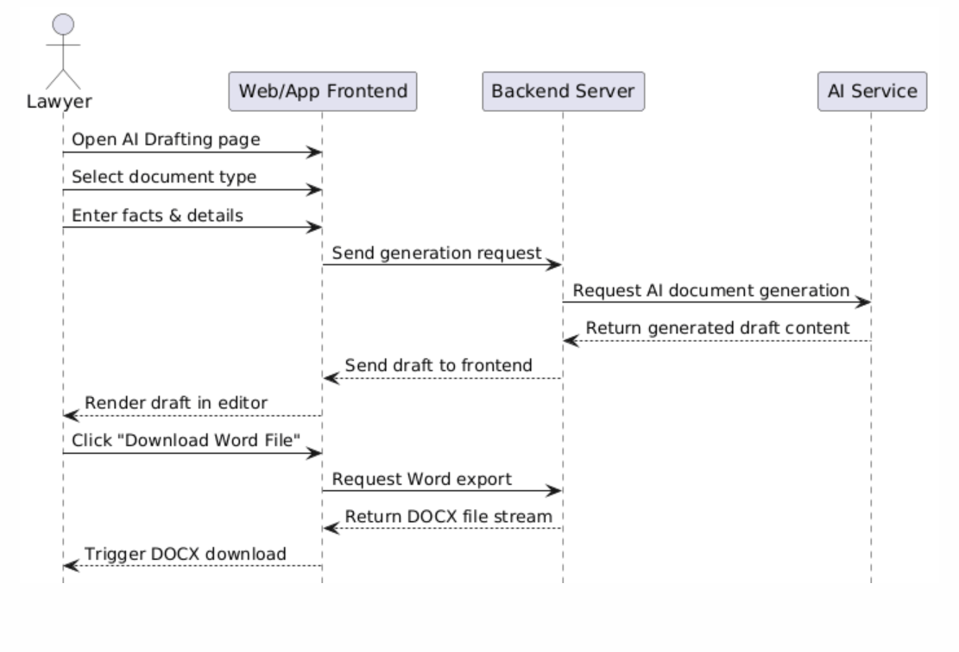
Figure 3.52: AI-Based Legal Drafting Sequence Diagram

Communication
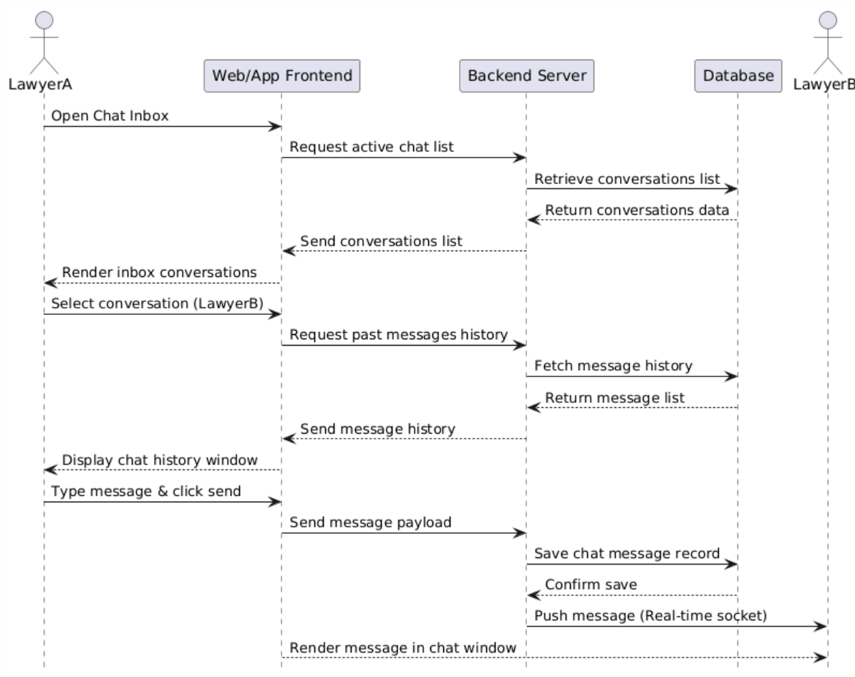
Figure 3.53: Communication Sequence Diagram

Briefcase
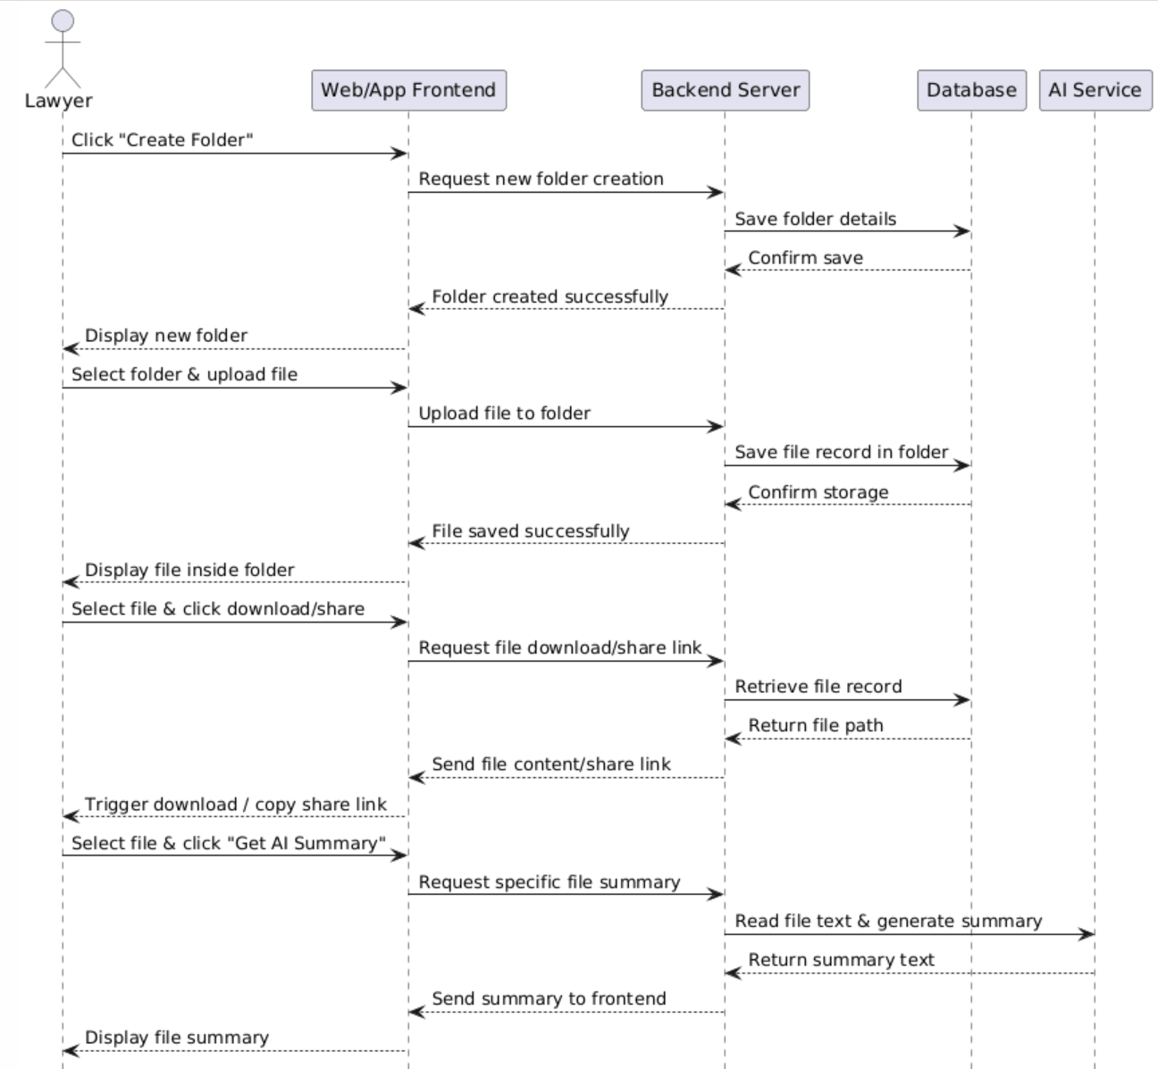
Figure 3.54: Briefcase Sequence Diagram

AI-Based ChatBot
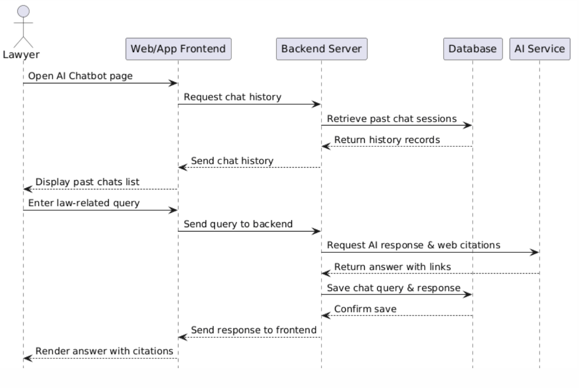
Figure 3.55: AI-Based Chatbot Sequence Diagram

Digital Guidance
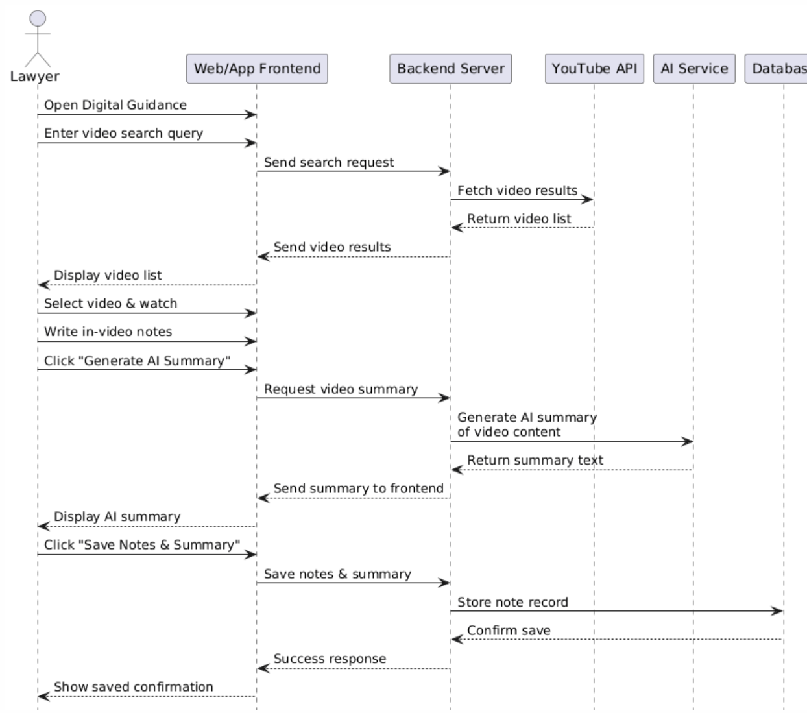
Figure 3.56: Digital Guidance Sequence Diagram

Notifications and Deadlines
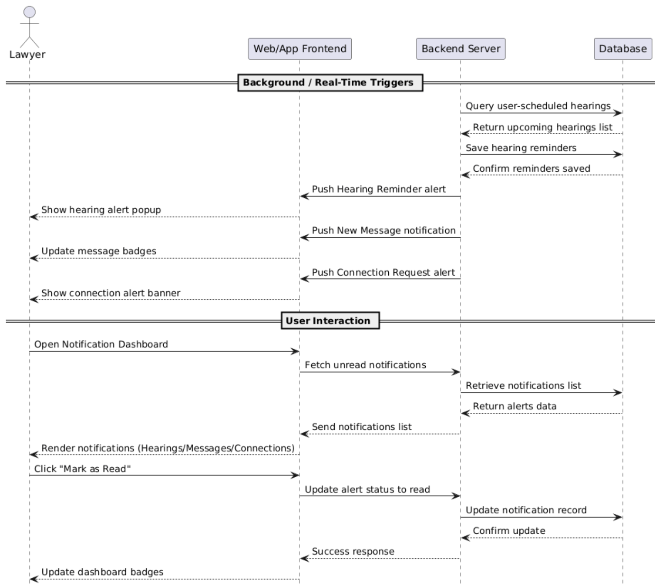
Figure 3.57: Notifications and Deadlines Sequence Diagram

Professional Networking
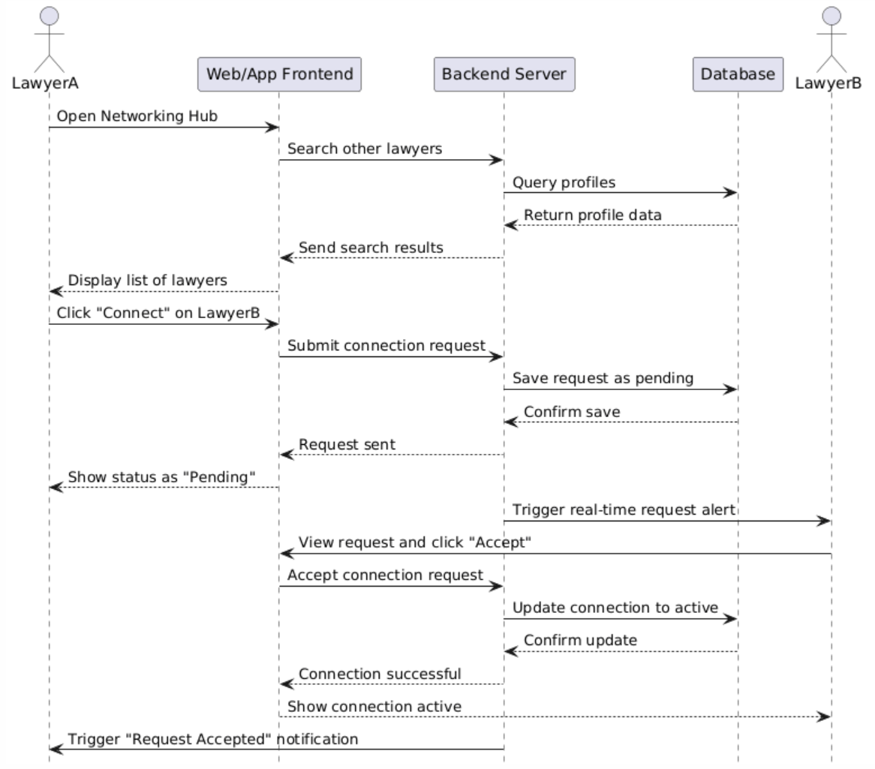
Figure 3.58: Professional Networking Sequence Diagram

Calender
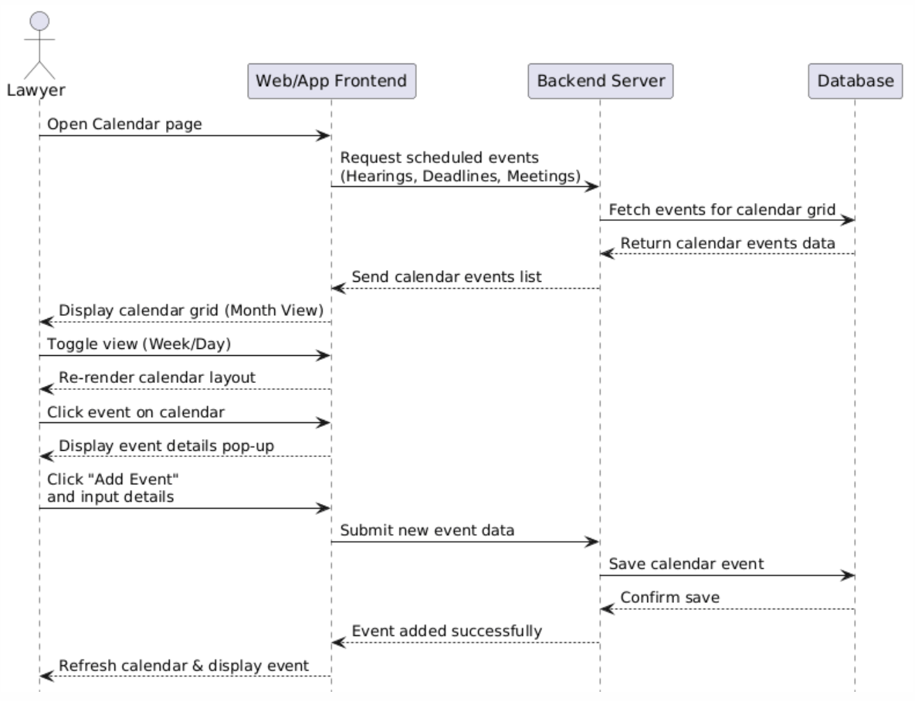
Figure 3.59. Calender Sequence Diagram

Case Marketplace
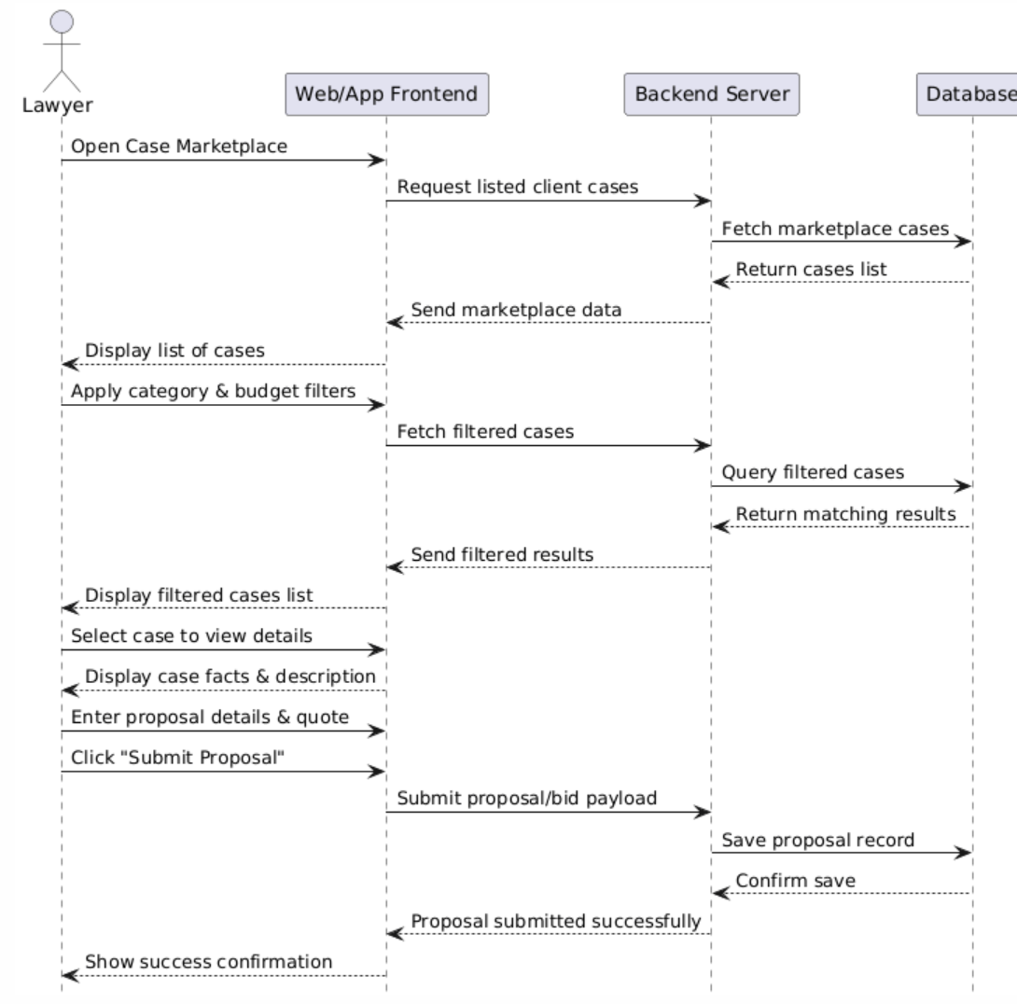
Figure 3.60. Case Marketplace Sequence Diagram

My Clients
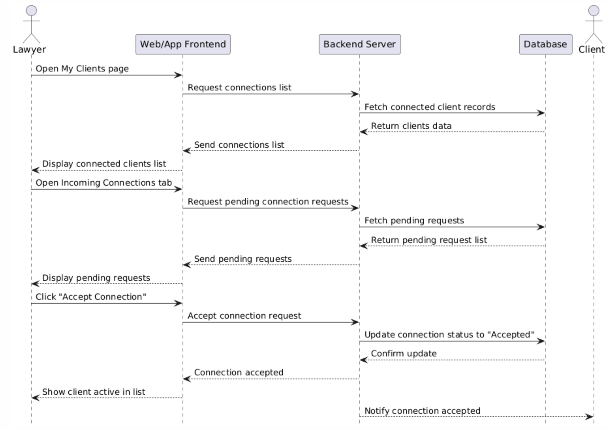
Figure 3.61. My Clients Sequence Diagram

Schedule Appointment
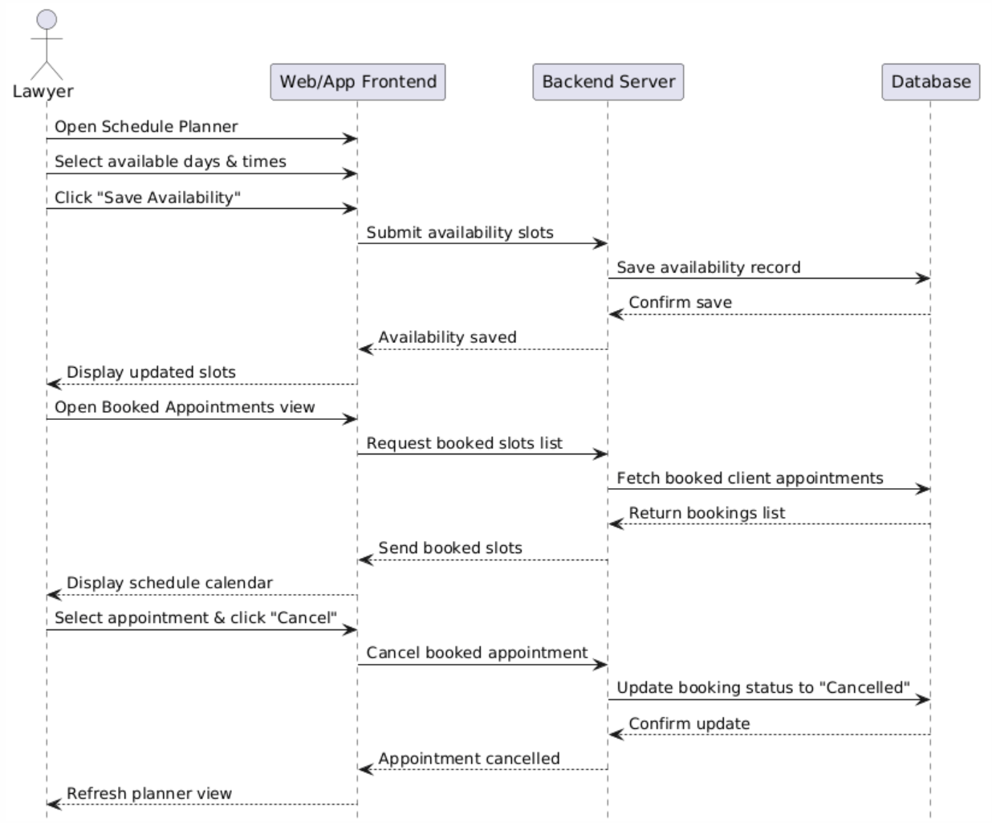
Figure 3.62. Schedule Appointment Sequence Diagram

Client Registration and Profile
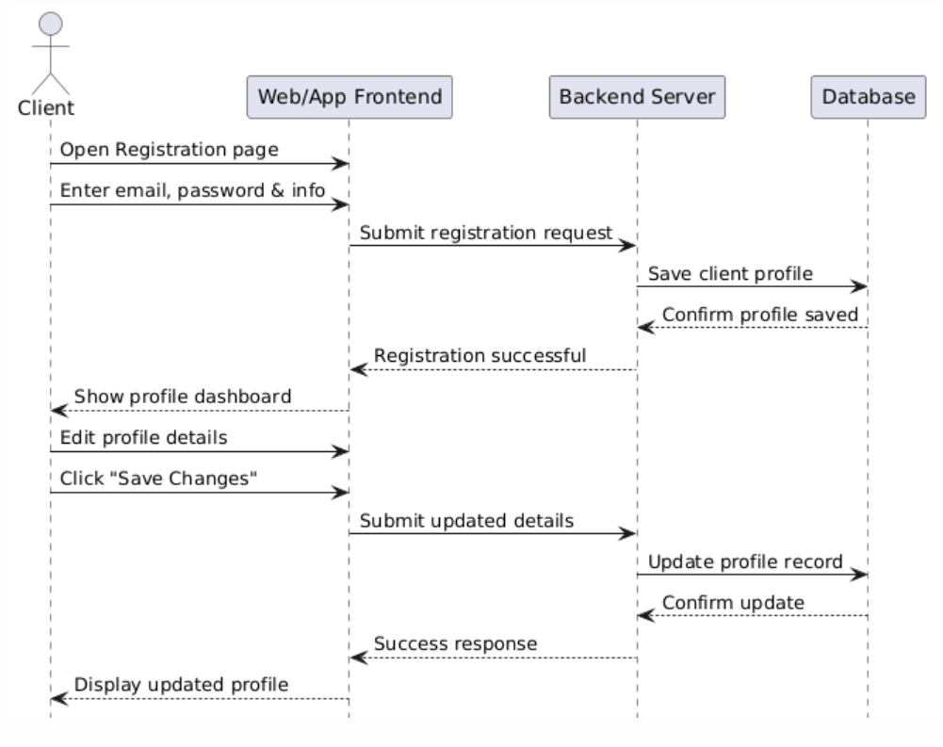
Figure 3.63. Client Registration and Profile Sequence Diagram

Filed Cases
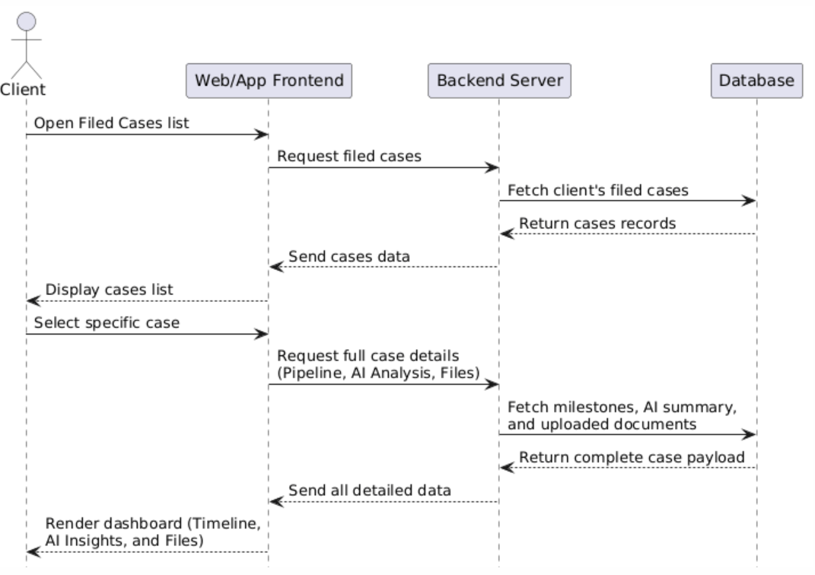
Figure 3.64. Filed Cases Sequence Diagram

Communication and Notification
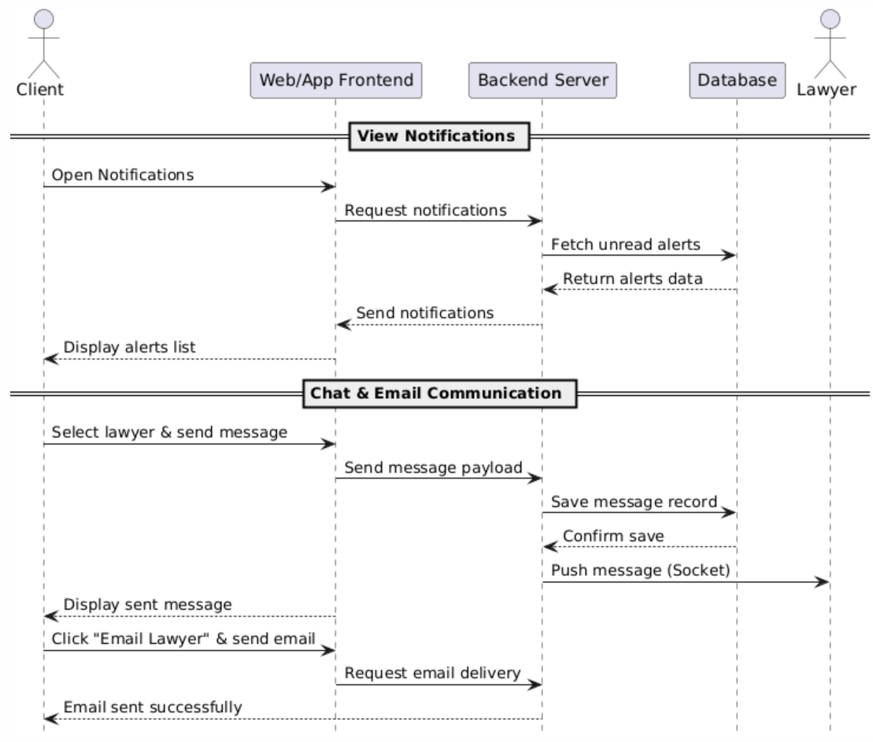
Figure 3.65. Communication and Notification Sequence Diagram

E-Filing
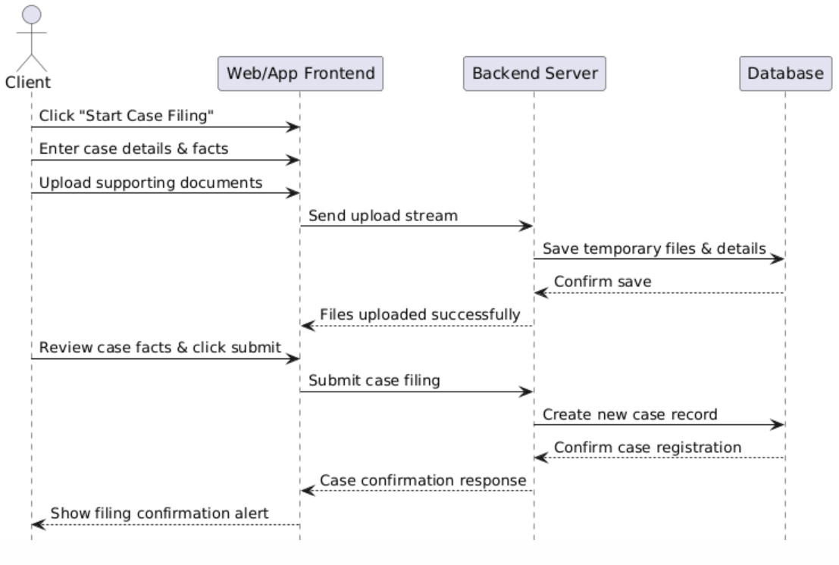
Figure 3.66: E-Filing Sequence Diagram

Lawyer Filtering and Selection
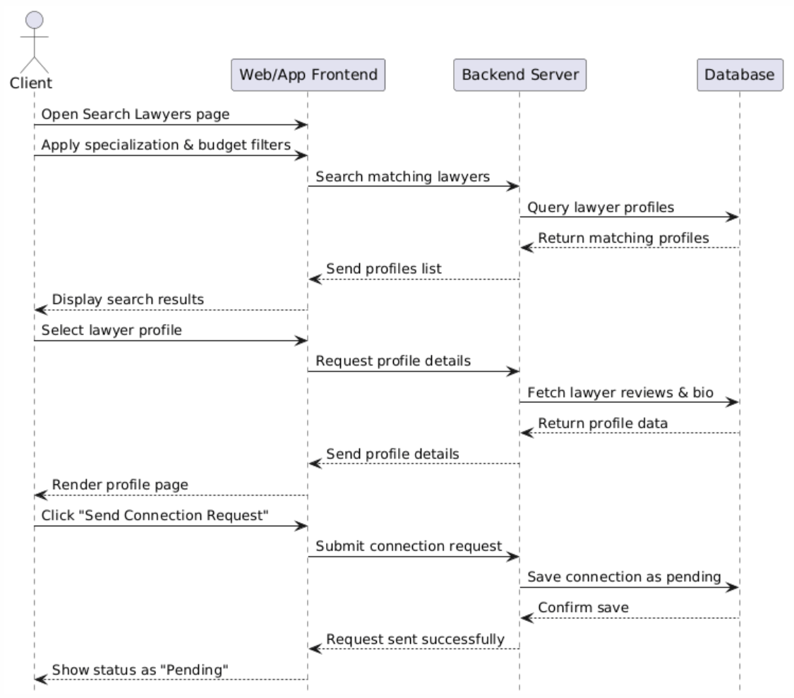
Figure 3.67: Lawyer Filtering and Selection Sequence Diagram

View Lawyer Profile and Reviews
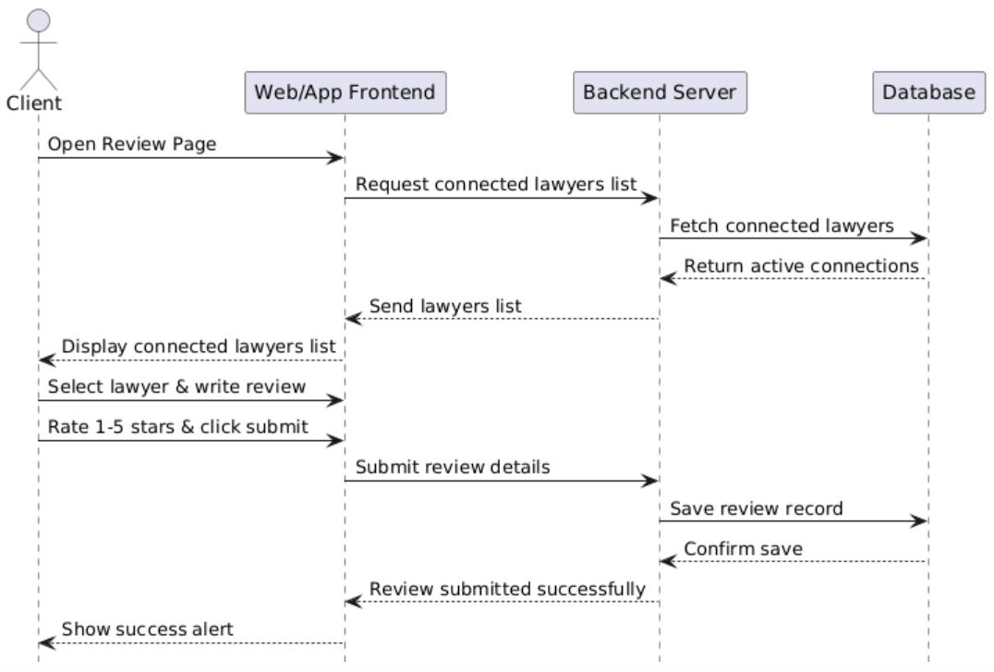
Figure 3.68: View Lawyer Profile and Reviews Sequence Diagram

GPA Calculator
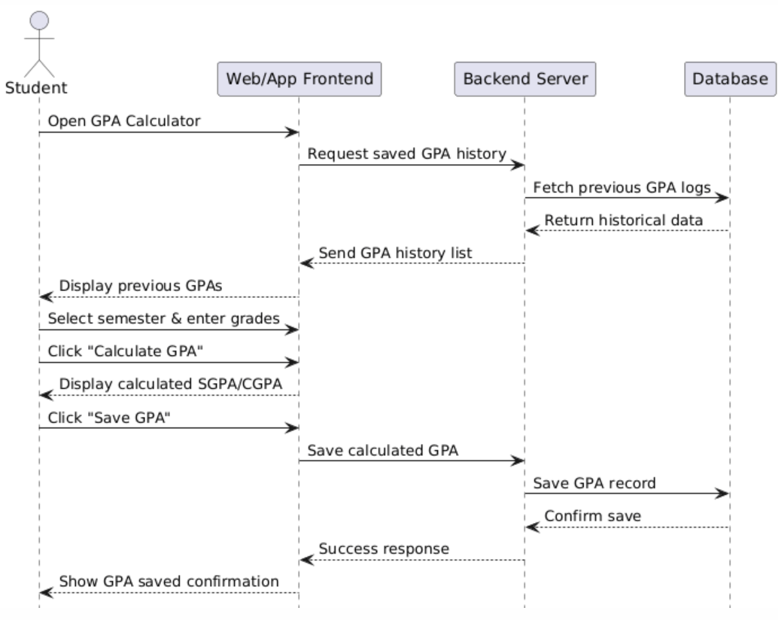
Figure 3.69: GPA Calculator Sequence Diagram

Study planer
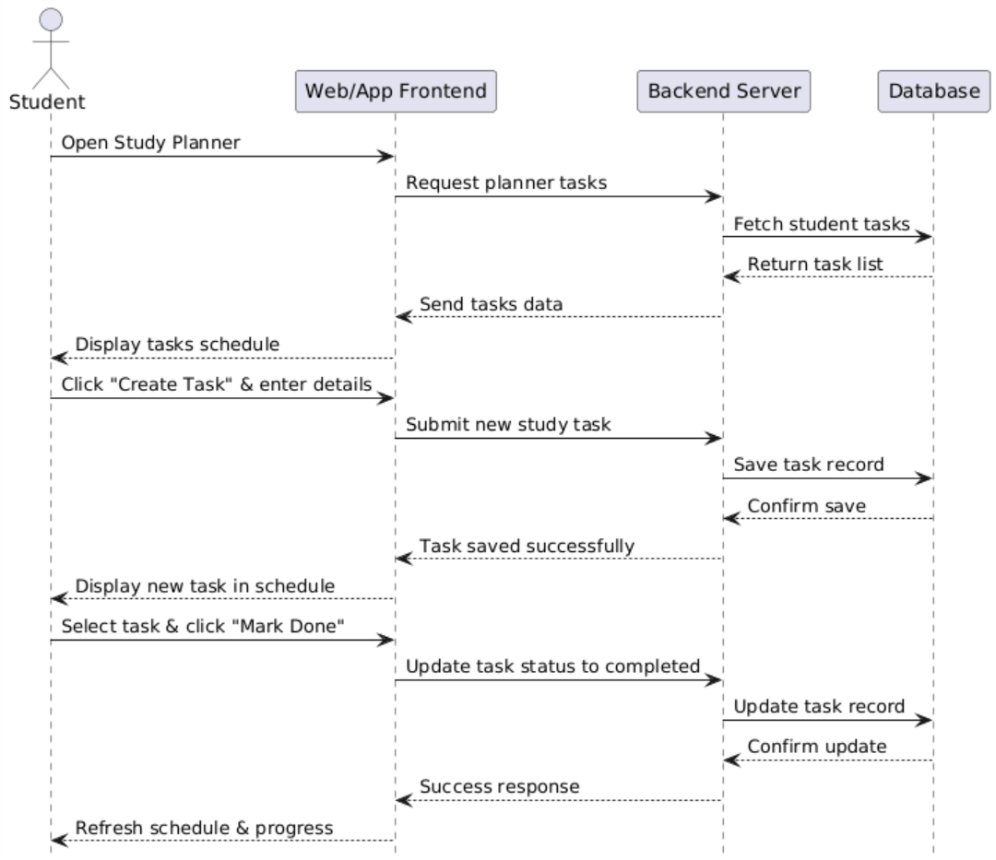
Figure 3.70: Study Planner Sequence Diagram

Notes Sharing and Upload
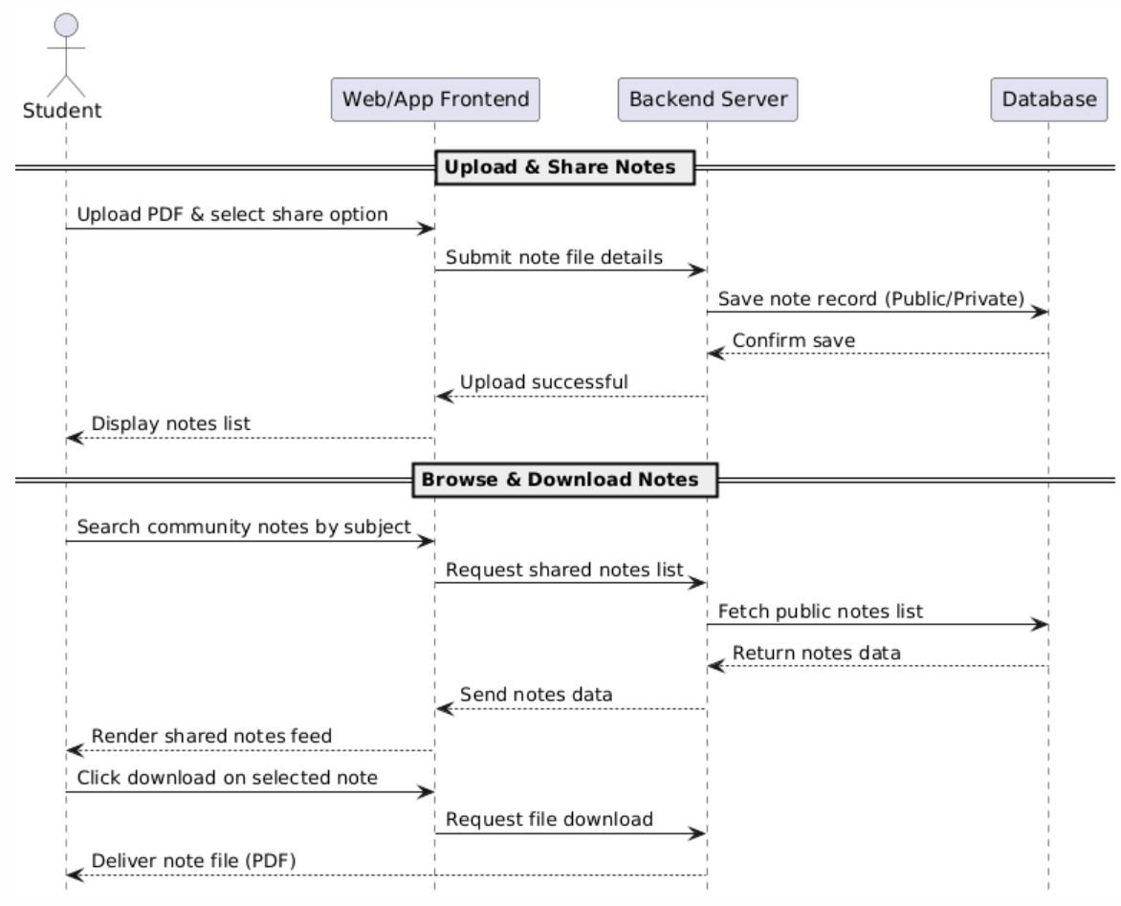
Figure 3.71: Notes Sharing and Upload Sequence Diagram

Past Papers
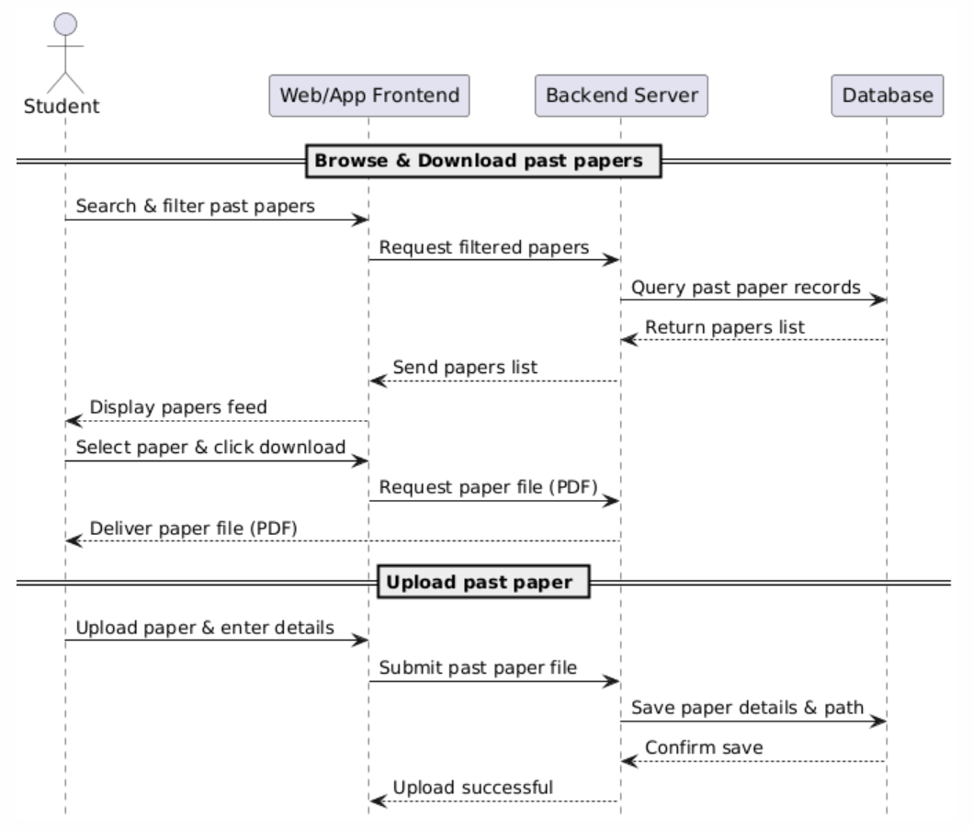
Figure 3.72. Past Papers Sequence Diagram

Software Architecture Diagram
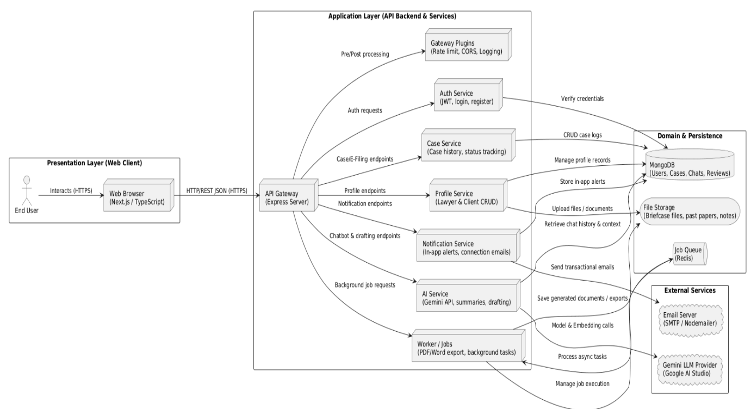
Figure 3.73. Software Architecture Diagram

Class Diagram
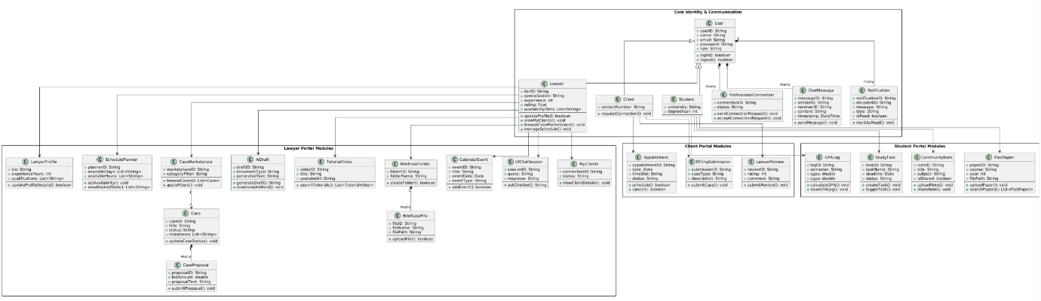
Figure 3.74. Class Diagram

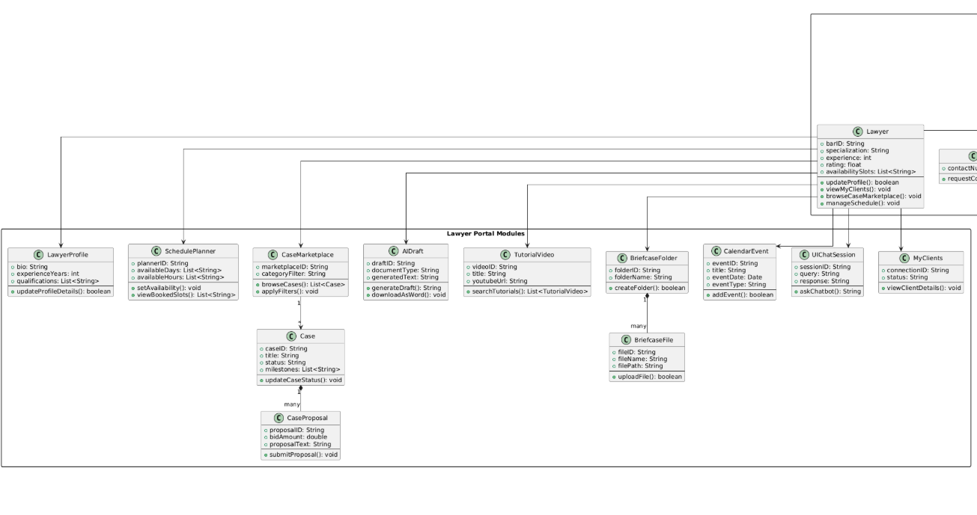
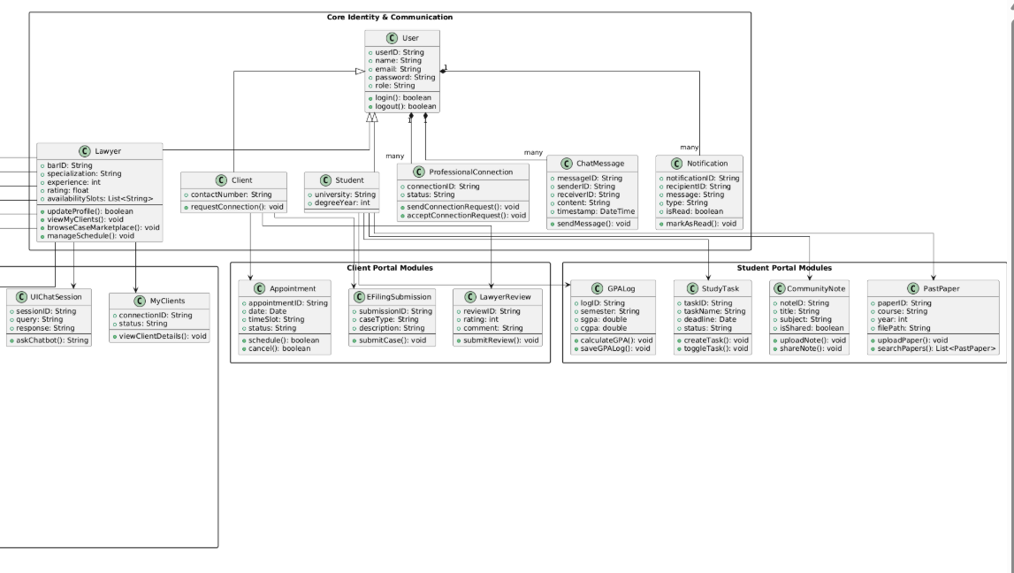

Database Diagram
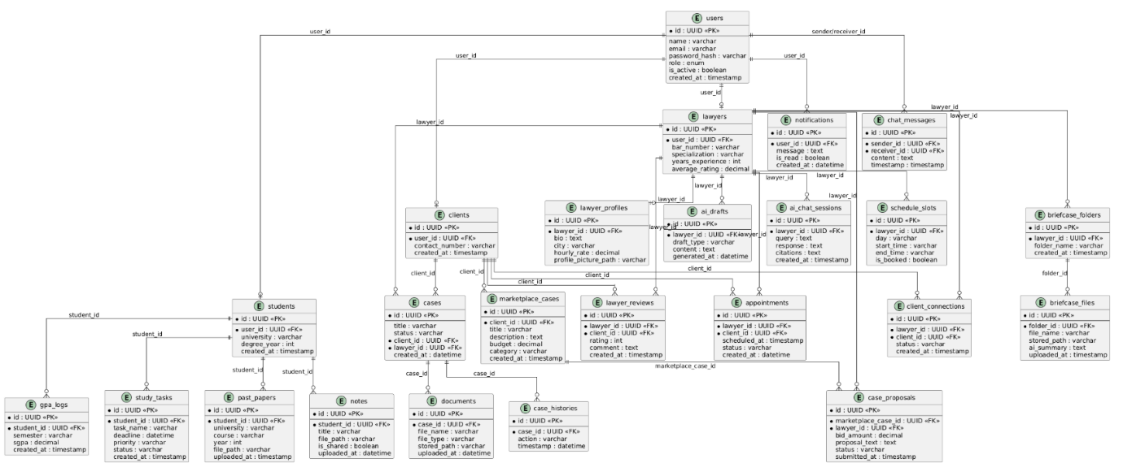
Figure 3.75. Database Diagram

Collaboration Diagram
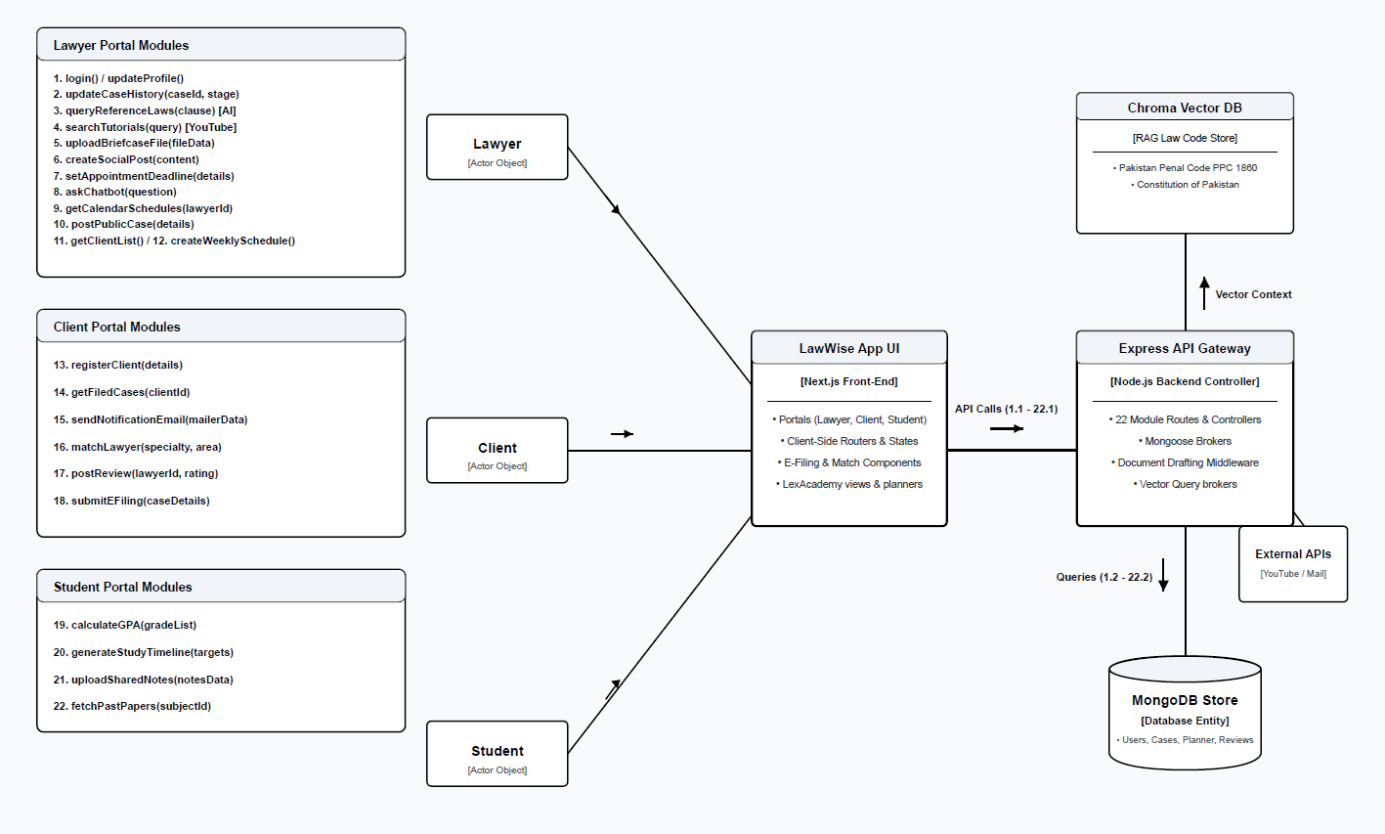
Figure 3.76. Collaboration Diagram

System Testing

Test Cases Design
Table 4.1. Login and Signup
Test Case #: |  | TC01 |  |  | Test Case Name: |  | Login and Signup
System: |  | Lawwise |  |  | Subsystem: |  | Authentication
Designed By: |  | Maryam Bakhtyar |  |  | Design Date: |  | 15-07-2025
Executed By: |  | Maryam Bakhtyar |  |  | Execute Date: |  | 17-07-2025
Short Description: |  | User(Lawyer/ Client/ Student) shall be able to login to system
Pre-Conditions
- The user should have registered account (Lawyer / Client / Student).
- The log in page should be available.
Test Case | Action/step |  | Input Data | Expected System Response |  | Actual Response |  | Pass/ Fail | Post Condition
TC01-01 | Valid input of email and password. |  | Valid email / password | User logged in and taken to dashboard homepage. |  | Welcome message shown; logged in successfully. |  | Pass | The user is redirected to their respective dashboard.
TC01-02 | Invalid email/password entry by the user. |  | Invalid email/password | Authentication fails and prevents login attempt. |  | Error notification raised; did not allow login. |  | Pass | The user stays at the login page.
TC01-03 | User registers using incomplete form. |  | Mandatory empty fields such as name and password. | Form submission is blocked and prompts completion. |  | Empty field warning raised by browser. |  | Pass | User prevented from completing registration.
TC01-04 | User enters all the valid credentials for signup. |  | Valid entries | The account creation process takes place. System displays: "Account created successfully" |  | The account creation process takes place. System displays: "Account created successfully" |  | Pass | The new user profile will be created using the mongo database and then redirected to the dashboard.

Table 4.2. Case History and Tracking
Test Case #: |  | TC02 |  |  | Test Case Name: |  | Case history and Tracking
System: |  | Lawwise |  |  | Subsystem: |  | Case Management
Designed By: |  | Minal Amjad |  |  | Design Date: |  | 20-07-2025
Executed By: |  | Minal Amjad |  |  | Execute Date: |  | 16-09-2025
Short Description: |  | Allows lawyers to log legal matters, set deadlines, manage files, and close cases.
Pre-Conditions
- Lawyer should be registered in the system.
- Lawyer should possess one past or current case assigned.
- Case database and document storage should be availed.
Test Case | Action/step |  | Input Data | Expected System Response |  | Actual Response |  | Pass/ Fail | Post Condition
TC02-01 | Attorney makes a new case. |  | Valid case information | Case registered in the system and shown in grid. |  | Systems displays list of past and active cases. |  | Pass | Case is stored in MongoDB.
TC02-02 | Lawyer adds a task to a case. |  | Title and deadline date of the task. | Adds new task card to the case. |  | Deadline card added to the tasks list. |  | Pass | The task added to the case array.
TC02-03 | Lawyer downloads the case file. |  | Click Download button | Retrieve file and start downloading process. |  | File has been downloaded successfully. |  | Pass | File is stored on user’s computer.
TC02-04 | Lawyer completes the case. |  | Close Case button | Case will be marked as done and can no longer be edited. |  | Case status changed to done on Dashboard. |  | Pass | Case file locked in DB.

Table 4.3. Lawyer Profile Managemnet
Test Case #: |  | TC03 |  |  | Test Case Name: |  | Profile management
System: |  | Lawwise |  |  | Subsystem: |  | Management
Designed By: |  | Mahnoor Tariq |  |  | Design Date: |  | 20-07-202
Executed By: |  | Mahnoor Tariq |  |  | Execute Date: |  | 17-09-2025
Short Description: |  | Permits users to edit personal information, practices, qualifications.
Pre-Conditions
- Lawyer should be registered into the system.
- Lawyer account will have to be active.
- The storage of profile data (database) has to be available.
Test Case | Action/step |  | Input Data | Expected System Response |  | Actual Response |  | Pass/ Fail | Post Condition
TC03-01 | Lawyer edits personal information & picture. |  | Valid user input and image for crop | Data input will be stored, images cropped.  . |  | Personal information was changed, crop modal worked well. |  | Pass | Personal information edited in wizard.
TC03-02 | Lawyer selects target practice areas. |  | Selects practice area check cards | Toggled input field, marked card accordingly. |  | Practice area is selected and marked correctly. |  | Pass | Practices set in user profile state.
TC03-03 | Lawyer adds qualifications |  | Inputs degree, school, and year | Educational row appended dynamically on setup list. |  | Rows were added automatically to list with proper data. |  | Pass | Qualification saved in history.
TC03-04 | Lawyer submits profile updates. |  | Accepts terms and clicks save profile button. | Packets of data sent to MongoDB, redirecting to home grid. |  | Profile is saved in database successfully. |  | Pass | Profile stored in the database.

Table 4.4. Briefcase
Test Case #: |  | TC04 |  |  | Test Case Name: |  | Briefcase
System: |  | Lawwise |  |  | Subsystem: |  | Legal Knowledge base
Designed By: |  | Minal Amjad |  |  | Design Date: |  | 01-08-2025
Executed By: |  | Minal Amjad |  |  | Execute Date: |  | 20-08-2025
Short Description: |  | Categorizing case-related documents into library folders, downloading files, and producing AI summaries immediately.
Pre-Conditions
- Login required.
- Availability of the knowledge base and AI services online.
Test Case | Action/step |  | Input Data | Expected System Response |  | Actual Response |  | Pass/ Fail | Post Condition
TC04-01 | Create library folder. |  | Folder name. | Creating a new container for storing documents. |  | A new folder has been created successfully and shown in the grid. |  | Pass | Folders are stored in MongoDB.
TC04-02 | Uploading documents in a library folder. |  | Selecting PDF/DOC file | Saving documents securely and creating link to folder. |  | Uploads files and saves them in the folder list. |  | Pass | Saves document file on the file server.
TC04-03 | Lawyer initiates AI folder analysis. |  | Pressing "Start AI Analysis" button | AI processes documents and produces executive summary. |  | Pop-ups AI summary in a window pane. |  | Pass | AI produces a summary.
TC04-04 | Lawyer downloads the file from Briefcase. |  | Clicking download button | Fetches file from the database and starts downloading in browser. |  | Document file downloaded on the computer. |  | Pass | Document saved locally.

Table 4.5. Digital Guidance
Test Case #: |  | TC09 |  |  | Test Case Name: |  | Digital Guidance
System: |  | Lawwise |  |  | Subsystem: |  | Educational Guidance
Designed By: |  | Maryam Bakhtyar |  |  | Design Date: |  | 20-07-2025
Executed By: |  | Maryam Bakhtyar |  |  | Execute Date: |  | 01-08-2025
Short Description: |  | Facilitates lawyers to look up YouTube video tutorials on law, add notes, and get video summaries via AI.
Pre-Conditions
- Login to system.
- YouTube Data API v3 and OpenAI summary APIs must be operational.
Test Case | Action/step |  | Input Data | Expected System Response |  | Actual Response |  | Pass/ Fail | Post Condition
TC09-01 | Lawyer looks up tutorials. |  | Searches using a keyword. | System searches YouTube for videos. |  | Custom thumbnail video results displayed. |  | Pass | List contains relevant videos.
TC09-02 | Lawyer adds notes to tutorial. |  | Input text in note section. | Study notes saved under the specific video. |  | Success notification popped on screen. |  | Pass | Notes saved in database.
TC09-03 | Lawyer asks for video summary. |  | Presses "AI Summary" button. | System gets context from video & generates bullet takeaways. |  | Side bar pops up with summary text. |  | Pass | Video summarized successfully.

Table 4.6. My Clients
Test Case #: |  | TC10 |  |  | Test Case Name: |  | My Clients
System: |  | Lawwise |  |  | Subsystem: |  | Client Request Hub
Designed By: |  | Minal Amjad |  |  | Design Date: |  | 15-11-2025
Executed By: |  | Minal Amjad |  |  | Execute Date: |  | 01-12-2025
Short Description: |  | Lawyer looks at live clients and views their contact information and any assets shared with them.
Pre-Conditions
- User should be logged in.
- Connection agreement should be present in the database.
Test Case | Action/step |  | Input Data | Expected System Response |  | Actual Response |  | Pass/ Fail | Post Condition
TC10-01 | Lawyer looks at client details. |  | User clicks client from list. | Client details are shown in a panel with his/her phone number, email ID, and case logs. |  | The details are shown in the secondary panel successfully. |  | Pass | Profile card displayed on screen.
TC10-02 | Lawyer adds connection between client and a particular case file. |  | Select target case file/folder | Associate client directory with the case logs. |  | Successfully associated. |  | Pass | Link updated in MongoDB case files.

Table 4.7. Notifications and Reminders
Test Case #: |  | TC11 |  |  | Test Case Name: |  | Notifications & Reminders
System: |  | Lawwise |  |  | Subsystem: |  | Notification Hub
Designed By: |  | Maryam Bakhtyar |  |  | Design Date: |  | 15-08-2025
Executed By: |  | Maryam Bakhtyar |  |  | Execute Date: |  | 01-09-2025
Short Description: |  | Handles connection request notifications and resolves deadlines for cases.
Pre-Conditions
- User should be signed in.
- Notification services on backend should be operational.
Test Case | Action/step |  | Input Data | Expected System Response |  | Actual Response |  | Pass/ Fail | Post Condition
TC11-01 | A lawyer reacts to a connection request. |  | Click Accept/Reject Button | Action logged by system and alert dismissed. |  | Alert cleared; connection established. |  | Pass | User connections added to DB.
TC11-02 | A lawyer settles a case deadline alert. |  | Click Mark as Done | Resolves target deadline as completed. |  | Confirmation message shown, alert dismissed. |  | Pass | Deadline marked complete in DB.

Table 4.8. Professional Networking
Test Case #: |  | TC12 |  |  | Test Case Name: |  | Professional Networking
System: |  | Lawwise |  |  | Subsystem: |  | Notification Hub
Designed By: |  | Maryam Bakhtyar |  |  | Design Date: |  | 01-09-2025
Executed By: |  | Maryam Bakhtyar |  |  | Execute Date: |  | 20-09-2025
Short Description: |  | Lawyer makes professional networking requests and engages with other professionals in the field of law.
Pre-Conditions
- User should be logged in.
- All Networking directories should be running in MongoDB.
Test Case | Action/step |  | Input Data | Expected System Response |  | Actual Response |  | Pass/ Fail | Post Condition
TC12-01 | Lawyer makes a networking request. |  | Clicking on “Connect” button | Make connection request to the respective person |  | "Connection Request Pending" displayed after clicking on connect button |  | Pass | Request made in database.
TC12-02 | Lawyer visits professional networking feed page. |  | Open Networking tab | Load feed of local legal experts |  | Loads feed of active local legal experts |  | Pass | Display feed of all connected professionals.

Table 4.9. AI Assistance and Legal Drafting
Test Case #: |  | TC05 |  |  | Test Case Name: |  | AI Assistance and Legal Drafting
System: |  | Lawwise |  |  | Subsystem: |  | Legal Intelligence
Designed By: |  | Mahnoor, Minal, Maryam |  |  | Design Date: |  | 01-03-2026
Executed By: |  | Mahnoor, Minal, Maryam |  |  | Execute Date: |  | 10-05-2026
Short Description: |  | Lawyer uses AI assistant for research purposes and creates templates for drafting legal documents.
Pre-Conditions
- User must be logged in.
- OpenAI/LLM API must be online.
Test Case | Action/step |  | Input Data | Expected System Response |  | Actual Response |  | Pass/ Fail | Post Condition
TC05-01 | User requests an answer for a legal question from AI. |  | Custom query (such as contract) | AI answers legal query with citations to laws. |  | Detailed AI output with citations is displayed on screen. |  | Pass | Legal question saved in chat log.
TC05-02 | Lawyer creates a template for contract drafting. |  | Input template selected by lawyer | Automatically generated contract text. |  | Generated legal contract is visible on screen. |  | Pass | Contract generated for further editing.
TC05-03 | Lawyer downloads a generated contract. |  | Download/Export action performed | Exported contract file in Word format. |  | Downloaded file in Word format. |  | Pass | Saved locally to storage.

Table 4.10. My Calendar and Appointments
Test Case #: |  | TC06 |  |  | Test Case Name: |  | My Calendar & Appointments
System: |  | Lawwise |  |  | Subsystem: |  | Scheduling Module
Designed By: |  | Mahnoor Tariq |  |  | Design Date: |  | 15-07-2026
Executed By: |  | Mahnoor Tariq |  |  | Execute Date: |  | 01-08-2026
Short Description: |  | Attorneys view their professional calendars, booking time slots, and attend consultations over video conferencing.
Pre-Conditions
- User needs to log in.
- Lawyer’s calendar database should synchronize.
Test Case | Action/step |  | Input Data | Expected System Response |  | Actual Response |  | Pass/ Fail | Post Condition
TC06-01 | Review appointment schedule |  | Open Calendar page | Load monthly or weekly grid with markings |  | Calendar loads with active slot bookings. |  | Pass | Schedules are displayed.
TC06-02 | Active hour or days selected |  | Save slot schedules for client pick-up. | Notice displayed and slot schedules saved. |  | Generated legal contract is visible on screen. |  | Pass | Slots saved to DB.
TC06-03 | Launches a video conference call |  | Click on Join Consultation Button | Connect video channel and enable feed. |  | Redirects user to meeting room with audio and video enabled. |  | Pass | Video consultation room is running.

Table 4.11. Communication
Test Case #: |  | TC07 |  |  | Test Case Name: |  | Communication
System: |  | Lawwise |  |  | Subsystem: |  | Messaging Portal
Designed By: |  | Mahnoor Tariq |  |  | Design Date: |  | 01-08-2025
Executed By: |  | Mahnoor Tariq |  |  | Execute Date: |  | 15-08-2025
Short Description: |  | Lawyer sends messages, file attachments, and voice recordings to clients.
Pre-Conditions
- . User should be logged in.
- Microphone permission in browser should be granted.
Test Case | Action/step |  | Input Data | Expected System Response |  | Actual Response |  | Pass/ Fail | Post Condition
TC07-01 | Send a secure text message by lawyer. |  | Type message and click on send | Text should appear instantaneously and double tick will be registered. |  | Instantly appears in chat window. |  | Pass | Text message is stored in MongoDB.
TC07-02 | Send a voice note to client by lawyer. |  | Record, stop and send audio | Should compile the .webm file and send it to chat list. |  | Voice player is added to chat window. |  | Pass | Voice note gets saved on file server.
TC07-03 | Upload file attachment by lawyer. |  | Select file from files | Send file attachment to chat and show download link. |  | Update link to file in chat window. |  | Pass | Active attachment in chat window.

Table 4.12. CaseMarket Place
Test Case #: |  | TC08 |  |  | Test Case Name: |  | Case Market Place
System: |  | Lawwise |  |  | Subsystem: |  | Client Request Hub
Designed By: |  | Mahnoor Tariq |  |  | Design Date: |  | 15-12-2025
Executed By: |  | Mahnoor Tariq |  |  | Execute Date: |  | 01-01-2026
Short Description: |  | Lawyer searches for open case requests made by clients and claims them.
Pre-Conditions
- User must be logged in.
- Status of lawyer should be verification done.
Test Case | Action/step |  | Input Data | Expected System Response |  | Actual Response |  | Pass/ Fail | Post Condition
TC08-01 | Lawyer views the open case listing. |  | Opens Marketplace | Displays all open cases submitted by clients. |  | Listing shown of all open cases. |  | Pass | All listings displayed.
TC08-02 | Lawyer claims a particular case listing. |  | Claimed Case Listing | Establishes link between the two parties. |  | Display message: "Claimed case successfully" |  | Pass | Lawyer assigned to case in DB.

Table 4.13. E-Filing
Test Case #: |  | TC02 |  |  | Test Case Name: |  | E-Filing
System: |  | Lawwise |  |  | Subsystem: |  | E-Filing Management
Designed By: |  | Mahnoor Tariq |  |  | Design Date: |  | 15-10-2025
Executed By: |  | Mahnoor Tariq |  |  | Execute Date: |  | 15-11-2025
Short Description: |  | Clients have the privilege to prepare a new complaint, upload the legal papers for the case, read through them, and file the cases through e-filing.
Pre-Conditions
- The client should be properly registered and logged in.
- The client should be active on the portal.
- File Storage Server and Database have to be up and running.
Test Case | Action/step |  | Input Data | Expected System Response |  | Actual Response |  | Pass/ Fail | Post Condition
TC02-01 | Client opens the e-filing module. |  | None | The system presents the e-filing dashboard with options to create a new filing, draft documents, and view old filings. |  | The system shows the e-filing dashboard screen successfully. |  | Pass | The e-filing dashboard page is shown.
TC02-02 | Case description drafted by client. |  | Title of Case, Type of Case, Details of Opponent, Short Description of Case. | System validates fields and stores information as draft, facilitating the uploading of documents stage. |  | System validates fields and displays message "Case draft created successfully". |  | Pass | The draft for the case is created successfully in the system.
TC02-03 | The client uploads the necessary legal documents. |  | PDF files (e.g., "petition.pdf", "evidence.pdf"). | The system checks the document types, their sizes, uploads the documents, and attaches them to the draft of the case. |  | Files get uploaded, and the system displays the message: "Documents uploaded successfully." |  | Pass | The documents are uploaded and attached to the draft.
 | The client submits the completed e-filing form. |  | Click on the "Submit Case" button. | The system processes the case, assigns a unique case tracking ID number, and modifies the status. |  | The system processes the request and displays the message: "E-Filing has been successfully submitted. Case Tracking ID: LW-EF-9871." |  | Pass | The case status changes to "Pending Review."

Table 4.14. Filed Cases
Test Case #: |  | TC02 |  | Test Case Name: |  | Filed Cases
System: |  | Lawwise |  | Subsystem: |  | Case Management
Designed By: |  | Minal Amjad |  | Design Date: |  | 15-11-2025
Executed By: |  | Minal Amjad |  | Execute Date: |  | 25-11-2025
Short Description: |  | Clients can see all their filed cases, filter cases based on their status, review case details, and even download the corresponding court orders.
Pre-Conditions
- User should be registered on the system.
- The status of the account should be active.
- There should be already existing filed cases in the database that correspond to the user's account.
Test Case | Action/step | Input Data | Expected System Response |  | Actual Response |  | Pass/ Fail | Post Condition
TC02-01 | Client navigates to the "Filed Cases" page. | None | The system pulls up and shows a complete list of cases that have been filed by the client (Case ID, Case Title, Case Status, and Filing Date). |  | The system successfully pulls up the list of filed cases. |  | Pass | Filed cases list page displayed.
TC02-02 | Client performs case list search/ filter. | Search term (e.g., "Case ID") or Status Filter (e.g., "Active"). | Filtered cases based on the entered search term/status are shown in the screen. |  | System updates the filtered cases based on search criteria. |  | Pass | Results from the filtered search are shown in the screen.
TC02-03 | Client view details of the particular case. | Clicks on the particular Case ID . | This takes him/her to the detailed case information which includes the milestones, hearing history, lawyer assigned, and case documents. |  | System shows all the case details and chronologies. |  | Pass | Detailed case profile page opens up.

Table 4.15. Lawyer Search and Filtering
Test Case #: |  | TC02 |  | Test Case Name: |  | Lawyer Search & Filtering
System: |  | Lawwise |  | Subsystem: |  | Client Module
Designed By: |  | Maryam Bakhtyar |  | Design Date: |  | 15-10-2025
Executed By: |  | Maryam Bakhtyar |  | Execute Date: |  | 01-11-2025
Short Description: |  | The Clients will have the opportunity to search for registered lawyers, apply various filters (like area of specialty, location, and experience), and even arrange the list according to suitability.
Pre-Conditions
- The client must be registered in the system.
- Database having profiles of registered lawyers, along with their location, rating, experience, and area of specialty.
Test Case | Action/step | Input Data | Expected System Response |  | Actual Response |  | Pass/ Fail | Post Condition
TC02-01 | Client navigates to the "Find Lawyer" page. | None | The application renders the lawyer search page along with the search bar, filter panel, and all available lawyer cards. |  | The application opens the lawyer search page with the search bar, filter panel, and all available lawyer cards. |  | Pass | Display Lawyer Search & Filter Dashboard
TC02-02 | Client uses the filters option to view lawyers according to specialization. | Selection for Specialization (e.g., "Family Law"). | The application filters lawyer records to display only those lawyers specializing in the selected category. |  | Lawyers with specialization in "Family Law" are displayed. |  | Pass | Filtered List of Lawyers according to Selected Specialization is displayed.
TC02-03 | Client uses the multi-criteria filters option for the directory. | Location = "Lahore", Experience = "5+ Years". | The application filters lawyer records based on location and experience. It displays only those lawyers that belong to Lahore AND have experience of 5+ years. |  | Only lawyers matching the given criteria get displayed.. |  | Pass | Lawyer List according to Multi-Criteria Filters is displayed.

Table 4.16. Lawyer Reviews and Ratings
Test Case #: |  | TC02 |  | Test Case Name: |  | Lawyer Reviews & Ratings
System: |  | Lawwise |  | Subsystem: |  | Client Module
Designed By: |  | Minal Amjad |  | Design Date: |  | 15-01-2026
Executed By: |  | Minal Amjad |  | Execute Date: |  | 01-02-2026
Short Description: |  | The clients can see past reviews for that particular lawyer, add their review, give ratings out of five stars, and submit feedback. The system then updates the lawyer's overall average rating.
Pre-Conditions
- Client needs to be registered in the system and signed in.
- Client must either be a customer of the lawyer (or consulted with him/her), or must at least be an active user in the system.
- Database needs to be up and running to add reviews and recalculate aggregate score of the lawyer.
Test Case | Action/step | Input Data | Expected System Response |  | Actual Response |  | Pass/ Fail | Post Condition
TC02-01 | Client views lawyer's profile containing current reviews. | None | The system shows profile of the lawyer including all previous reviews, each comment, and the rating. |  | The system shows profile of the lawyer with previous reviews. |  | Pass | Reviews section is displayed to the client.
TC02-02 | Client submits an incomplete review form (Validation check). | Blanks star rating and review text fields. | The system detects missing required data fields and shows error messages. |  | The system shows message: "Please provide a star rating and comment." |  | Pass | Form is not submitted and retains entered values by the client.
TC02-03 | Client submits a completed review and rating form. | Star Rating: "5 Stars", Comment: "Extremely professional lawyer. Explained everything clearly." | The system saves the new review in the database and shows the user confirmation messages. |  | System saves review and shows message: "Review submitted successfully!" |  | Pass | Review is saved in the database associated with the lawyer.
 | System computes average rating of the lawyer. | Done automatically upon successful review submission. | The system updates the average score and review counter on the lawyer's profile banner section. |  | System updates lawyer average score and increases review count. |  | Pass | Updated lawyer profile displays the current scores and counts.

Table 4.17. Client Communication
Test Case #: |  | TC02 |  | Test Case Name: |  | Client Communication & Chat
System: |  | Lawwise |  | Subsystem: |  | Client Module
Designed By: |  | Mahnoor Tariq |  | Design Date: |  | 15-01-2026
Executed By: |  | Mahnoor Tariq |  | Execute Date: |  | 01-02-2026
Short Description: |  | There is the provision for the clients to be able to interact with their legal experts through in-app messaging services, chatting history, send text messages, file attachments related to cases and send recorded voice messages.
Pre-Conditions
- Client should register and log in to the system.
- Client should have an active case or be connected with a lawyer.
- Chat server should be active for real-time messaging and uploading files.
- Microphone access permissions must be granted by the browser/device.
Test Case | Action/step | Input Data | Expected System Response |  | Actual Response |  | Pass/ Fail | Post Condition
TC02-01 | Client clicks the messaging inbox. | None | The system fetches and shows the chat dashboard screen with the list of active conversations with lawyers and previews of recent chats. |  | The system successfully shows the inbox design with active conversations lists. |  | Pass | Inbox dashboard screen is shown.
TC02-02 | Client clicks a particular active chat thread. | Client clicks a lawyer's name, e.g., "Adv. Asif Ali". | The system fetches and shows the chat message history between the client and lawyer clicked along with the active chat message window for typing. |  | Chat message history and active message chat window is opened. |  | Pass | Chat message history screen is displayed.
TC02-03 | Client types a text message to the lawyer. | Text Message: "Hello Advocate, has the court date been confirmed?" | The system delivers the message instantly, shows the message with a sent status in the chat window and saves it to the database. |  | Text message is delivered, shown in the chat window, and marked as "sent" |  | Pass | Message delivered and saved to the chat.
 | Client uploads and sends a document in chat. | Upload: "hearing_notice.pdf" | System checks the format and size of file, then uploads it to the database and shows it as an attachment in the chat. |  | File is uploaded and presented in chat as an attachment. |  | Pass | Document uploaded and attached to message.
 | Client makes and sends an audio message. | Use the microphone, click "Start recording", record audio, click "Stop recording", click "Send". | System receives audio input from microphone, converts it into an audio file and uploads to the server, presenting a player in chat. |  | System records the audio input and creates the player: "Voice message (00:12)" |  | Pass | Voice message created, sent, and played back successfully.

Table 4.18. Client Notification
Test Case #: |  | TC02 |  | Test Case Name: |  | Client Notification Module
System: |  | Lawwise |  | Subsystem: |  | Client Module
Designed By: |  | Maryam Bakhtyar |  | Design Date: |  | 15-01-2026
Executed By: |  | Maryam Bakhtyar |  | Execute Date: |  | 01-02-2026
Short Description: |  | Options available for the client include seeing a list of the last few notifications that have been received by the system (such as case information or message status), seeing unread badge counts, getting push notifications in real time, and marking those notifications as seen.
Pre-Conditions
- Client must have registered himself in the system and logged in.
- Client's account must be active.
- The push notification server must be active.
Test Case | Action/step | Input Data | Expected System Response |  | Actual Response |  | Pass/ Fail | Post Condition
TC02-01 | The client looks at the unread notifications badge number. | None | The system shows a red badge (such as "3") badge over the Bell icon on the header that shows the actual number of unread notifications in the database. |  | The bell icon has a red circle indicating the correct number of unread notifications. |  | Pass | The unread notification badge is shown on the dashboard.
TC02-02 | The client gets real-time alert/toast message. | Triggered upon system event (for example, lawyer updates the case). | A real-time alert/toast pops up on the upper right side of the client's screen; the bell badge increments its value to 1. |  | The system dynamically triggers a popup alert and increases the unread count to 1. |  | Pass | The new system event alert is shown on the screen.
TC02-03 | The client reads one of the notification messages. | The client clicks on an unread notification message. | The system changes the state of the message from "unread" to "read," clears out any highlighting, and decrements the number of the unread badges by 1. |  | The message state automatically changes to "read" and the unread badge decreases. |  | Pass | The selected notification is read.

Table 4.19. Personalized learning
Test Case #: |  | TC02 |  | Test Case Name: |  | Personalised Learning Module
System: |  | Lawwise |  | Subsystem: |  | Student Module
Designed By: |  | Maryam Bakhtyar |  | Design Date: |  | 15-02-2026
Executed By: |  | Maryam Bakhtyar |  | Execute Date: |  | 25-02-2026
Short Description: |  | The students are provided the facility to personalize their learning interests (legality and level of difficulty) and monitor their personalized progress.
Pre-Conditions
- User is required to register on the system and log in.
- Active student profile is essential.
- Access to the personalized recommendation engine and learning resources database is important.
Test Case | Action/step | Input Data | Expected System Response |  | Actual Response |  | Pass/ Fail | Post Condition
TC02-01 | Student defines learning preferences. | Legal interest: "Corporate Law", Level: "Intermediate". | System retains the settings entered by the user and creates a customized learning plan for him/her. |  | System retains preference configuration and shows message: "Preferences saved successfully." |  | Pass | Student's learning plan and profile are updated.
TC02-02 | Student sees recommended materials. | None | System identifies legal interest and level specified and loads suitable materials such as articles, videos, and case laws related to the student's field and expertise. |  | System displays "corporate law" study guides in the form of cards on the dashboard. |  | Pass | Tailored learning resources are displayed on screen.
TC02-03 | Student marks progress in studying a topic. | Marks a topic as completed. | System records user's progress and increments the overall progress tracker percentage. |  | System records user's progress, updates tracker at 10% level, and reveals the next topic for the user. |  | Pass | User's progress is saved, overall learning tracker is updated.

Table 4.20. Past Papers
Test Case #: |  | TC02 |  | Test Case Name: |  | Past Papers
System: |  | Lawwise |  | Subsystem: |  | Student Module
Designed By: |  | Mahnoor Tariq |  | Design Date: |  | 01-02-2026
Executed By: |  | Mahnoor Tariq |  | Execute Date: |  | 16-02-2026
Short Description: |  | There is also an opportunity to browse through past examination papers on law and search for them by subject, year, or university of interest, look through them online and download in PDF format.
Pre-Conditions
- The Student must be registered on the system.
- The database shall hold the uploaded past papers containing relevant meta-data (subject, year, university, file location).
- The server hosting the files for download must be online.
Test Case | Action/step | Input Data | Expected System Response |  | Actual Response |  | Pass/ Fail | Post Condition
TC02-01 | Student search and filter past papers. | Subject: "Criminal Law", Year: "2023", University: "Punjab University". | System filters the past papers collection based on the subject, year, and university. |  | List is filtered and past papers that match the filter criteria are displayed. |  | Pass | List of filtered past papers is displayed.
TC02-02 | Student views past paper details.. | Select and click "Preview" icon/button for a past paper. | System uses in-app PDF document viewer component and loads the details of the selected past paper. |  | Document viewer modal window is loaded and content is displayed instantly. |  | Pass | Document preview modal window is open.
TC02-03 | Student downloads a past paper. | Select past paper and click "Download" icon/button. | System downloads the selected past paper from the server and saves it in the user's device. |  | File downloaded successfully and stored on the local storage of the user. |  | Pass | PDF file of the past paper is saved locally.

Table 4.21. Mini Library
Test Case #: |  | TC02 |  | Test Case Name: |  | Mini Library
System: |  | Lawwise |  | Subsystem: |  | Student Module
Designed By: |  | Minal Amjad |  | Design Date: |  | 15-02-2026
Executed By: |  | Minal Amjad |  | Execute Date: |  | 25-02-2026
Short Description: |  | Students can browse for legal books and articles in the library, add their favorites to their bookmarks, and read digitized books via an online reader.
Pre-Conditions
- Students need to register and log in to the application.
- There should be digitized legal books, reference documents, and metadata available on the digital library catalog.
- There should be accessibility to the media server that houses the digitized books and documents.
Test Case | Action/step | Input Data | Expected System Response |  | Actual Response |  | Pass/ Fail | Post Condition
TC02-01 | Student conducts the search on library catalog. | Search Query: "Constitutional Law". | The system performs search on digital library catalog and presents all the relevant books, articles or documents that include the search keyword. |  | The system refreshes the list and presents books related to "Constitutional Law." |  | Pass | Search results matching the query are presented.
TC02-02 | Student adds the book to favorites list. | Student clicks "Add to favorites" link/icon near the required book ("Introduction to Legal Drafting"). | The system saves the book in favorites list for the student and switches the icon to the active state while saving it in the database. |  | The link/icon gets activated and message appears: "Added to favorites". |  | Pass | Book is successfully added to the personal bookshelf of the student.
TC02-03 | Student opens book from library. | Student clicks "Read now" / "Open book" link/ button. | The system opens in-app interactive reader and loads the pages of chosen book. |  | The system loads the book pages into the in-app reader allowing to scroll them smoothly. |  | Pass | Reader window is successfully opened with the content of required pages.

Table 4.22. Notes Sharing
Test Case #: |  | TC02 |  | Test Case Name: |  | Notes Sharing
System: |  | Lawwise |  | Subsystem: |  | Student Module
Designed By: |  | Minal Amjad |  | Design Date: |  | 20-02-2026
Executed By: |  | Minal Amjad |  | Execute Date: |  | 01-03-2026
Short Description: |  | The students have the choice to upload personal notes for studying (in PDF), search for other students' uploaded notes, download the uploaded notes, and review the uploaded notes.
Pre-Conditions
- The student must be registered and logged into the system.
- The file database and cloud storage servers used to upload notes must be operational.
- The student must allow file access permissions if uploading notes.
Test Case | Action/step | Input Data | Expected System Response |  | Actual Response |  | Pass/ Fail | Post Condition
TC02-01 | Student uploads personalized study notes. | Title: "Criminal Law Basics", Subject: "Criminal Law", File: "criminal_law_notes.pdf". | The system processes the input fields, uploads the PDF file to the server, saves information in the database, and presents the success message. |  | The system uploads the PDF file and shows message: "Notes uploaded successfully!" |  | Pass | Shared notes are published and available to view in the shared notes area.
TC02-02 | Student searches and downloads the shared notes. | Search Terms: "Criminal Law", clicks "Download". | The system filters the shared notes according to the terms, shows the results, and provides a file download option. |  | The system processes the filtering of notes and downloads the selected PDF file. |  | Pass | Selected PDF notes are downloaded successfully onto the local machine.

Table 4.23. GPA Calculator
Test Case #: |  | TC02 |  | Test Case Name: |  | GPA Calculator
System: |  | Lawwise |  | Subsystem: |  | Student Module
Designed By: |  | Maryam Bakhtyar |  | Design Date: |  | 20-02-2026
Executed By: |  | Maryam Bakhtyar |  | Execute Date: |  | 05-03-2026
Short Description: |  | The users can choose to add their credits and grades for computing their GPA and academic records for computing CGPA.
Pre-Conditions
- User must be logged-in to the application.
- The client-side scripts for performing calculations as well as grading scales (A = 4.00, B+ = 3.33, etc.) need to be loaded properly.
Test Case | Action/step | Input Data | Expected System Response |  | Actual Response |  | Pass/ Fail | Post Condition
TC02-01 | Student performs Semester GPA calculation using appropriate data entry. | Course 1: Credit Hours = 3, Grade = A (4.0 GP)  Course 2: Credit Hours = 4, Grade = B+ (3.33 GP)  Course 3: Credit Hours = 3, Grade = B (3.0 GP) | System uses the SGPA formula: Sum(GP*Credits)/Sum(Credits) and computes the right GPA: 3.43. |  | System immediately processes the user's inputs and displays: "Your SGPA is 3.43." |  | Pass | SGPA calculation is completed correctly and displayed to the student.
TC02-02 | Student enters invalid or blank inputs into any of the fields (Validation). | Course 1: Credit Hours = -2, Grade = "Select Grade" (blank). | System prevents calculation by marking invalid fields and showing error message: "Please enter valid credit hours and select grade for each course." |  | System highlights the fields and displays: "Please enter appropriate credit hours." |  | Pass | Calculation prevented, ensuring accurate inputs only.

Table 4.24. Insights and Guides
Test Case #: |  | TC02 |  | Test Case Name: |  | Insights & Guides
System: |  | Lawwise |  | Subsystem: |  | Student Module
Designed By: |  | Maryam Bakhtyar |  | Design Date: |  | 01-03-2026
Executed By: |  | Maryam Bakhtyar |  | Execute Date: |  | 10-03-2026
Short Description: |  | The users will be able to do research about career guides and law guides, check data insights and trends, and even save these guides for future references to study them later.
Pre-Conditions
- The students must be registered in the application and logged in.
- The application database should consist of published career guides, articles, and data trend stats.
Test Case | Action/step | Input Data | Expected System Response |  | Actual Response |  | Pass/ Fail | Post Condition
TC02-01 | Student performs search and filtering of legal/career guides. | Keyword: "Bar Exam Prep", Category: "Career Guides". | The system will filter through the results and display guides and articles that match the selected category and keyword. |  | The updated view displays the guide like "A Step-by-Step Guide to the Bar Exam". |  | Pass | Correct matches have been shown.
TC02-02 | Student adds a guide to favorites. | User clicks the "Save Guide" button on a card. | The system saves the guide into the student's profile and changes the icon to an active state. |  | The system adds the guide to favorites and shows a toast notification saying, "Guide added to your saved shelf." |  | Pass | Successfully added to favorites

Table 4.25. Study Planner
Test Case #: |  | TC02 |  | Test Case Name: |  | Study Planner
System: |  | Lawwise |  | Subsystem: |  | Student Module
Designed By: |  | Mahnoor Tariq |  | Design Date: |  | 01-03-2026
Executed By: |  | Mahnoor Tariq |  | Execute Date: |  | 10-03-2026
Short Description: |  | The students can choose to customize their study task schedules, manage task information, indicate completion status of tasks, and monitor progress through their calendar planner dashboard.
Pre-Conditions
- The student needs to register and log in to the system.
- The system database needs to be up to store and retrieve planned information.
Test Case | Action/step | Input Data | Expected System Response |  | Actual Response |  | Pass/ Fail | Post Condition
TC02-01 | Student creates a new study task. | Title: "Revise Contract Law", Subject: "Contract Law", Date: "2026-06-01", Time: "14:00". | System validates fields, saves data in the database, and displays "Study task scheduled successfully!". |  | New study task appears on the student's planner view. |  | Pass | New study task appears in the schedule.
TC02-02 | Student modifies an existing task | Click "Edit" button, change Date to "2026-06-02", Time to "16:00" and hit "Update" button. | System updates the information about the task in the database, changes its position in the planner accordingly. |  | Task is changed and appears under another date/time. |  | Pass | Task is successfully edited.
 | Student finishes a scheduled task. | Click the checkbox next to the task. | System changes status of this task to "Completed", gives it the finished look and increases the weekly progress indicator. |  | Tasks appear finished and a progress bar gets incremented for the current day. |  | Pass | Task is successfully marked as completed and stats adjusted.

Unit / Integration / Acceptance Testing

Authentication Module
Unit Testing
- Check mail format and password strength.
- Be able to log in with valid and invalid usernames.
- Comparison and hashing of check passwords.
- Validate email verification code generation and expiry.
Integration Testing
- Make sure that the interface of a log in form is linked to the MongoDB API to verify the user.
- Check the access to the dashboard following a successful login.
- Verify that the email verification process successfully updates the user's isEmailVerified flag in MongoDB.
Acceptance Testing
- Make sure that a lawyer is able to log in using valid credentials.
- The invalid credentials should raise the correct error messages.
- Ensure that unauthorized users do not access secured pages.

Dashboard Module
Unit Testing
- Reminders, deadlines and notifications on tests.
- Test dashboard and message loading such as cases and messages.
- Check the operation of the number of unread messages counter.
Integration Testing
- Ensure that the dashboard is connected to the API and database (MongoDB).
Acceptance Testing
- Make sure the dashboard loads within a reasonable period of time.
- Ensure that all future hearings, reminders and work are displayed properly.

Lawyer Profile Management Module.
Unit Testing
- Test the fields in profile update.
- Authenticate specialization, experience, and qualifications.
- Test the certificate/document upload facility.
- Validate the availability slots weekly structure logic.
Integration Testing
- Make sure that the profile UI has been connected to the API regarding updates in MongoDB
- Interaction of uploaded certificates with the storage service.
- Ensure profile updates set the isProfileComplete status flag to true.
Acceptance Testing
- The profile is updated instantly
- Lawyers can configure and save their weekly consultation availability slots.

Case History/ Tracking Module.
Unit Testing
- Test the case creating capability.
- Check case retrieval capabilities.
- Review case progress update feature.
- Check uploads of files
Integration Testing
- Make sure that the case form is linked to the API to MongoDB insertion.
- System allows uploading of test documents, which are stored and metadata saved appropriately.
- Search case using database query.
- Verify that the lawyer status PATCH route correctly marks a case status as "completed" in MongoDB.
Acceptance Testing
- Ensure that lawyers are able to add, view and track cases.
- Ensure that document previews work .

AI-Based Drafting Module
Unit Testing
- Authenticate any user-inputs.
- Check the parameters of AI requests.
- Get the form of the drafts produced.
- Process empty, incomplete or over-long inputs.
Integration Testing
- Confirm the status of user forms with the back end, AI API, and response processing.
- Make sure that drafts are generated into MongoDB.
- Added PDF export check functionality.
Acceptance Testing
- Ensure that the AI is able to produce a full legal document.
- Make sure that the draft prepared has all the necessary legal sections.

AI Chatbot
Unit Testing
- Authenticate AI input text to elucidate.
- Setting up of tests of AI-generated summaries and explanations.
Integration Testing
- Elaborate on AI responses using the LLM API and present on the UI.
- Verify chatbot contexts match vector storage search results (Constitution and PPC)
Acceptance Testing
- Make AI offer easy and simplified legal explanations.

Digital guidance Module
Unit Testing
- Check whether the requests to YouTube API work.
- Authenticate search keywords input.
Integration testing
- Make sure that API are directed to the Youtube page.
- Look if the certain keyword redirects to the the required youtube video
Acceptance Testing
- Ensure that videos are loaded and they can be played.
- Make sure that the presented tutorials are applicable to the chosen subjects.

Briefcase Document Module
Unit Testing
- Document file type and extension validation

- Maximum 15MB file size validation

- Folder creation check, folder name validation
Integration Testing
- Uploaded documents should be stored in MongoDB

- Deleting a folder unassigns all the files in it
Acceptance Testing
- The lawyer should be able to create folders, upload documents and download files

- Deleting folders/files instant update of the workspace should occur

Professional Networking Module
Unit Testing
- Test the connection request sending functionality.
- Lawyer to lawyer messaging.
- Cross-check profile search filters.
Integration Testing
- Check networking UI connections to the API and MongoDB.
- Should work with database storage on the chat system.
Acceptance Testing
- Ensure that a lawyer is able to send and accept connection requests.
- Make sure that messages are real-time.

Communication and Appointment Module.
Unit Testing
- Check the functionality of sending and receiving messages.
- Check the dates and time of appointments
- How they communicate in real time and how are they connected
Integration Testing
- Check chat UI connections to the database.
- Make the appointment form communicate with the API and the scheduler
- Check calendar view is linked to the MongoDB and the back end.
- Verify that booking an appointment updates the lawyer's availability slot status to isBooked: true.
Acceptance Testing
- Make sure that chat messages are displayed in real time.
- Make sure that appointments are made properly and appear in the schedule.

Messages, Deadlines & Reminders Module.
Unit Testing
- Check the logic of scheduling reminders.
- Check date and time entries.
- Formatting of check notifications.
Integration Testing
- Confirm if the notification page gets all the information from database
Acceptance Testing
- Ensure that hearings and meetings are reminded to lawyers in time.
- Make sure that all of the reminders appear in the dashboard.

Calendar Module
Unit Testing
- Utility functions for formatting dates into slots in the calendar

- Event type classification in the calendar events

- Date/title authentication for custom events
Integration Testing
- Synchronize events of case hearings and deadlines with the UI calendar

- Custom events should be saved in local storage
Acceptance Testing
- Properly load calendar grid and agenda

- Adding/deleting of custom events should update UI elements

Case Marketplace Module
Unit Testing
- Request field validations

- Genration of the unique Case ID/Request ID format

- AI case analysis failover
Integration Testing
- Request and documents should be saved in MongoDB

- Accept/reject actions should update the connection and add Cases in MongoDB
Acceptance Testing
- The client should be able to file a case request and directly assign it to a lawyer

- Accepting of case requests by lawyers in marketplace should be performed

My Clients Module
Unit Testing
- Test the functionality of searching client filters.

- Test the functionality of profile picture and initials display.
Integration Testing
- Connect my clients list on UI to the state of database connectivity.
Acceptance Testing
- Confirm lawyer can search, view profile and send message.

Schedule Planner Module
Unit Testing
- Test validation of format for time slots.

- Test changing weekday state while adding/removing slots.
Integration Testing
- Fetch lawyer schedule slots and update availability array in MongoDB.
Acceptance Testing
- Lawyer can manage schedule and save slots.

Client Registration and Profile Module
Unit Testing
- Test the input fields such as full name, email, and password strength.

- Test the process of password encryption and its verification against entered data

- Test the validation of the telephone number format rules.
Integration Testing
- Test if the information from the registration form is successfully stored into MongoDB.

- Test if the profile changes update the cached session instantly in the UI layer.
Acceptance Testing
- Test whether a client can register, log in and use the client dashboard successfully.

- Test whether any changes to client profile update instantly.

E-Filing Module
Unit Testing
- Check on inputs (title, description) in case filing.
- Check document file type ( PDF, JPG).
- Generation of unique case ID.
- Validate client consultation request scheduling inputs.
Integration Testing
- Make sure document is uploaded on the system.
- Case form is stored in MongoDB through API fetches.
- Verify case creation fails if no document files are uploaded
Acceptance Testing
- Client is able to file a case.
- Every document that is uploaded will be under My Cases.

Lawyer filtering
Unit Testing
- Filter tests (city, specialization, category).
- Check rating and review calculations.
- Search functionality of test keywords.
Integration Testing
- Filter lawyer in UI to MongoDB database.
- Lawyer profile is viewed through keywords.
Acceptance Testing
- Right lawyers are shown in filter results.
- The profile of selected lawyer is displayed without any errors.

Lawyer reviews
Unit Testing
- Test review form submission.
- Validate rating value (1–5).
- Data retrieval of test lawyers profile.
Integration Testing
- Profile reviews are entered on database MongoDB through API fetch calls.
- Submission of the review is sent and instantly the lawyer rating are updated.
Acceptance Testing
- The clients will be able to see profiles, ratings and reviews.
- Reviews are classified in the right order.

Filed Cases Module
Unit Testing
- Test the parameters and data structures used in the retrieval of the case details.

- Test the file types limitations and upload limit validation.

- Test the validation of empty case description field.
Integration Testing
- Connect the filed cases dashboard with the MongoDB case collections based on email addresses.
- Connect the APIs that retrieve the document with file storage services.
Acceptance Testing
- Test if the client can see all the cases filed by him/herself and monitor stage progress.

- Test whether the client is able to download documents and see the preview.

Client Messaging & Notification Module
Unit Test
- Validate text and styling format of messages sent.

- Validate logic for displaying message count and number of notifications.

- Validate notification date and time format.
Integration Test
- Confirm real-time connection between chat input field and database.

- Confirm automatic notification generation after change of case status within the client center.
Acceptance Test
- Confirm display and update in real time of messages

- Confirm alerting of clients when a case is accepted or updated.

GPA Calculator Module
Unit Testing
- Test calculations of grade points using marks.

- Test formula for GPA calculations.

- Validate conditions for marks and credit hour values (0-100).
Integration Testing
- Confirm save, load and delete functionalities for semester records on local device storage.

- Confirm updating of history list when GPA is added.
Acceptance Testing
- Students can calculate their GPA and save results in history list.

- Make sure that GPA results display proper grade badges.

Study Planner Module
Unit Testing
- Test tomorrow task reminder check for due date.

- Search for tasks based on active, today, week, and history filters.

- Validate task duration and subject categories fields.
Integration Testing
- Confirm integration with planner database and test streak check feature.

- Confirm updating of study stats count field when task is completed in MongoDB.
Acceptance Testing
- Students can add/delete study plans and mark task status

- Make sure that overdue and upcoming tasks are marked with warning alerts.

Notes Sharing & Upload Module
Unit Testing
- Validate file type and size.
- Fields of title and description of tests.
- Failure in uploading tests.
Integration Testing
- Notes upload and shown on system .
- Data is saved on MongoDB.
Acceptance Testing
- Notes can be uploaded, seen, and downloaded without difficulties by students.

Past paper
Unit Testing
- Paper details input and attachment validation checks.

- Sort papers according to LLB year levels.

- Verify the size limitation for uploading files.
Integration Testing
- Past papers and model answers are stored in the MongoDB.

- Increment the download counter when database requests are made.

- Verify that sharing will trigger copying to clipboard or using the Web Share API.
Acceptance Testing
- Students should be able to search, download, upload, and share past papers.

- Verify that the downloaded model answers open in a new window or tab.

Implementation

Work Breakdown Structure (WBS)
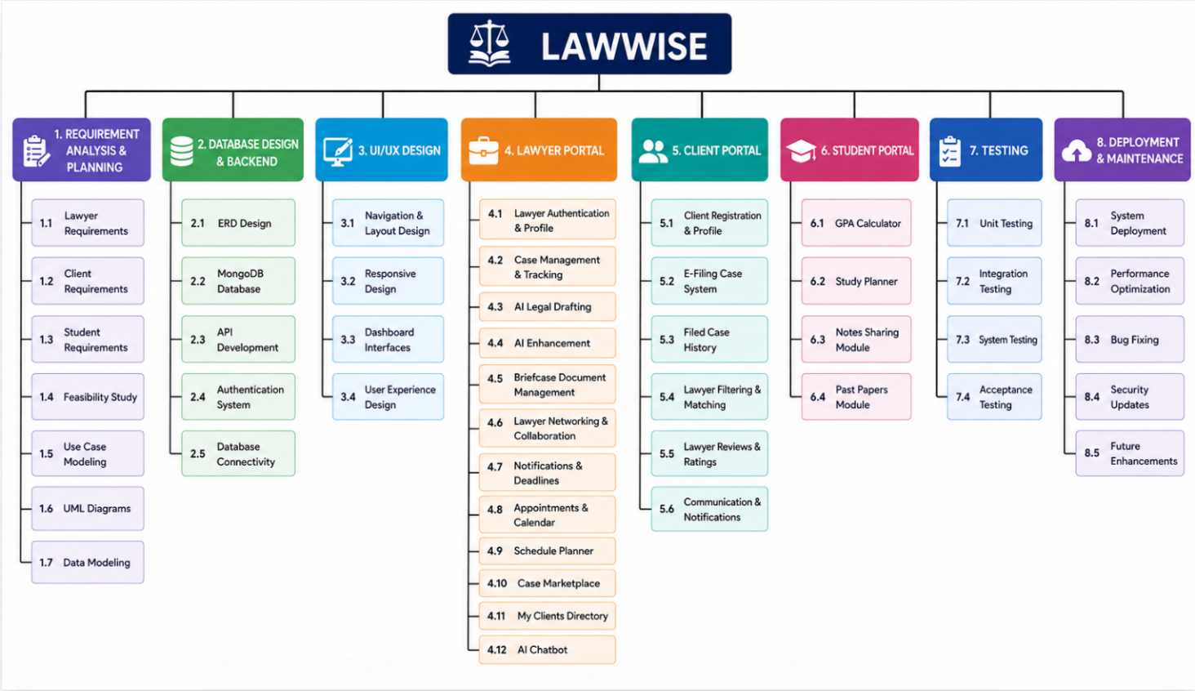
Figure 5.1. Work breakdown structure

Team Roles and Responsibilities

Table 5.1. Individual Tasks
Team Member | Activity
Minal Amjad | Case History Tracking: View and filter all past handled cases with status and outcome
Minal Amjad | Briefcase: Upload, organize, and AI-analyze case documents in a personal vault
Minal Amjad | Consultations: View and confirm/cancel appointment bookings from clients
Minal Amjad | My Clients: Browse and manage the list of active clients linked to the lawyer
Minal Amjad | Analytics: Dashboard charts showing caseload, client count, and performance stats
Mahnoor Tariq | Communication: Real-time chat between lawyer and their clients
Mahnoor Tariq | Manage Schedule: Define weekly available hours and block off unavailable time slots
Mahnoor Tariq | Calendar: Monthly/weekly view of all confirmed appointments and deadlines
Mahnoor Tariq | Case Marketplace: Browse open client case requests and accept cases to handle
Maryam Bakhtyar | Professional Networking: Send, accept, and manage connection requests between lawyers
Maryam Bakhtyar | Notifications: Real-time alerts for new messages, bookings, and case updates
Maryam Bakhtyar | Digital Guidance: Quick AI-powered Q&A interface for Pakistani statute lookups
Maryam Bakhtyar | Authentication: Registration, login, and email verification for Lawyer and Client users
Mahnoor Tariq | E-Filing: Step-by-step wizard for submitting court filing forms electronically
Mahnoor Tariq | Filed Cases: Client view of all submitted cases with status tracking
Minal Amjad | Lawyer Reviews: Submit a star rating and written review for a lawyer
Maryam Bakhtyar | Lawyer Search & Filtering: Search and filter lawyers by specialization, city, and rating
Maryam Bakhtyar | Personalized Learning: Recommended videos and materials based on enrolled subjects
Maryam Bakhtyar | GPA Calculator: Enter subject grades and credit hours to compute cumulative GPA
Maryam Bakhtyar | Insights & Guide: Performance charts and tips based on quiz scores and study habits
Maryam Bakhtyar | Chat Custom UI Renderers: ReactMarkdown custom tag renderers (, etc.), loaders, chips
Mahnoor Tariq | Past Papers: Browse and download past exam papers filtered by subject and year
Mahnoor Tariq | Study Planner: Create study tasks with deadlines and track completion progress
Mahnoor Tariq | Chat API & Base Layout: REST API routes (/api/chat, /history), token auth, ChatBox.tsx core layout, history drawer
Minal Amjad | Mini Library: Browse and download curated legal study materials and PDFs
Minal Amjad | Notes Sharing: Upload and view peer-shared study notes
Minal Amjad | Chat History & Ingestion: Save session structures, log message history, and fetch briefcase doc context
Minal Amjad | Ingestion & Parser (The Collector): Clean raw legal texts via regex, split into sections, handle rate-limit sleeps (ingest_constitution.js, ingest_ppc.js, rebuild_knowledge_base.js)
Mahnoor Tariq | Vector Similarity (The Matcher): Config ChromaDB client, standardize dimensions, query vector segments (vectorService.js)
Maryam Bakhtyar | LLM Prompt & Fallback (The Weaver): LLM query logic, tune legal system prompts, format tags, multi-tier fallback pipeline (aiService.js Chat section)

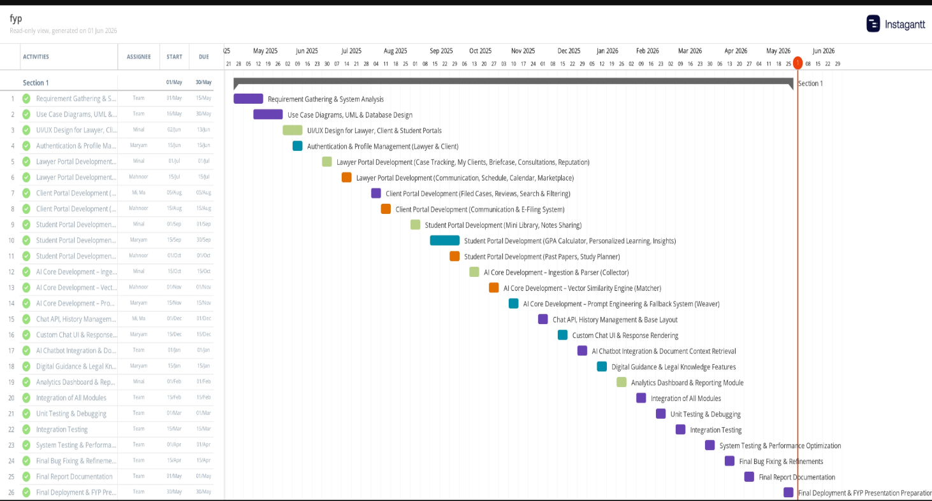
Figure 5.2. Gantt Chart

Tools and Technologies

Frontend (User Interface)
- Next.js & React: The primary toolset for building a speedy, SEO-optimized, and interactive UI.
- Vanilla CSS & CSS Modules: The tools used for designing the stylish Royal Blue/Navy theme.
- Axios: For processing all the backend API calls in an asynchronous manner.
- Lucide React / HeroIcons: For adding elegant icons in the dashboard.
- React Hooks: For effective state management (session and chat states).

Backend (Server & Logic)
- Node.js: Google Gemini AI: The primary high-intelligence engine for legal research.
- Groq Cloud (Llama 3): A specialized AI fallback used for its extreme speed (LPUs).
- Ollama: Used to run local, offline AI models (like gemma2:2b) directly on the machine.
- Gemini Embedding-001: The mathematical model that turns text into vectors for semantic search.
- RAG (Retrieval-Augmented Generation): The architectural pattern used to connect AI models with verified legal documents.

AI & Machine Learning (The Intelligence)
- Google Gemini AI: The main intelligent engine utilized for research into laws.
- Groq Cloud (Llama 3): This is a special artificial intelligence engine that can process information extremely fast (LPUs).
- Ollama: Engine that is used for running AI models locally (such as gemma2:2b).
- Gemini Embedding-001: Mathematical model responsible for vectorization of text.
- RAG (Retrieval-Augmented Generation): Pattern of architecture applied for connecting artificial intelligence engines with legal data sources.

Databases (Data Storage)
- MongoDB: The main NoSQL database used to hold data for user accounts, case entries, and messages.
- ChromaDB: A Vector Database that holds legal information and enables the AI to perform instant lookups.

Specialized Tools & APIs
- YouTube Transcripts API: Utilized for pulling video transcripts for the summarization AI capability.
- Python: Necessary for managing the vector server running on ChromaDB.
- Git/GitHub: Utilized for versioning and collaborative programming.
- Postman: (Suggested Mention) Utilized for testing and documenting the API endpoints.

Implementation Details

Frontend
The front-end development of Lawwise is designed to provide the user with an efficient, attractive, and easy-to-use interface. It serves as the intermediary between complex legal information and a busy lawyer’s day.
Below, you can find a brief description of frontend architecture:

Technology Stack
Next.js (React Framework): It forms the backbone of the frontend and enables fast loading speed, SEO, and SPA experience.
JavaScript (JSX): Used for creating interactive UI components.
Axios: The messenger that helps transfer data between the frontend and your Node.js backend.

Design Philosophy (Aesthetics)
Enterprise-Grade Design: Used a stringent theme that consists of Royal Blue, Navy (#111827), and White colors only, giving the site an "legal tech" feel of being serious and premium.
Glassmorphism: Subtle glass effects to the cards and sidebars.
Readable Typography: Ensuring all fonts are readable (mandatory for legal text).
Responsiveness: Perfectly optimized for viewing on any device from a lawyer's computer screen at the office to a mobile tablet in court.

Smart Features
Dynamic Data Fetching: Hydration of data happens via the backend's analytics and case routes so that the lawyer always gets fresh data.
Integration Services: The frontend manages logic related to YouTube services such as fetching and rendering of transcripts in a clean manner.
State Management: React Hooks (useState and useEffect) are used to manage user session and chat state without reloading the entire page.

Professional Polish
Navigational Consistency: The use of consistent sidebar and header navigation throughout the entire application to prevent confusion in users.
Micro-interactions: Animations that pop up whenever the mouse hovers above any button or card to simulate a realistic feeling.
Handling Errors: Specialized UI elements that indicate when a particular service is offline ("AI Is In Offline Mode").

Backend
The backend of Lawwise is a strong enterprise-level server made according to the principles of the MERN Stack designed to handle AI orchestration and legal data.
Below is the backend architecture explained:

Core Framework & Language
A fast asynchronous server to manage several simultaneous requests from lawyers and clients.
Modular Architecture: It means that backend consists of three major parts called Routes, Services, and Models.

Dual-Database Strategy
There are two different kinds of databases used in Lawwise for handling different needs:
MongoDB (Primary Database): To store structural data such as:
Users (Lawyers & Clients).
Cases Marketplace listings.
Chatting data, real-time chat, notifications, analytics.
ChromaDB (Vector Database): A specialized database for AI. It contains "embeddings" or mathematical representations of laws to provide Semantic Search and accurate legal citations..

The "AI Orchestrator" (Service Layer)
It is the most distinctive part of your backend. It works not only as an API but also serves as an intelligent agent:
Hybrid intelligence: It regulates the switching process between Google Gemini, Groq (Llama 3), and Local Ollama.
RAG (Retrieval Augmentation Generation): It "retrieves" factual information from ChromaDB and "feeds" the AI system with that data before providing a response to the user. In this way, we ensure correctness.

Integration & Security
Integration & Security
Environment Security: Utilizes .env files in order to keep your API keys (Gemini, Groq, MongoDB) confidential and not expose them to public use.
CORS and Middleware Settings: Allows for secure communications exclusively with your frontend (Next.js/React).
Video Processing: Integrates with YouTube systems to extract transcripts and process videos into legal text summarization.

AI Technologies
Lawwise makes use of a highly advanced "Hybrid AI Architecture," which makes sure of its reliability and intelligence.
Following is the list of AI technologies used by us in the project

1. Large Language Models (The "Brains")
Google Gemini (2.5-flash/1.5-flash): This is our Primary AI and will handle complex things like legal research, chat, and YouTube summarization.
Groq (Llama 3): This is our Secondary Cloud AI. Groq specializes in high-speed performance (LPUs). In case the Primary AI fails, the platform automatically switches to Llama 3 through Groq, without disrupting any of our services.
Ollama (Gemma2:2b): This is our Local AI. With Ollama, our platform can work offline. In case there is no Internet, the platform will make use of this Local Model on the user's device to give legal advice.

2. Vector Database & RAG (Knowledge Storage)
This is our AI Memory. It contains legal documents such as the constitution and PPC. Unlike a normal database, this database stores information in the form of "vectors".
Gemini Embedding (gemini-embedding-001): This is used to convert human languages into vectors. This enables the AI to comprehend the context of your legal questions and find the exact legal answers in ChromaDB.
RAG (Retrieval-Augmented Generation): This is the Technique that we use. Before giving an answer, Lawwise retrieves the original legal document from ChromaDB and augments the AI response with it. In doing so, it makes sure that the AI does not "hallucinate" with imaginary laws.

3. Specialized AI Logic
Custom built orchestration logic used to manage transition between Gemini, Groq and Ollama. A very important engineering aspect that provides huge value.
Semantic Search: Unlike Ctrl+F search, semantic searches look for relevant matches. (For example, search for "stealing" returns results related to "theft".)
AI Law Crawler: Automated script used to crawl, analyze and classify new legal information using AI.

Deployment
We made use of git and gitHub for collaboration, branching and merging for safe development.

Screenshots of Prototype / System

Home page
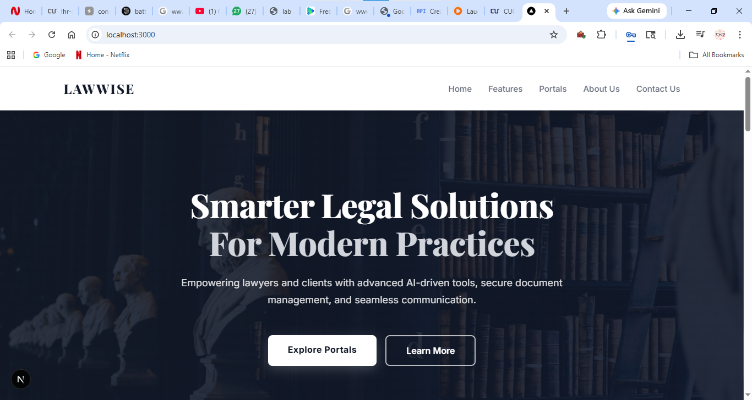

Figure 5.3. Home page
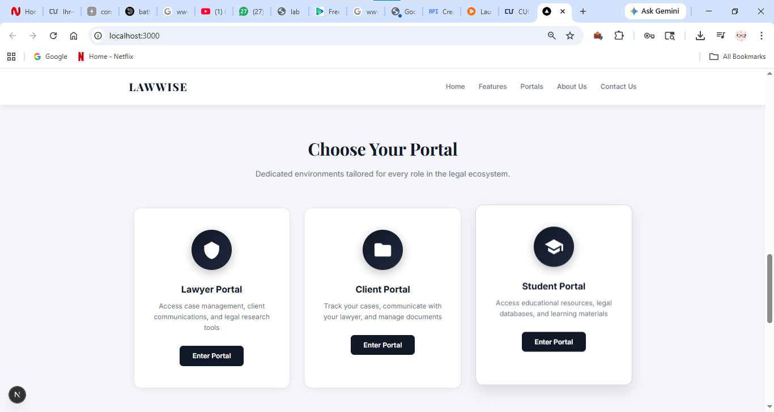
Figure 5.4. Home page
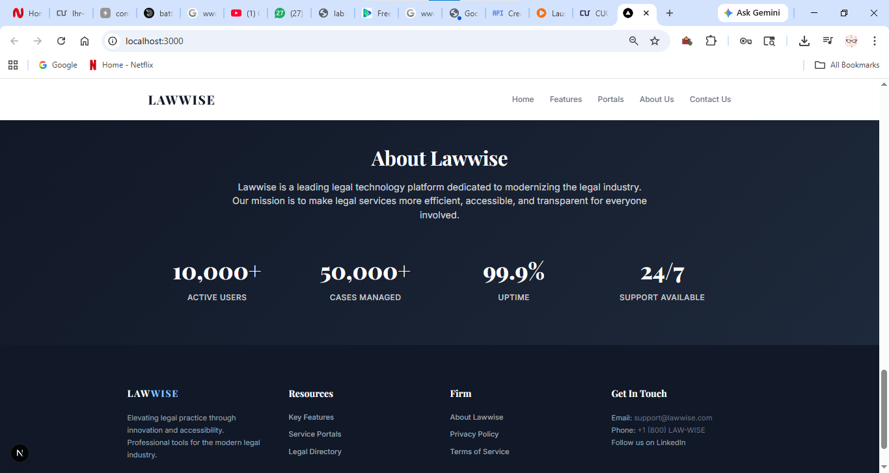
Figure 5.5. Home page

Lawyer Login
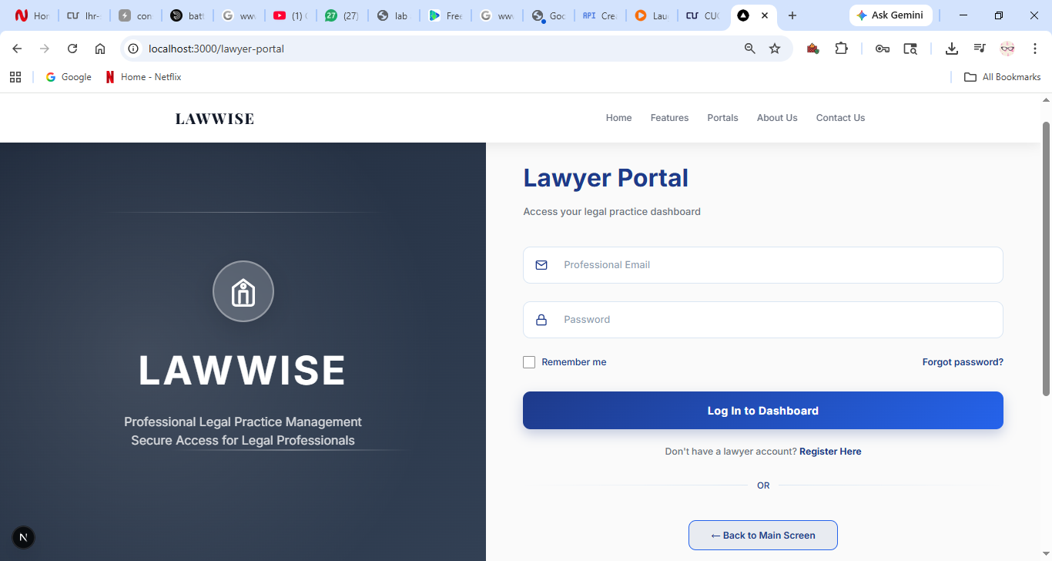
Figure 5.6. login page

Lawyer signup
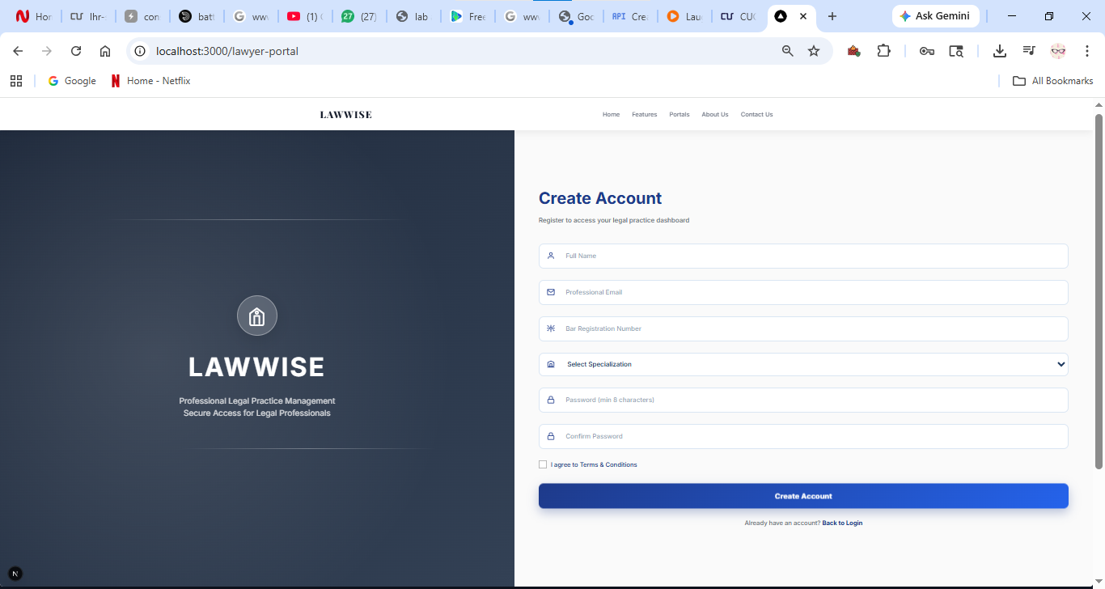

Lawyer Dashboard
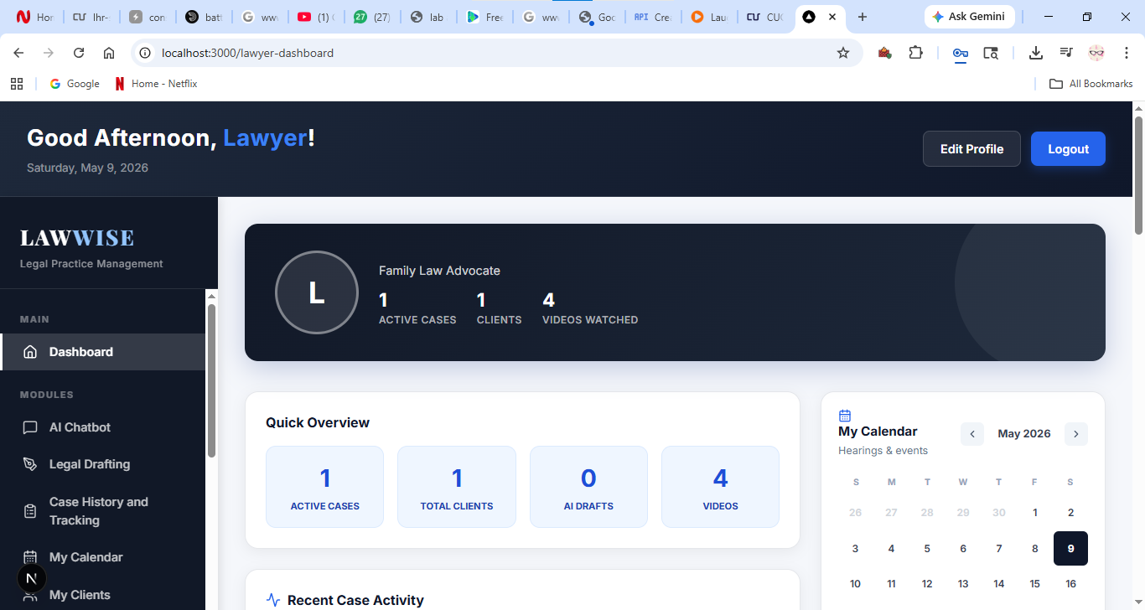
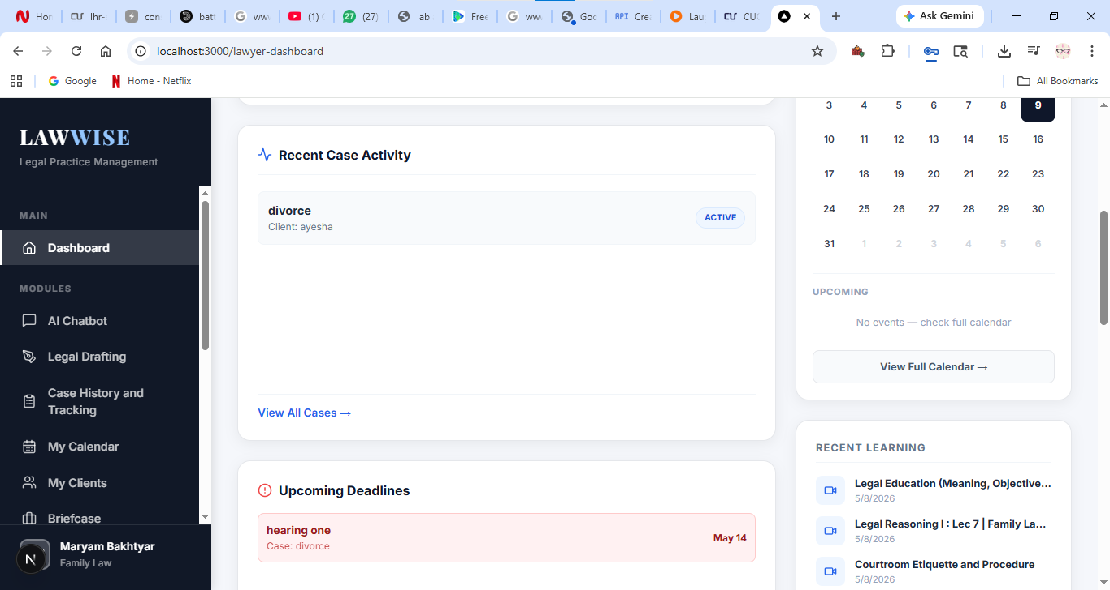
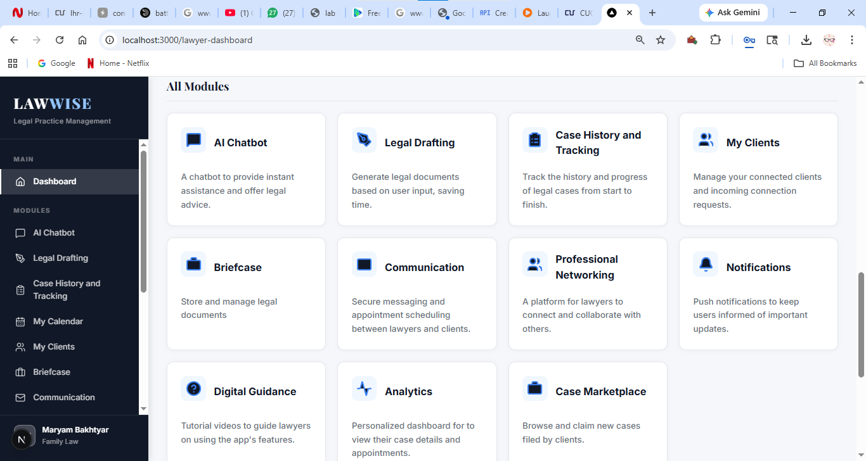

Figure 5.7. dashboard

Case history and tracking
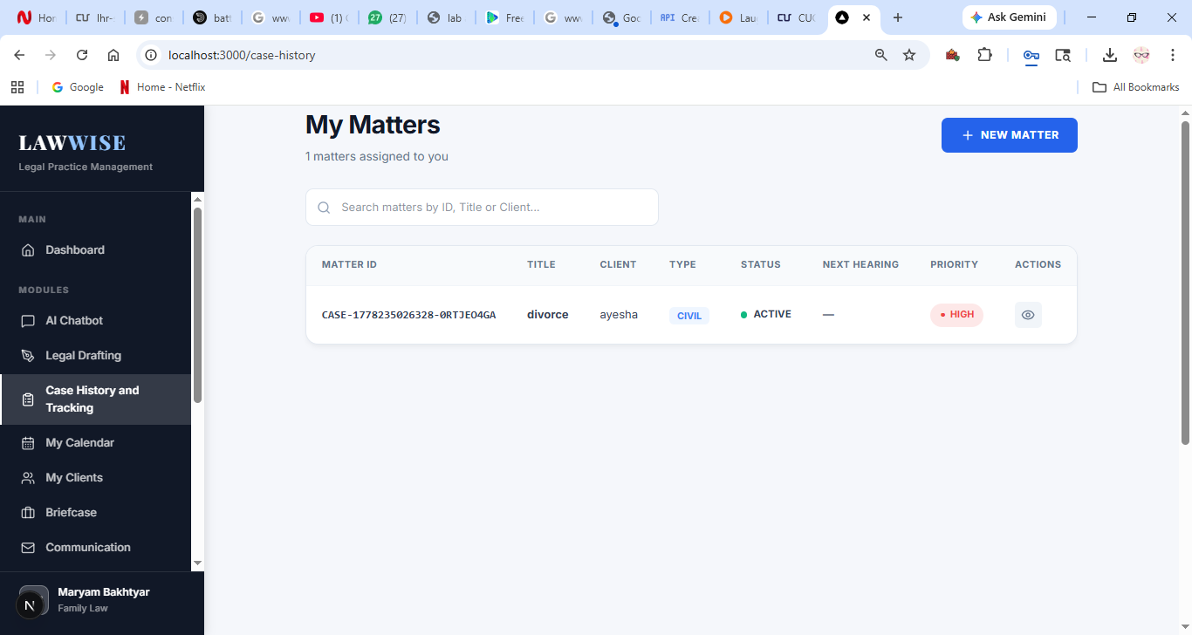
Figure 5.8. case history and tracking page
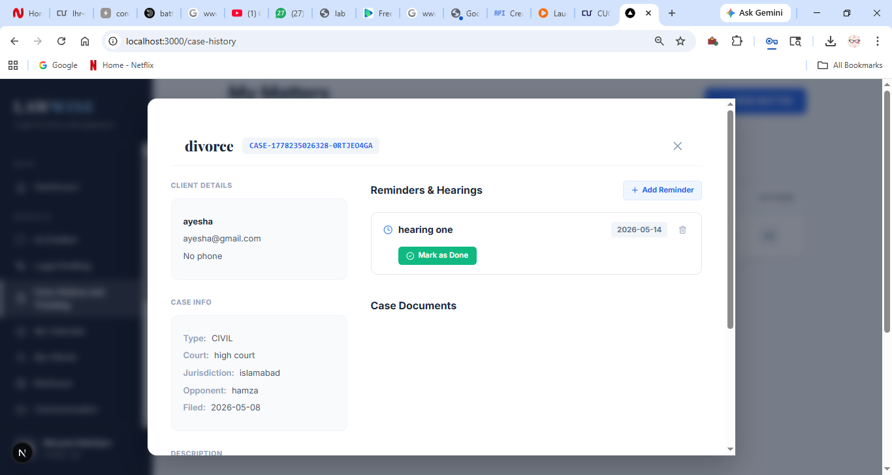
Figure 5.9. case history and tracking page

Profile management
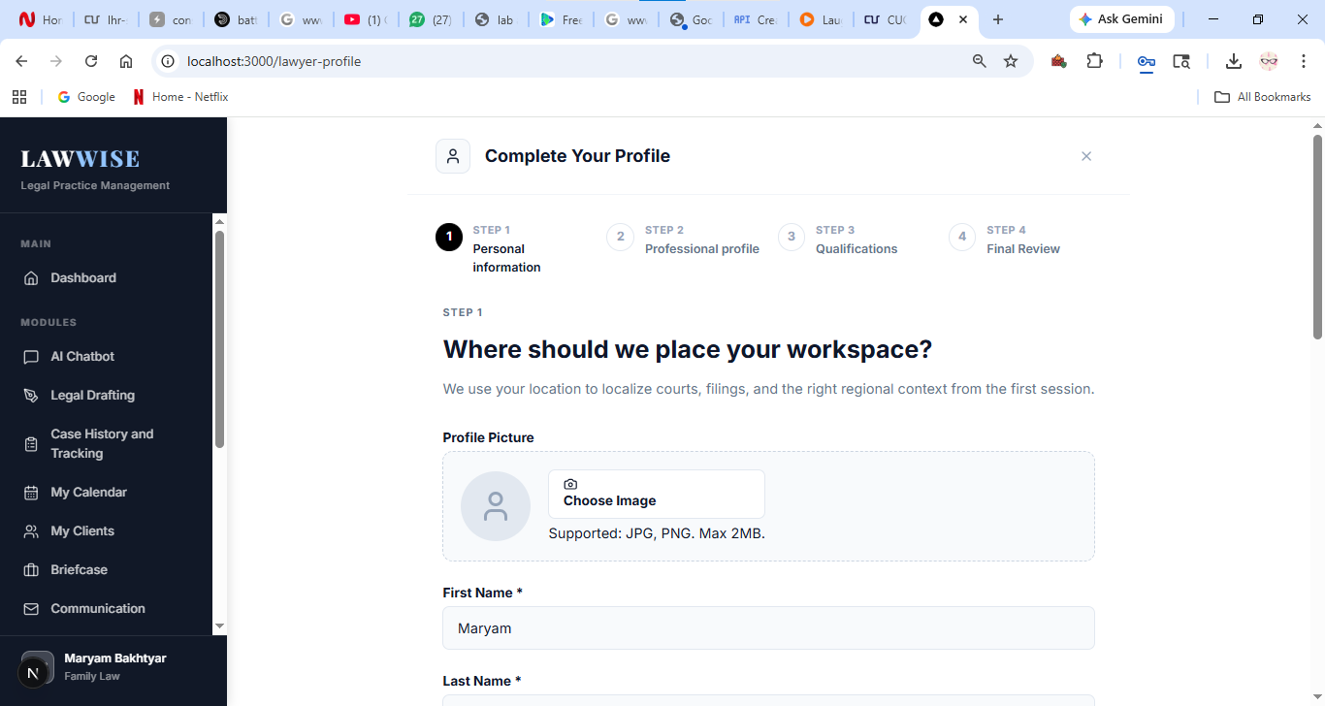
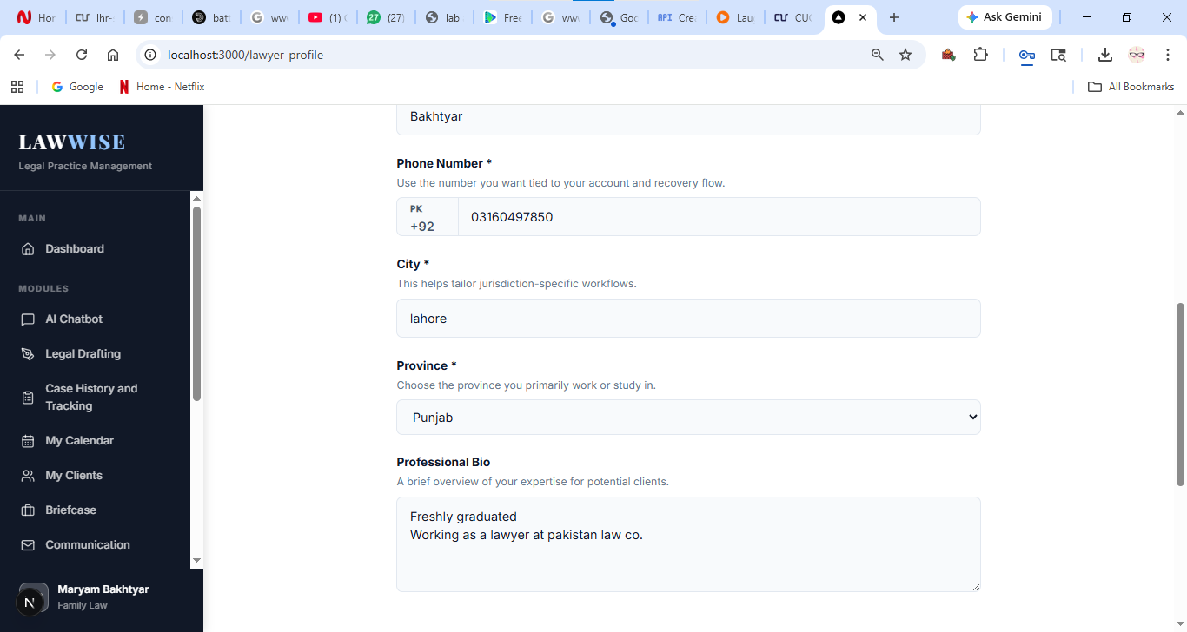
Figure 5.10. profile management page

Mini law library / Briefcase
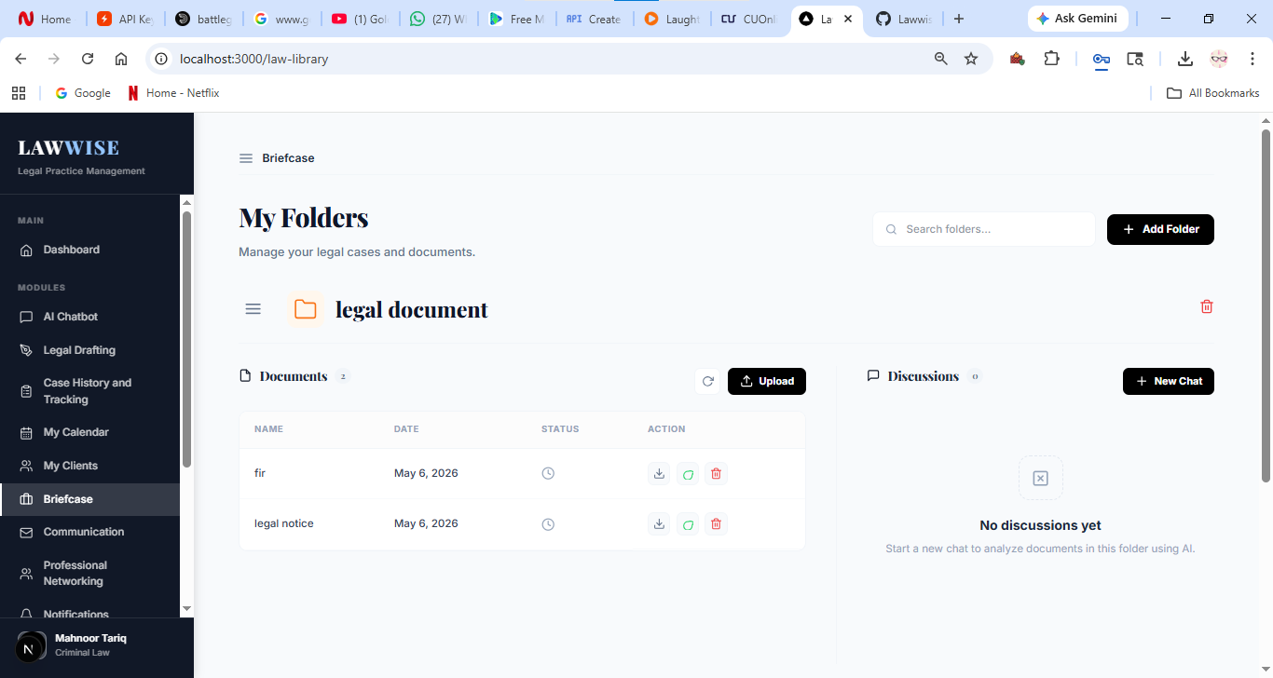
Figure 5.11. mini law library / briefcase

AI Chatbot
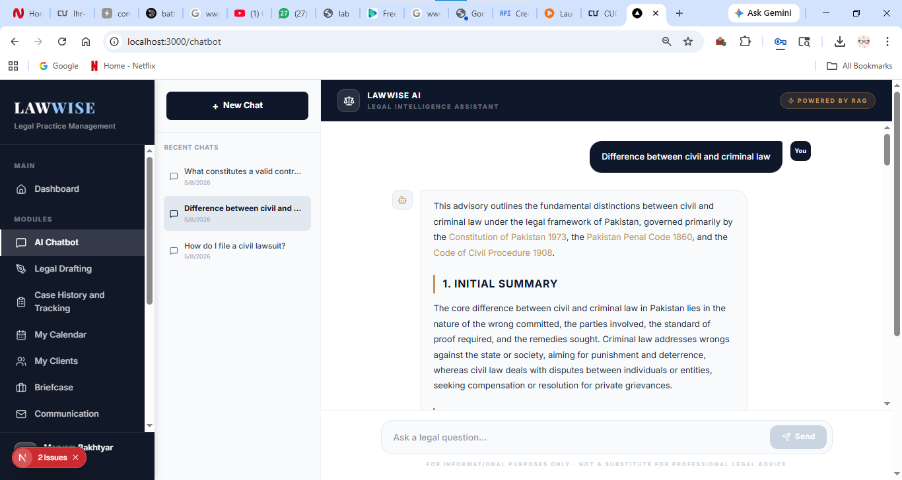
Figure 5.12. AI Chatbot page

Digital Guidance
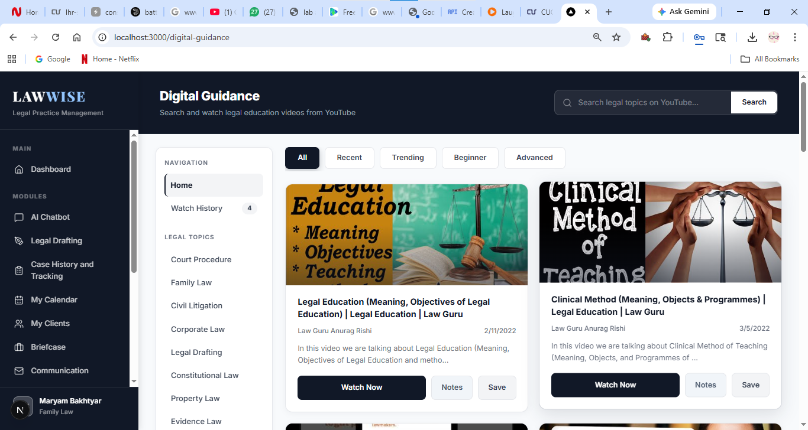
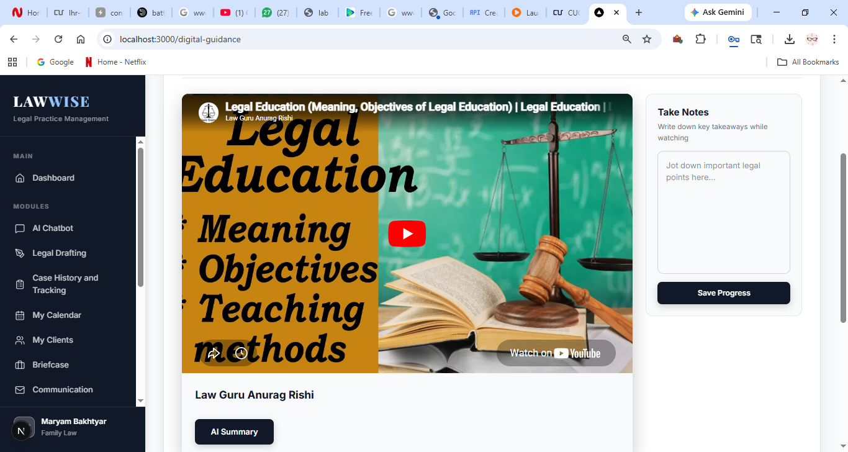
Figure 5.13. digital guidance page

Notifications and reminders
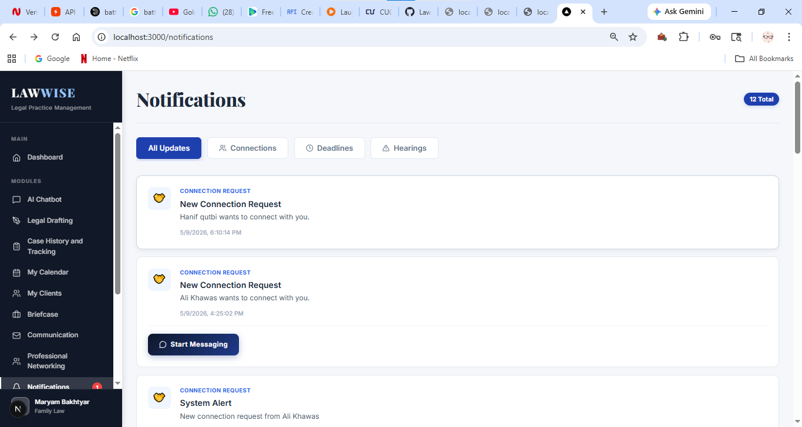
Figure 5.14. Notifications and reminders page

Professional networking
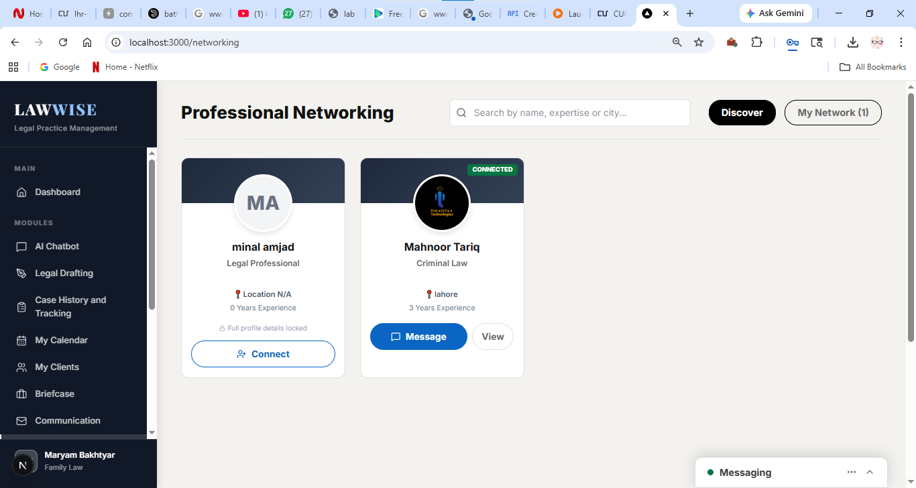
Figure 5.15. Professional networking page

Communication
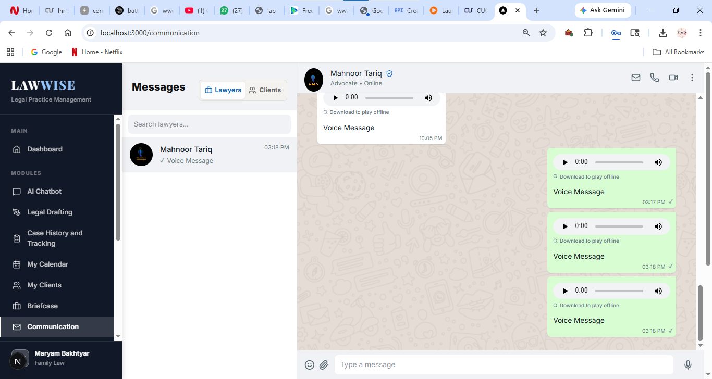
Figure 5.16. Communication

Analytics
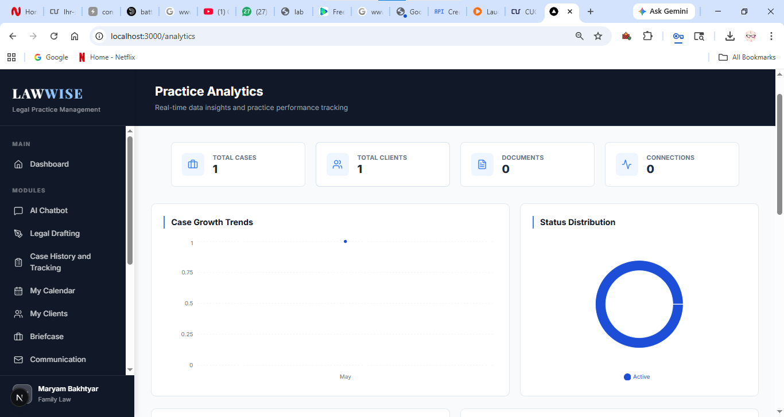
Figure 5.17 Analytics

My clients
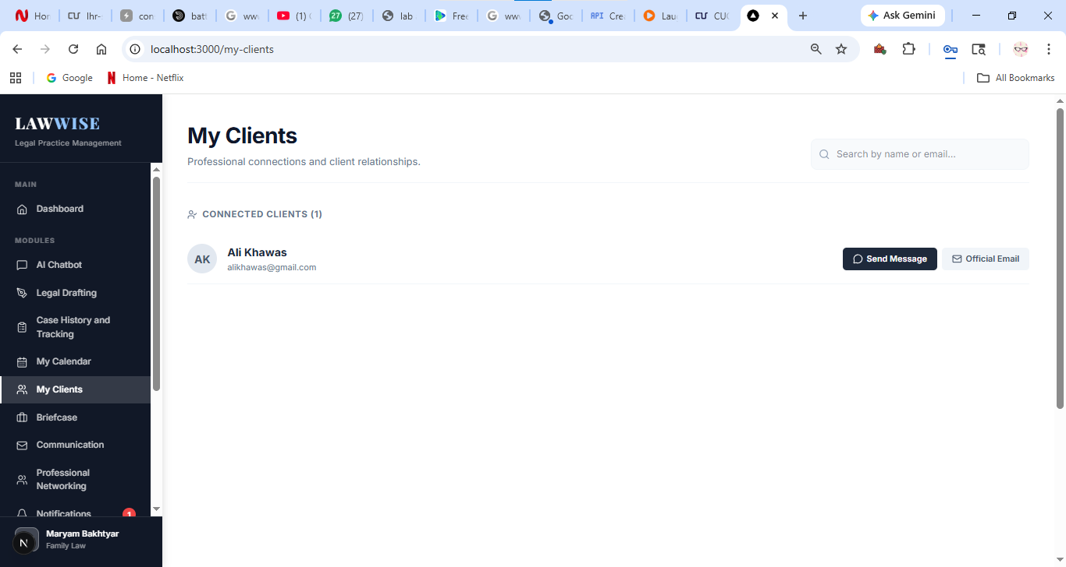
Figure 5.18 My Clients

AI Legal Drafting
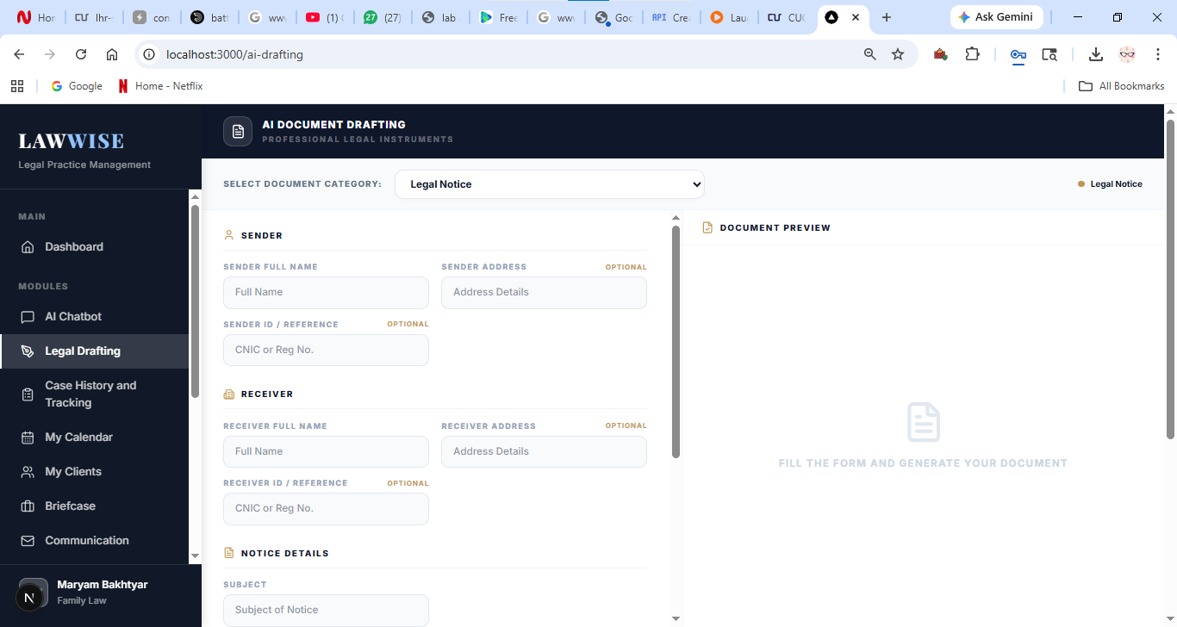
Figure 5.19 AI legal based drafting

Case Marketplace
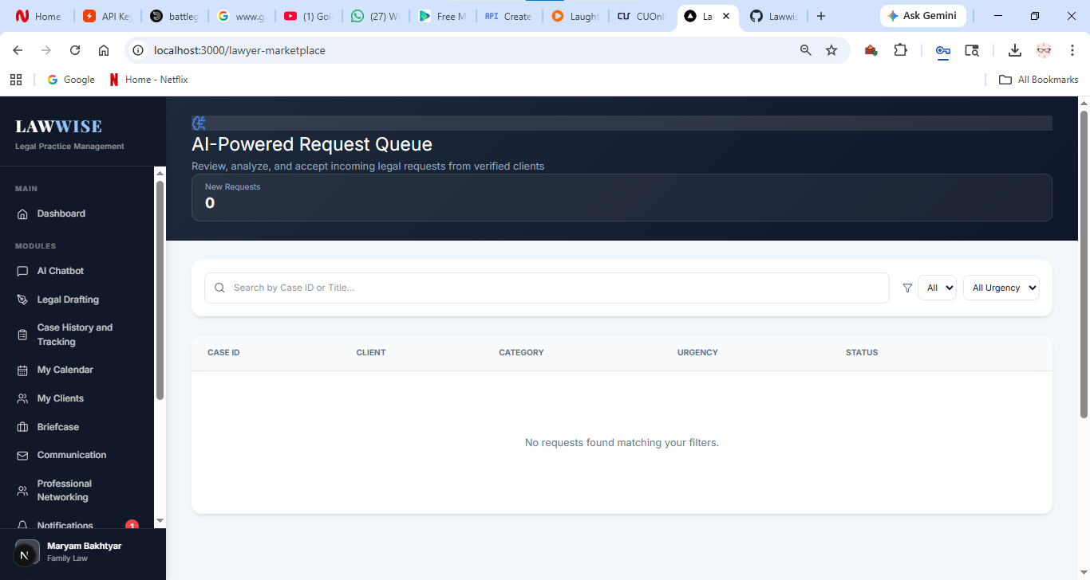
Figure 5.20 Case MarketPlace

Consultation Booking

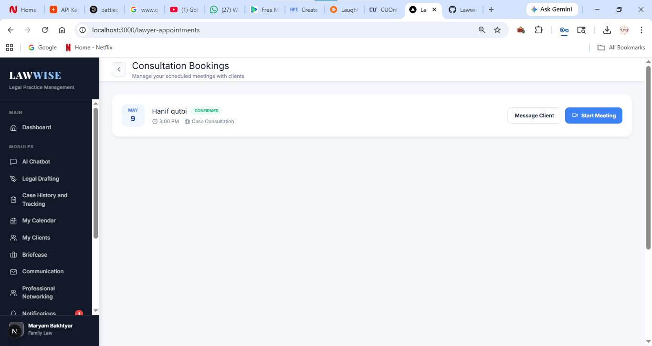
Figure 5.21 Consultation Booking

Manage Schedule
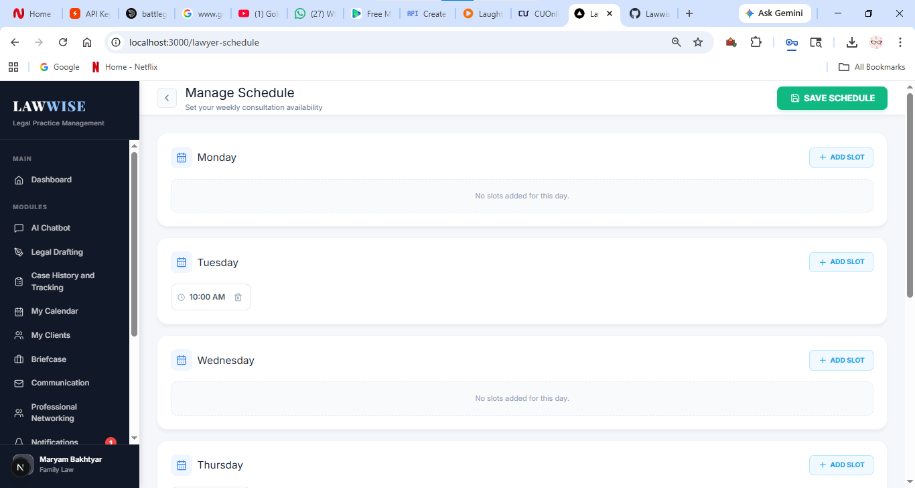
Figure 5.22 Manage Schedule

Client Login
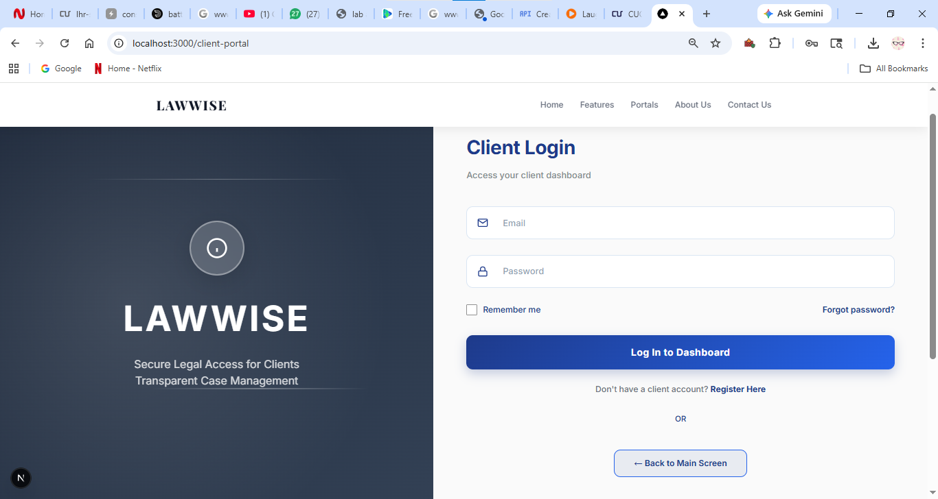
Figure 5.23 Client login

Client Sign Up
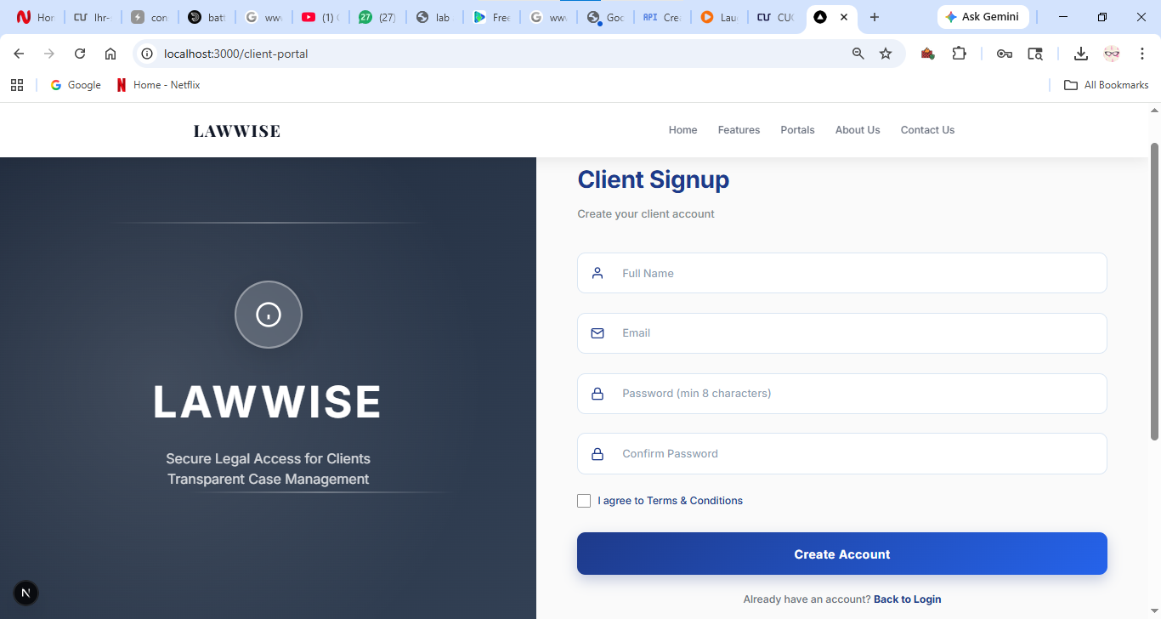
Figure 5.24 Client Sign Up

Client Dashboard
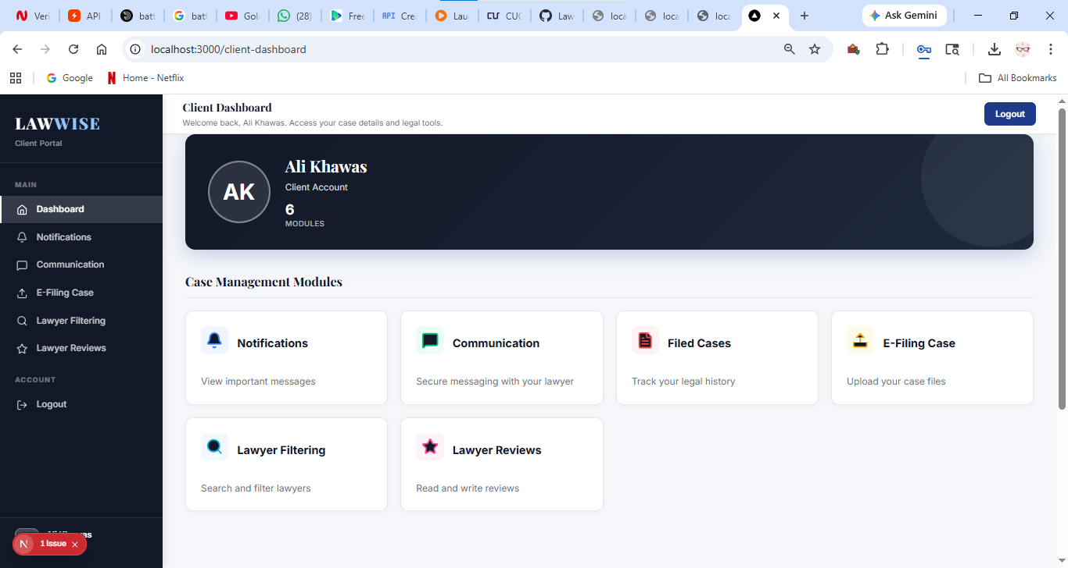
Figure 5.25 Client Dashboard

Client Notification and Reminders
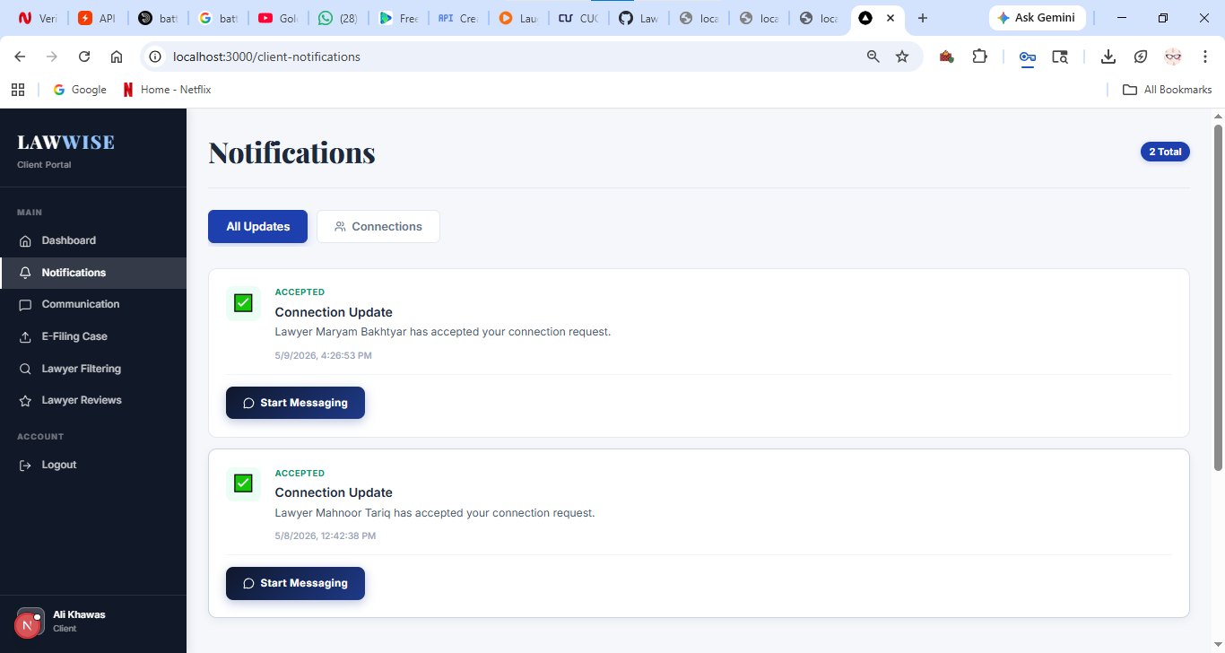
Figure 5.26 Client Notification and Reminders

Client Communication Screen
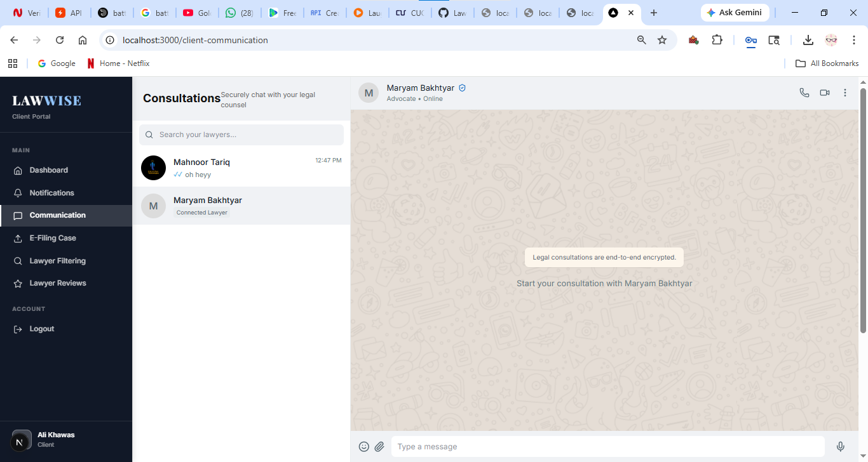
Figure 5.27 Client Communication

Filed Cases
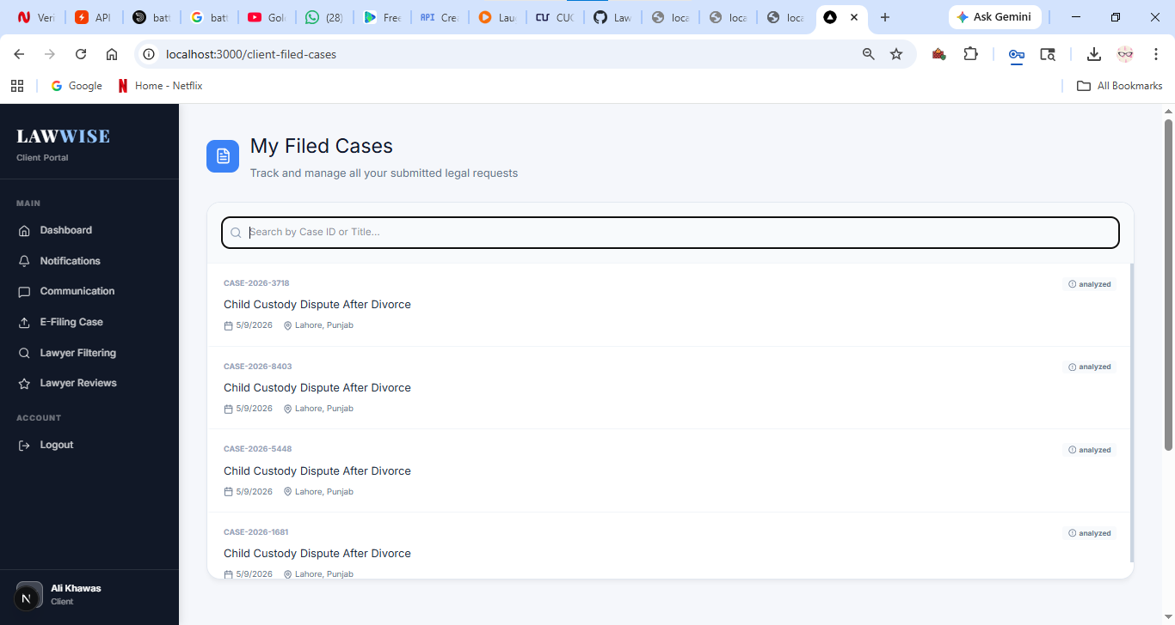
Figure 5.28 Filed Cases

E-Filing Cases
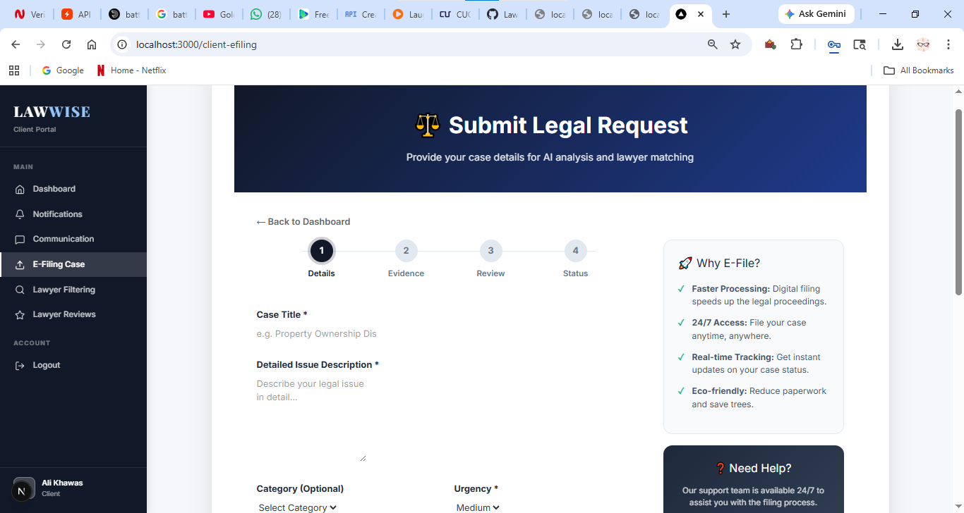
Figure 5.29 E-Filing Cases

Lawyer Filtering
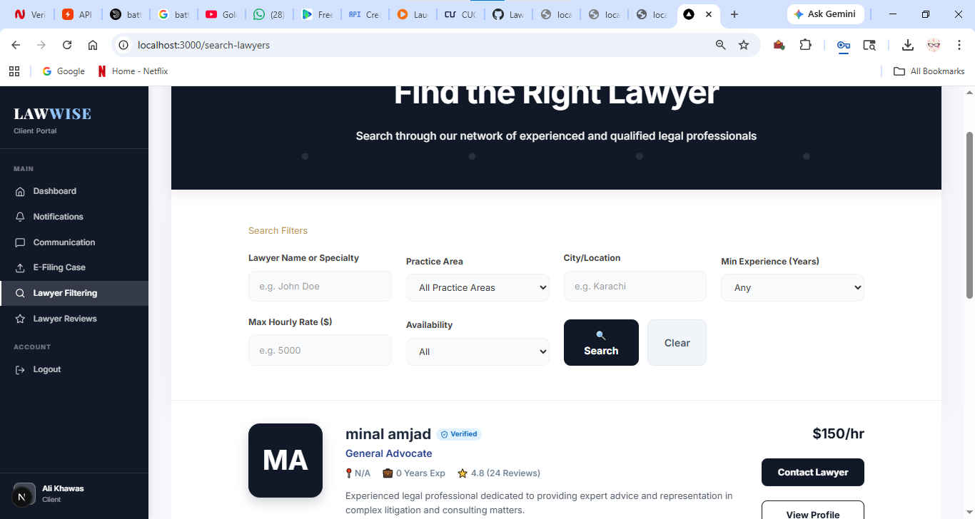
Figure 5.30 Lawyer Filtering

Lawyer Reviews
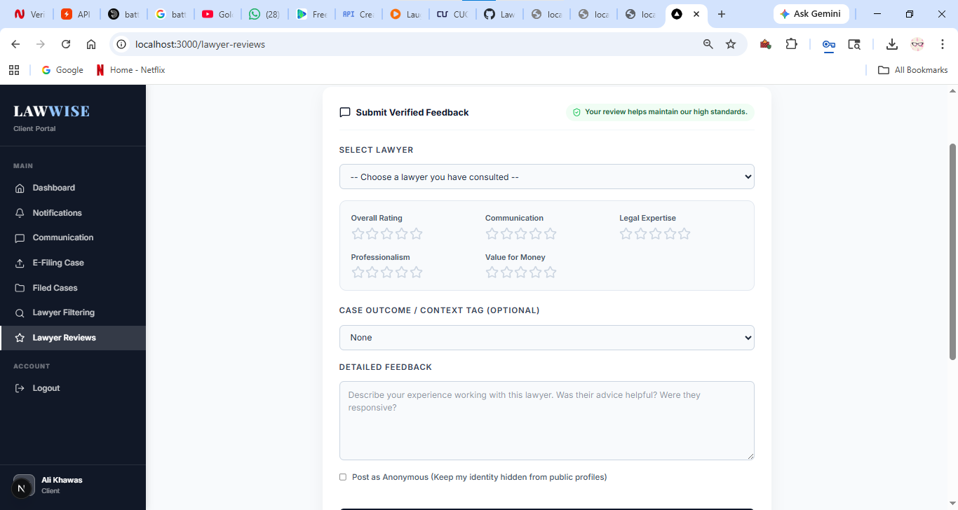
Figure 5.31 Lawyer Reviews

Student Login
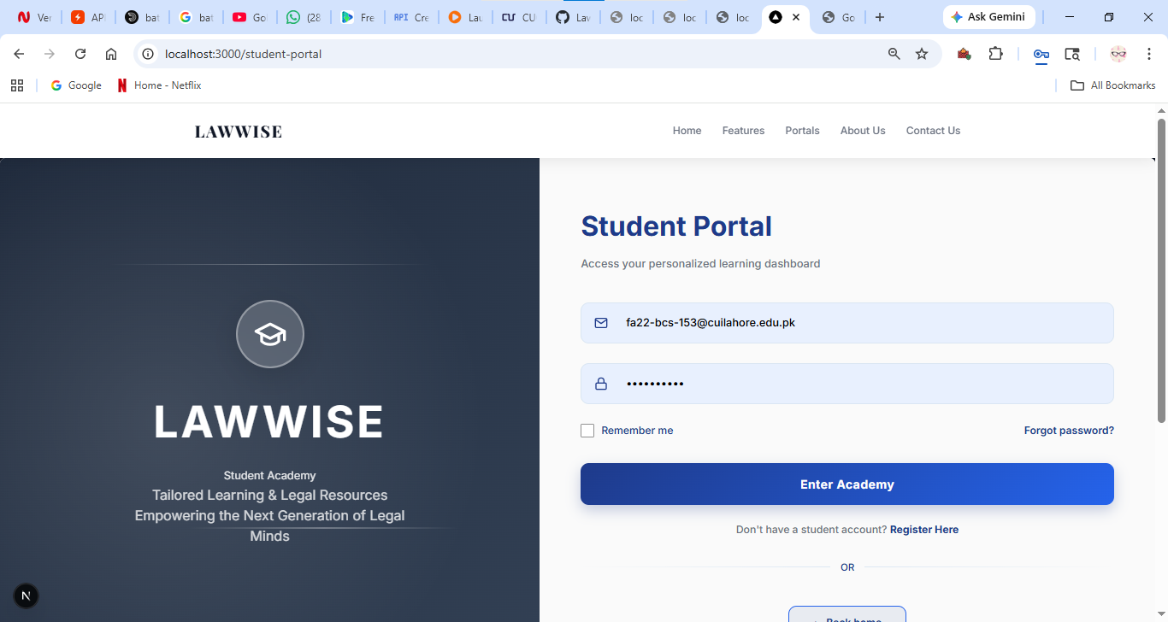

Student Sign Up
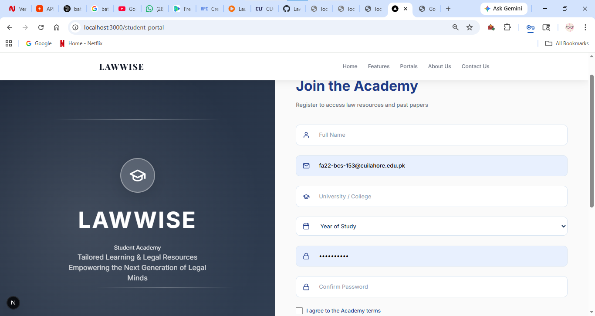

Studend Dashboard
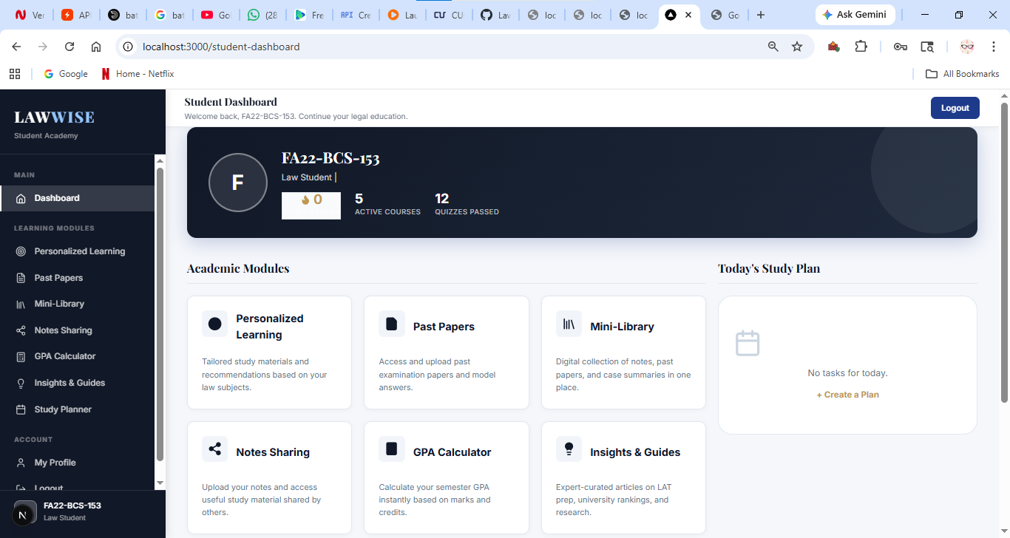

Personalized Learning
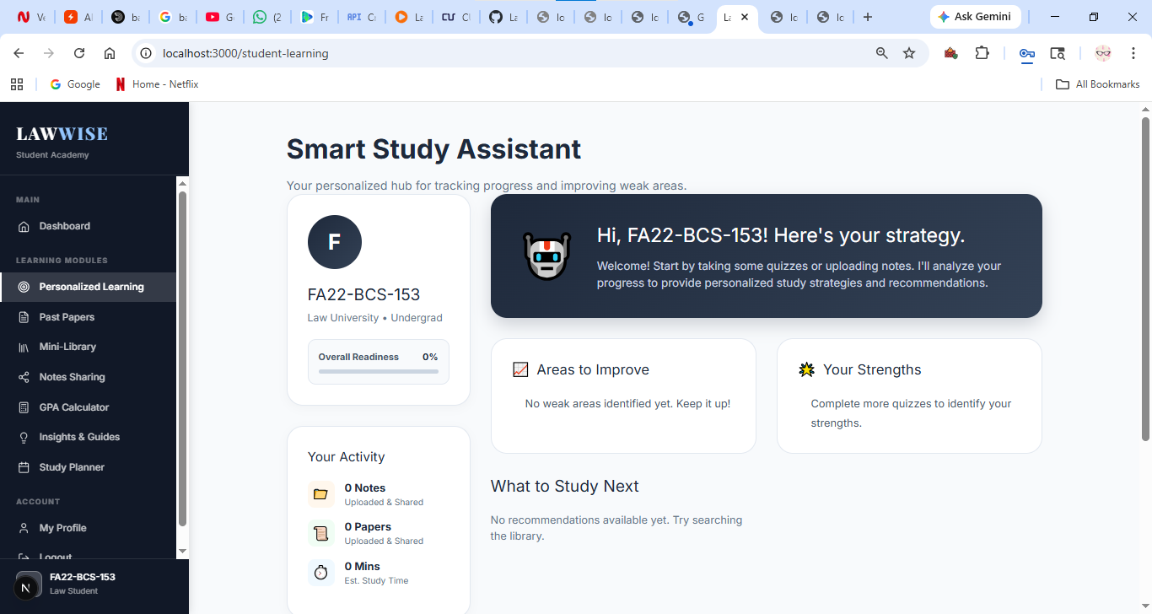

Past Papers
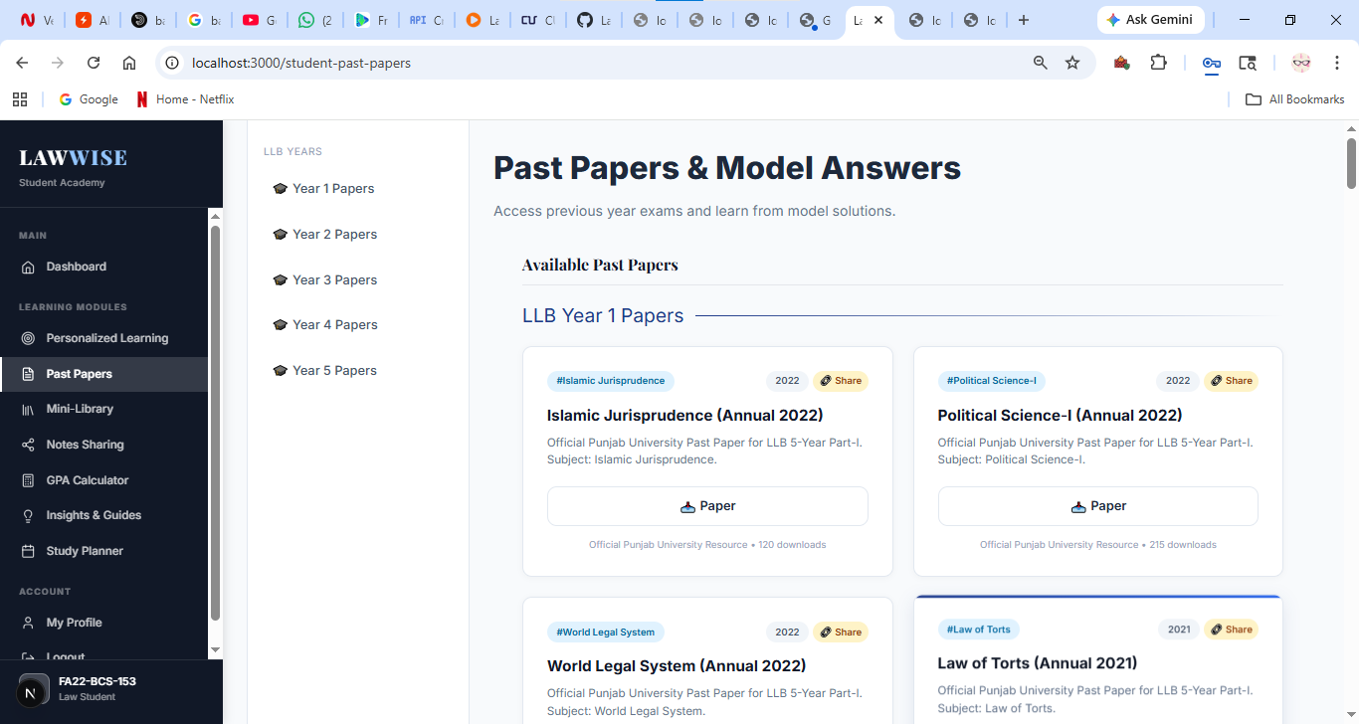

Mini Library
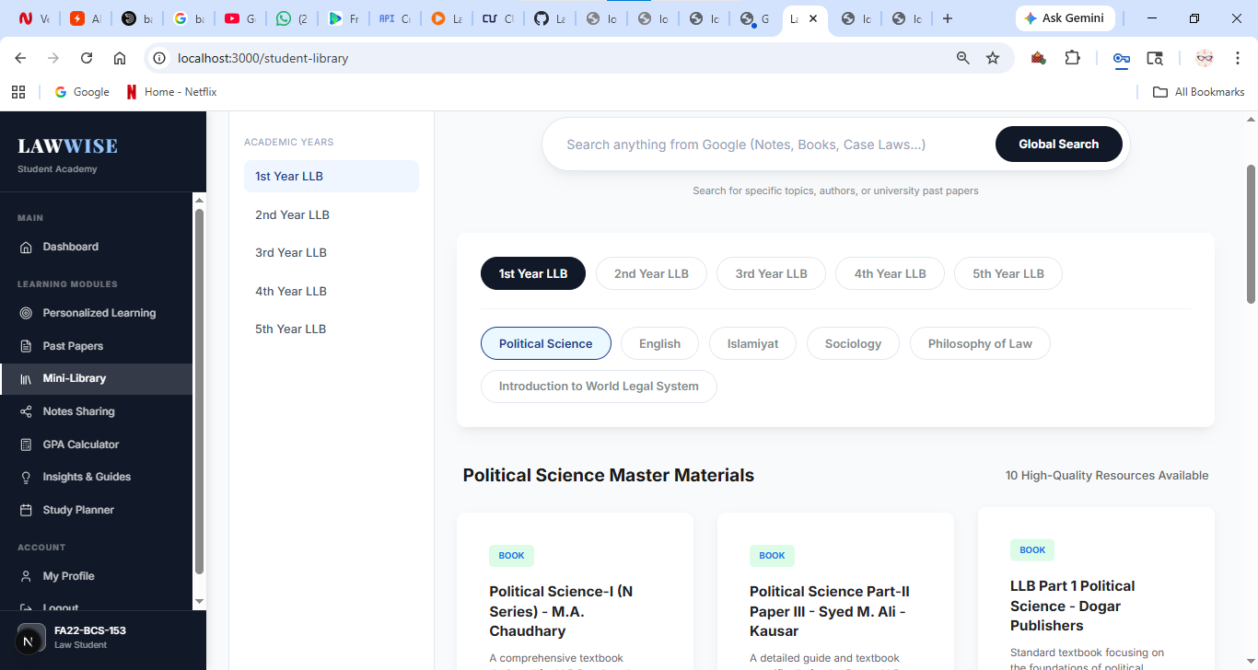

Notes Sharing
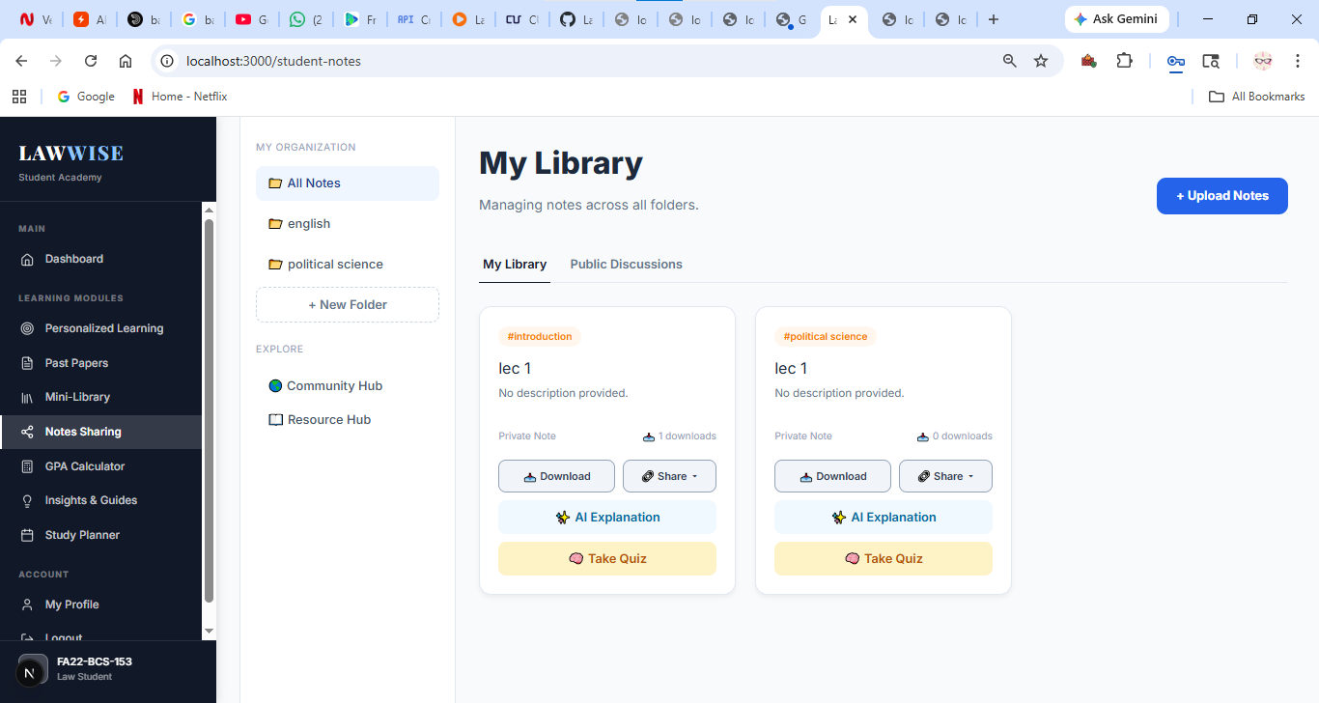

GPA Calculator
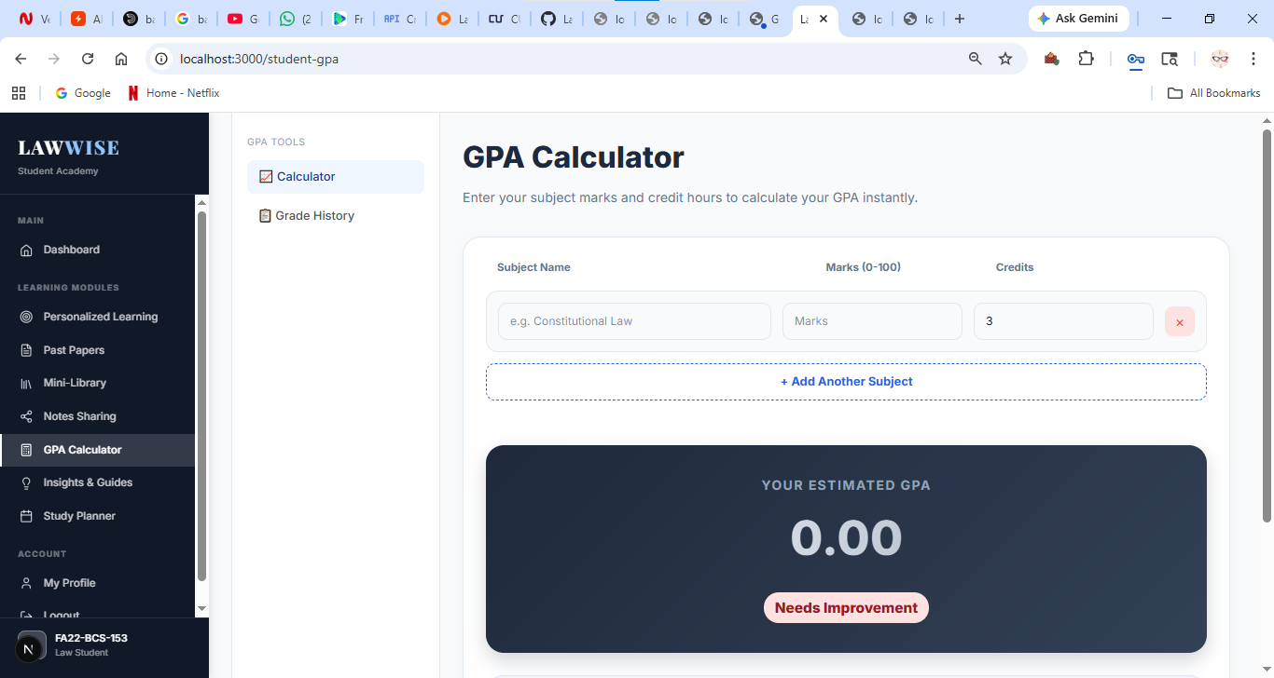

Insights and Guides
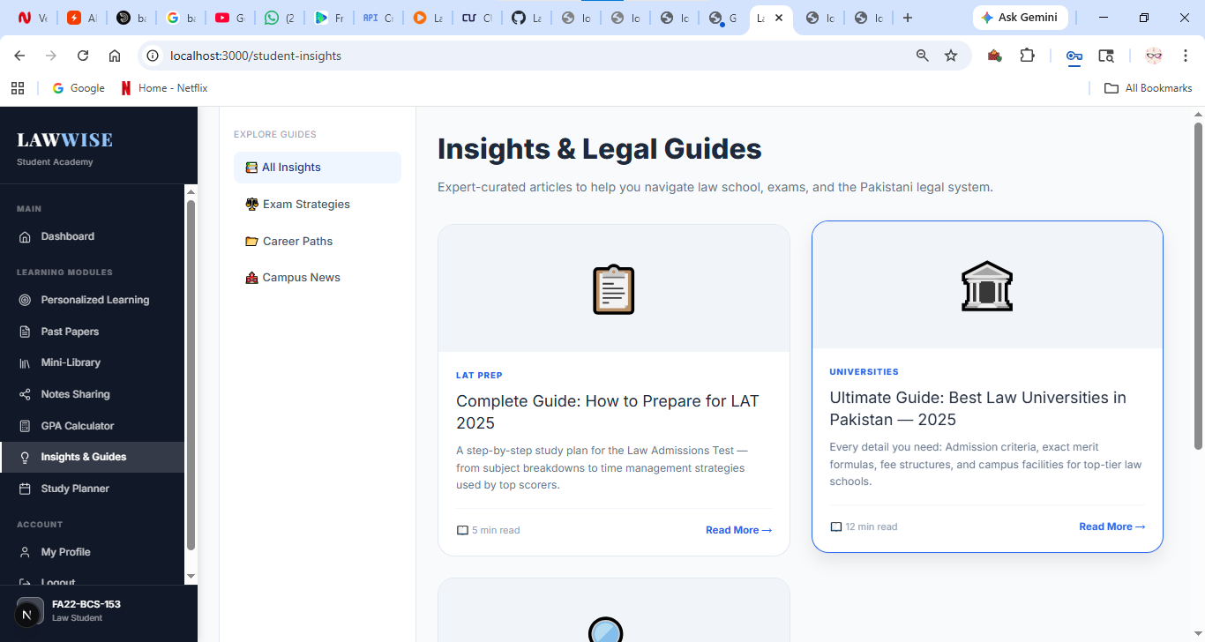

Study Planner
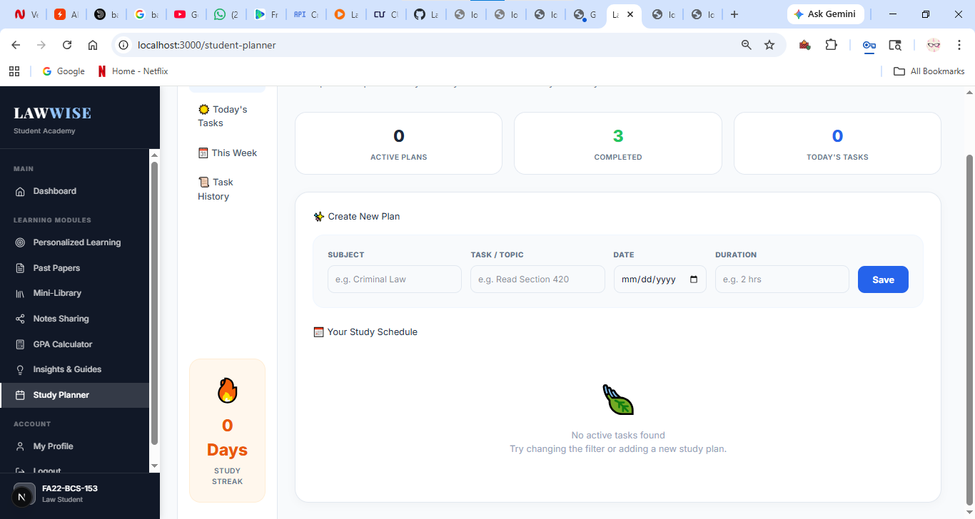

Challenges During Implementation
- Orchestrating the "AI Hybrid Fallback"
- Resource Constraints (Local LLM Performance)
- Synchronizing Dual Databases (MongoDB + ChromaDB)Responsiveness among multiple workflows
- Ensuring integrity of data
- Reducing AI Hallucination with RAG

Conclusions

Summary
LawWise is an integrated, cutting-edge platform designed for Legal Practice Management and Legal Education and purposefully developed to overcome the siloed nature and low digital presence in Pakistan's legal industry. Transformed from its initial distributed design running on a MERN stack to a modern unified Next.js App Router platform with robust Node.js and Express back-end capabilities, LawWise operates as a one-stop-shop ecosystem for three primary user categories: lawyers, clients, and law students.
The platform streamlines and enhances daily lawyer operations through case status updates, hearing reminders, scheduling appointments, and advanced AI-Assisted Legal Drafting which ensures that generated drafts are always professional and do not include any placeholder text. From the client's perspective, the platform facilitates easy access to the justice system through the provision of a list of advocates sorted according to their specialty and location, appointment booking, and automatic classification and summarization of the submitted case details by AI. Finally, for the purposes of law students, LawWise provides an educational module named "LexAcademy," which includes LAT test preparations, GPA calculator, study streaks, planners, and a digital notes repository accessible.
The essence of LawWise lies in its extremely robust and fail-safe AI orchestration layer. Its principal cloud brain uses Google Gemini 2.5 Flash, while if that fails due to API limitations, it smoothly rolls over to use Groq (running Llama 3.3 70B), and even if the previous two fail, then a fallback to an on-device offline Ollama using Gemma 2:2B ensures smooth operation in court sessions without any internet connection, and if all AI services are out of commission, it outputs raw statutory records stored locally in the Chroma vector database. This RAG model makes use of the vector embedding of actual statutes such as the Constitution of Pakistan 1973 and the Pakistan Penal Code 1860 to answer queries from verified sources, making sure that no hallucinations occur during the process. Following Pakistani legal jurisprudence, the AI abides by strict logical considerations like civil/criminal liability distinction, honest intent tests under Sections 420/406 of PPC to avoid over-criminalization of contractual disputes, QSO admissibility tests for digital evidence, and quashing of actions under Section 561-A of CrPC. Through the successful fusion of transactional databases such as MongoDB, along with semantic vector searches, multi-tenant portals, and other LLM-based capabilities, LawWise is able to create a streamlined and cutting-edge platform for the future of LegalTech within Pakistan.

Recommendations for Future Work
Below are some suggestions that are very relevant and can contribute greatly to future work on the LawWise ecosystem. The suggestions have been listed as follows:
Live Cause List Synchronization with Courts: In upcoming releases of the platform, web scraping or an official API integration with the Supreme Court of Pakistan and High Courts in Punjab (LHC), Sindh (SHC), Islamabad (IHC), Peshawar (PHC), and Balochistan (BHC) can be made. This will provide automatic synchronization of court rosters and daily cause lists along with push notifications for the lawyer's cases being up for hearing.
Whisper Urdu-Speech To Text for Legal Cases: In light of the fact that most local or session courts hold legal cases in the Urdu language, it will prove extremely useful to implement a localized version of the Whisper speech-to-text pipeline. This will enable advocates to record their oral arguments in the courtroom or make a voice note for their case which will be converted into written documents.
Fully Offline Mobile Application with Gemini : Moving all the portals to cross-platform mobile applications (React Native/Flutter) through local on-device models such as Gemini could help in performing instantaneous searches of the full code and constitution in offline mode on mobiles, which will be essential in regions without mobile coverage.
Virtual Moot Court for Law Students: Adding a feature to LexAcademy where law students can practice their oral arguments via virtual reality in an interactive AI-simulated moot court. The AI judge here, programmed to mimic the behavior of judges in the High Court Bench of Pakistan, would challenge the students on their references to case laws.
Legal Database Expansion into Specialist Areas: Although the present model of the RAG chatbot uses only the legal framework of Civil and Criminal law (using the Constitution and Pakistan Penal Code) for training and seeding of the model, its design allows scaling up of the process in the future. One key step that needs to be addressed concerns the expansion into ingestion, vectorization, and seeding the database from other specialist areas, which include Family Law (Family Courts Act 1964), Corporate and Taxation Law (Companies Act 2017), Labor Law, and Intellectual Property Law. Through expansion of the vector database to include these legal statues, along with the corresponding case laws, the scope of the chatbot will be expanded further.

References
[1] | H. Surden, "Machine learning and Law," Washington Law Review, vol. 89, no. 1, pp. 87-115, 2014.
[2] | k. D. Ashley, Artificial Intelligence and Legal Analytics: New Tools for Law Practice in the Digital Age, Cambridge: Cambridge University Press, 2017.
[3] | Rocket Lawyer Inc., "Rocket Lawyer – Online Legal Services Platform," 2023. [Online]. Available: https://www.rocketlawyer.com.
[4] | JURIX Foundation for Legal Knowledge Systems, "Proceedings of the International Conference on Legal Knowledge and Information Systems (JURIX 2021)," in IOS press, Vienna, 2021.
[5] | Pakistan Law bot, "AI-based Legal Chatbot for Pakistani Laws," Pakistan Law bot, 2022. [Online]. Available: https://pakistanlawbot.com.
[6] | Vizlegal, "Vizlegal – Legal Case Tracking and Court Records Platform," 2023. [Online]. Available: https://www.vizlegal.com.
[7] | Lexoo Ltd., "Lexoo – Global Legal Marketplace," 2023. [Online]. Available: https://www.lexoo.com.

